Adam Fitzpatrick, Gábor Major, Kelan Morgan, Qadeer Hussain

Date: 20th mar 23 | Tutor: Timothy Casey

Project “THE PROJECT” Project Manual

Garage System

**Contents**

User Interface 4

Common 4

Individual 6

System Layout 8

Database Layouts 10

Group Work 24

Individual Work 26

Adam Fitzpatrick 26

Add a New Customer 26

Amend/View Customer 33

Make a Booking 41

Receive Deliveries 48

Gábor Major 50

Add a New Stock Item 50

Delete a Stock Item 58

Amend/View a Stock Item 64

Stock Status Report 73

Kelan Morgan 78

Add a New Employee 78

Delete an Employee 84

Amend/View an Employee 90

Login/Change Password 98

Qadeer Hussain 112

Add a New Supplier 112

Delete a Customer 119

Commencement of Job 126

Completion of Job 138

# User Interface

## Common

Written by: Gábor Major

A lot of our UI is very similar for all of the screens.

For all of our menus, sub menus and specific elements like buttons and inputs, the CSS and structure and layout is the same.

All of the webpages have a link to the deafault.css file, and we used internal and inline CSS for our individual screens where needed.

For our background and side menu we used a picture which we turned for the side menu.

Our default font for all the text is Arial, with the fallbacks to Helvetica ad Sans-Serif.

Our side menu has a width of 250 pixels, margin left and right of 20 pixels.

The side menu, top sub menu, and content box all have the same border style, border thickness is 5 pixels, black and solid. It also has a border radius of 30 pixels.

The logo is located in the top of the side menu. It is just an image that can be clicked to bring you back to the main menu. The cursor is changed for this and all buttons so it looks clickable.

Next is the current page title. This is centre aligned, bold and font size of 30 pixels.

After these come the menu buttons for navigating. These all have set widths, margins, and paddings. The font is centred, bold and 20 pixels in size.

The menu buttons, sub menu buttons, input fields, and other buttons all have the same border styling, border thickness 3 pixels, black, and solid, with border radius of 20 pixels.

The border colour of any of the menu buttons changes to white when we are on that specific page.

The top sub menu is very similar to the side menu. However it is positioned exactly 320 pixels left of the side menu, with a height of 100 pixels.

The sub menu buttons are also similar to the side menu buttons, however the width of these buttons is changed to 30%. There are pages though were there are 4 top sub menu buttons instead of 3 and for those there is internal CSS which changes the width to 20%.

The content box takes up the rest of the page. It comes down 150 pixels and in 320 pixels from the left. The border of this algins with the side menu and the top sub menu borders.

There is also a min height set for this. We use min-height instead of height so that if any content in it is too big it can flex down the page.

The content box is then split into two sides left and right, they both take up the full height of the content box and they split the width to 50%, with a margin left, top, and right of 50 pixels.

All labels for input elements have top and bottom margin of 20 and 10 pixels, are bold, and font size of 30 pixels.

All inputs, textareas, selects and tables in here have a width of 60% of their parent div, and all have a 50% transparent white background.

All of the disabled and readonly inputs, textareas and selects change their background colour to mid grey with a transparency of 50%.

The two buttons for submitting and clearing have a width of 20% and margin of 20% + 5 pixels for the border. This way the two buttons next to each other line up with all of the input elements.

For inputs with the type number the spinner arrows are hidden.

Any tables used are also styled the same way as the inputs, however their width takes up most of the content box, and all the text is centre aligned.

## Individual

Adam Fitzpatrick

On both the Add a New Customer and Amend/View Customer screens the CSS remains the same as the common one

On the Make a Booking screen, the table with the booking slots adds a padding of 5 pixels, sets the width of the table to 62%, adds a margin of 0 pixels on the top and bottom, 50 pixels on the right and 50 pixels on the left.

Gábor Major

In the Stock Status Report screen the buttons used for ordering the report data have their width changed to 30% from 20% and their left margin changed to 15% + 5 pixels from 20% + 5 pixels.

There is also an extra div that holds the label and buttons on the top of the content box, its height is 20% and another div that holds the report table below this.

Kelan Morgan

In all of the Employee screens, the sub menu buttons width have been changed to 20% to fit as the default css is made for 3 buttons in the sub menu, but the employee sub menu has 4 buttons.

Due to the number of text fields required in the Add employees and the amend/view screens, the margin for the left and right content boxes is changed to 10px on the top and bottom to fit the fields within the content box.

In the amend/view employee screen the label margin is reduced to 10px on the top and bottom as there is extra space required due to the dropdown menu and amend/view button.

In the login pages the class login_box is used to specify the width and position of the login box, it is set to 400px width with dynamic height due to the box resizing for error messages, there is a border around the box and bevelled corners around the perimeter of the box, the background image of the site is also inserted into the background of the login box. The buttons have their own specified size, the buttons are 200px wide and have an auto margin to centre them, and the button is also bordered and bevelled like the login box. Every screen for the login has the logo on the left with the input fields on the left and the button beneath them, the error messages appear above the inputs and the change password button appears below the input fields.

Qadeer Hussain

On the Supplier Add Screen and the Customer Delete Screen, the sub menu buttons have a set width of 20%. There are 4 buttons on these screens as the default css is made for 3 buttons. The content box margin is set to 20 pixels top and bottom.

­In the Commencement of Jobs screen­ there is a table above the inputs of the screen and there is a top margin of 20 pixels for the table. The content box left and content box right have margin top 5 pixels. This is to reduce the amount of space between the content boxes and the table. The Completion of Job screen has the common CSS.

# System Layout

Written by: Kelan Morgan

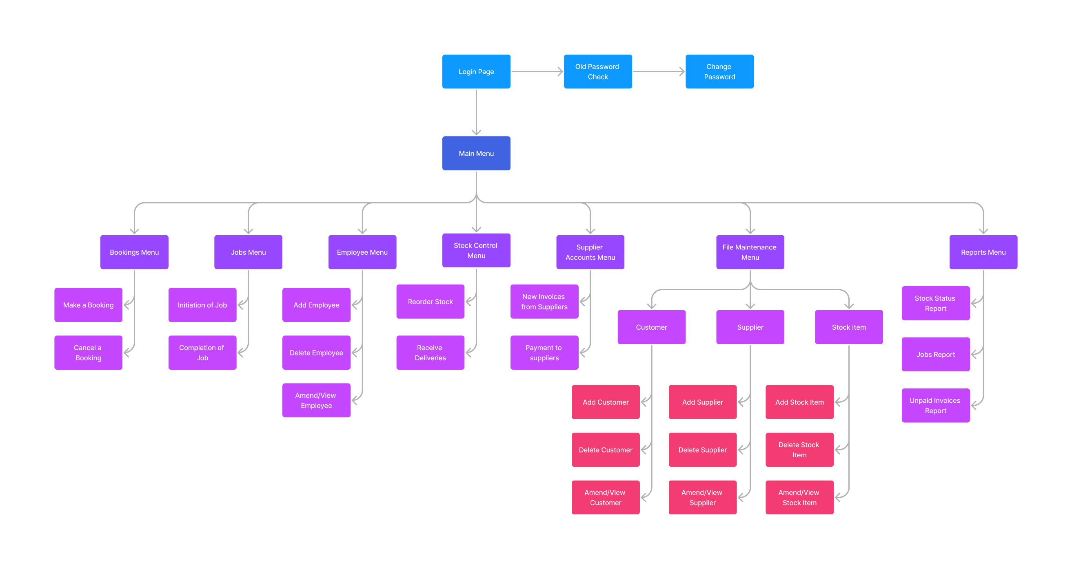

# Database Layouts

Written by: Adam Fitzpatrick

Bookings

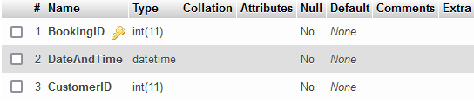

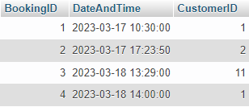

Customer

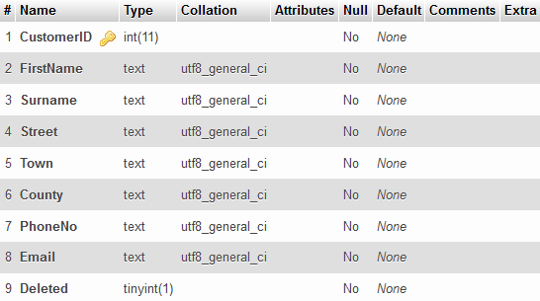

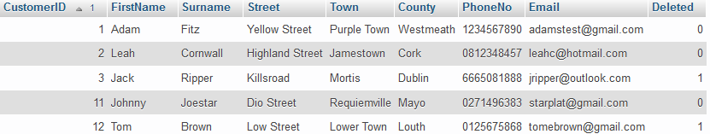

CustomerPayments

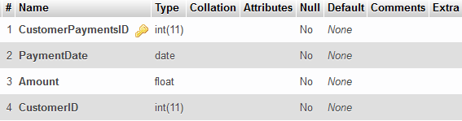

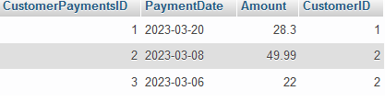

Written by: Gábor Major

Stock

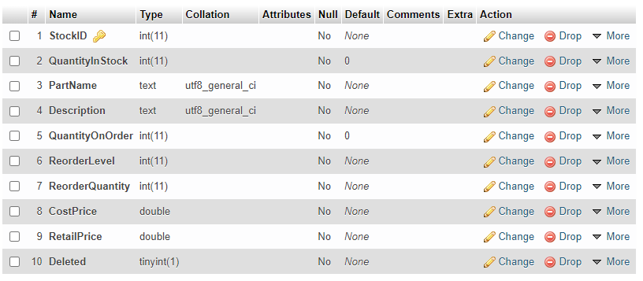

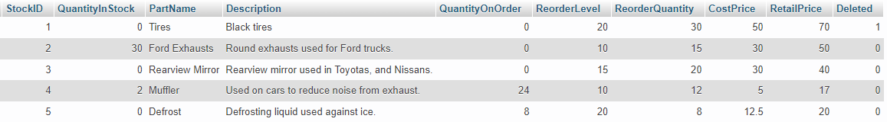

Stock/Orders

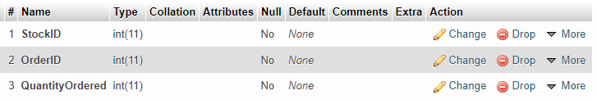

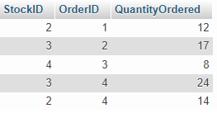

Stock/Supplier

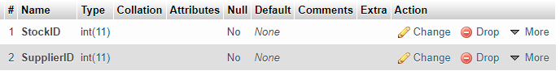

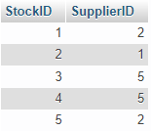

Written by: Kelan Morgan

Employee

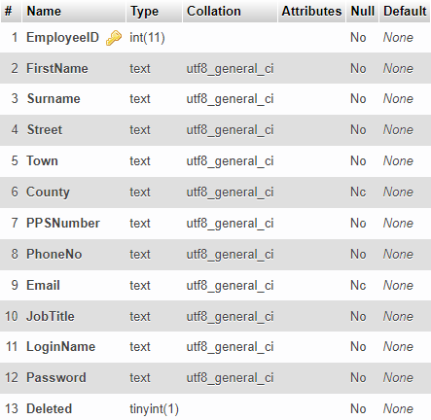

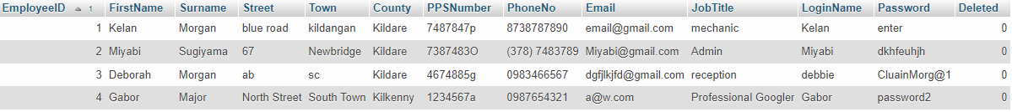

Order

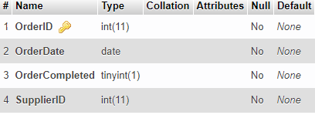

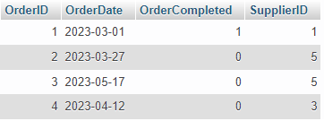

PaymentToSupplier

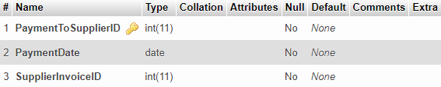

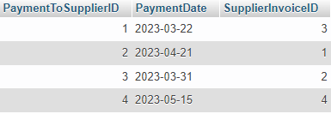

Written by: Qadeer Hussain

JobParts

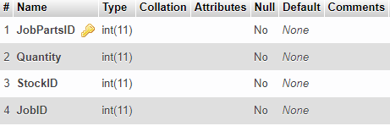

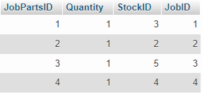

Jobs

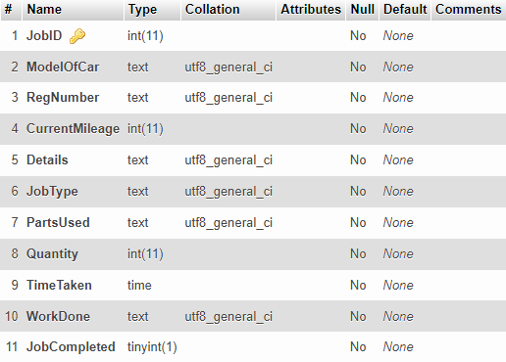

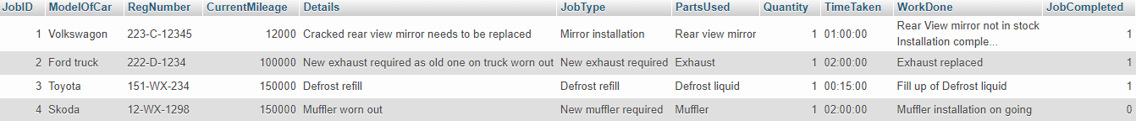

Supplier

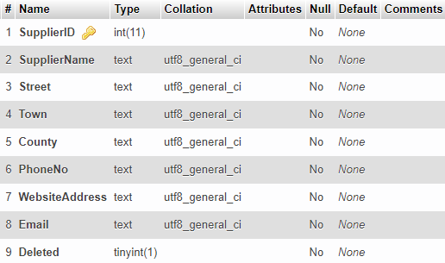

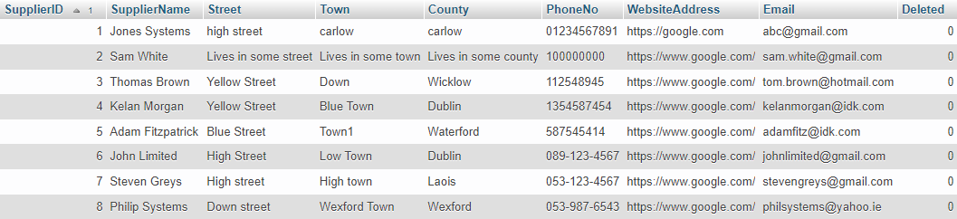

SupplierInvoice

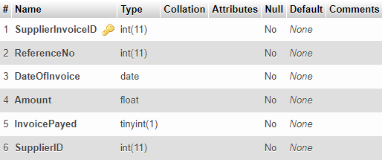

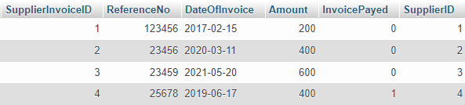

# Group Work

Written by: Adam Fitzpatrick

For our group project, we undertook the task of developing a garage system and worked collaboratively on several essential components including the ER diagrams, the common CSS, menu layouts and design, and database.

We first worked on our ER diagrams, which was vital for our database design. This   
process allowed us to identify the key entities and relationships that needed to be captured in the database. Through this we were able to develop a clear blueprint for the database, leading to more efficient and effective programming.

Next, we worked on the common CSS. We wanted to make a design that would be simple to navigate and easy on the eyes. This involved identifying a colour scheme and   
typography that would be used throughout the system.

Included with the creation of the CSS was the menu layouts and design. This involved deigning a navigation system that would be easy to use with clear labels. We decided to have the main menu items on the left side of the screen, with the sub-menus being located on the top of the page.

Finally, we collaborated on developing the database itself. We implemented the schema defined in the ER diagram, creating the necessary tables, defining the relationships   
between them, and populated the database with sample data. Through this process, we were able to test the application and ensure that it functioned correctly.

# Individual Work

## Adam Fitzpatrick

### Add a New Customer

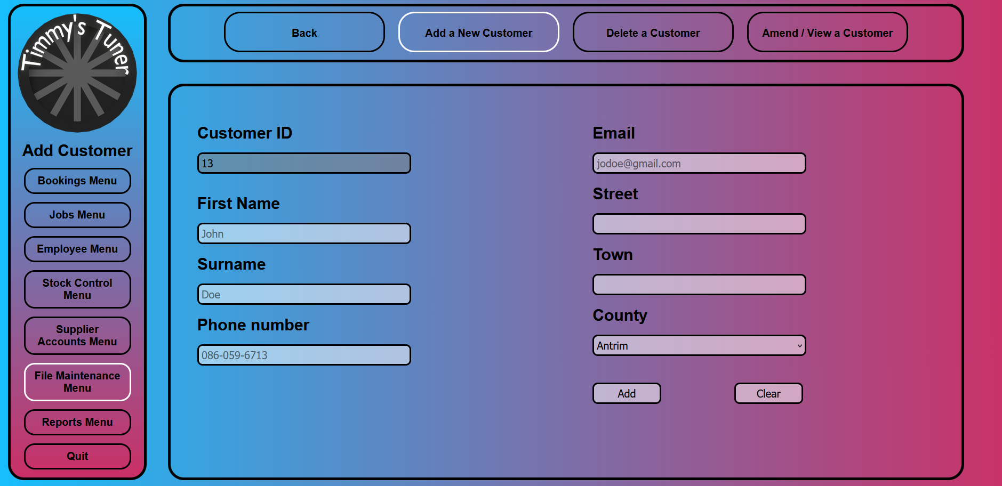

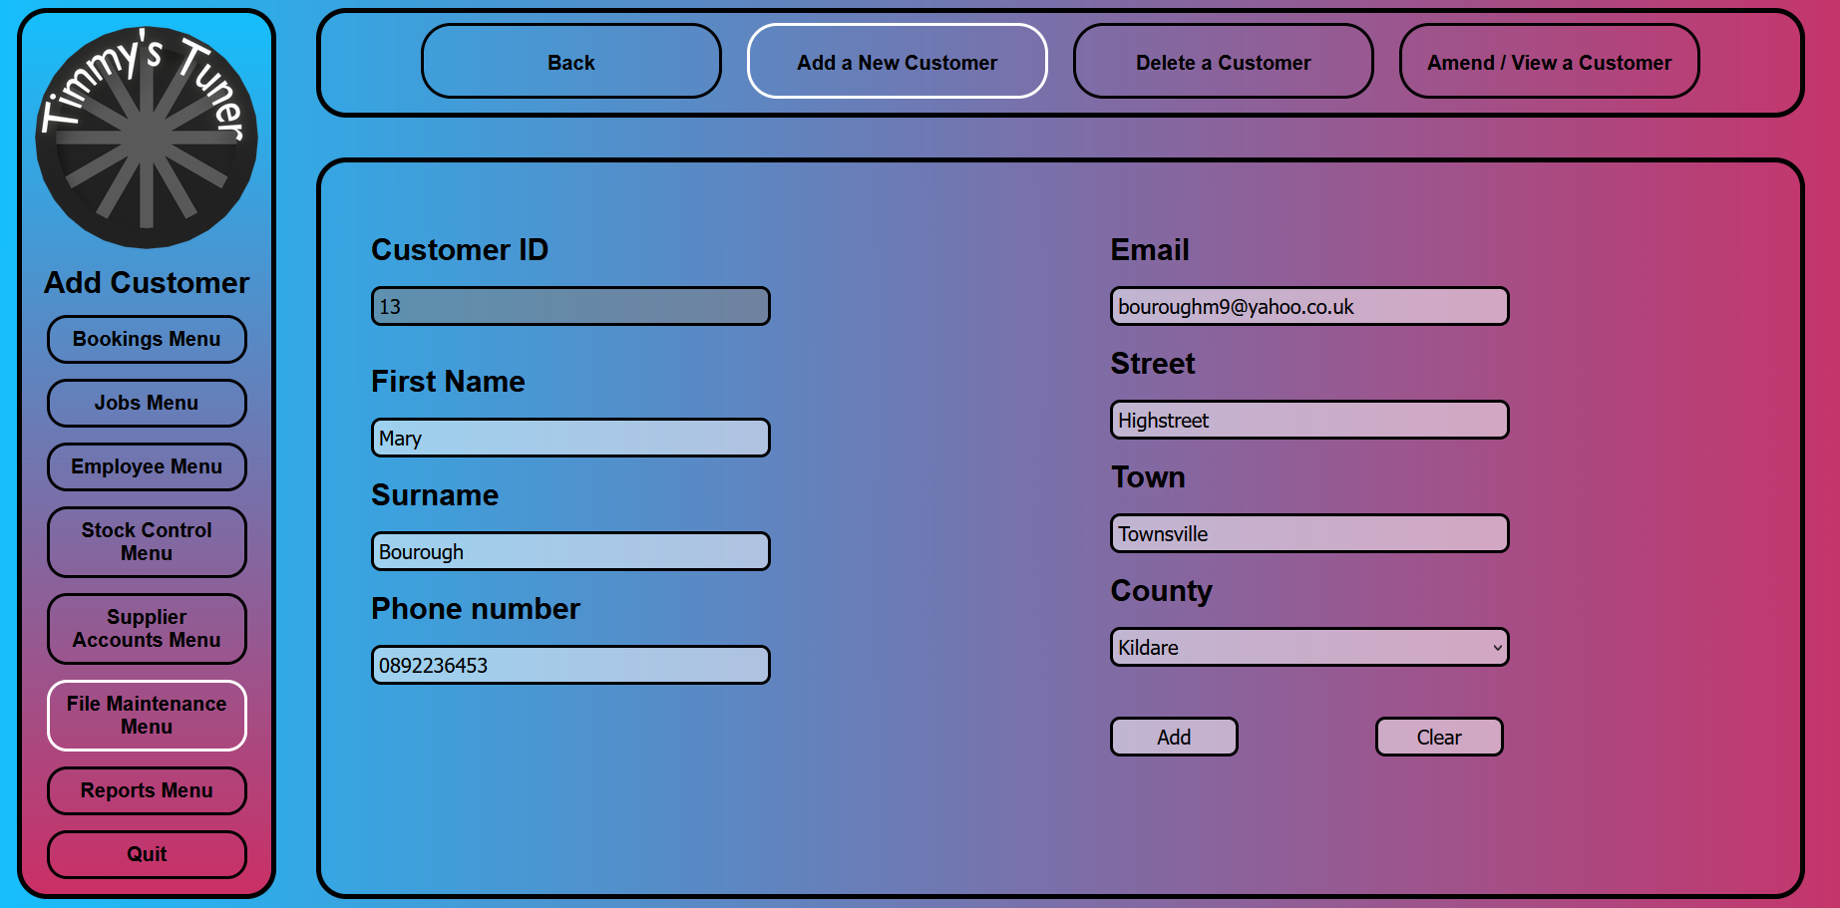

**add_a_new_customer.html.php**

<!--

    Author: Adam Fitzpatrick

    ID: C00273365

    Date: 2023.02.16

-->

<!DOCTYPE html>

<html lang="en">

    <head>

        <link rel="stylesheet" href="../../Css/default.css">

        <title>Add Customer</title>

        <style>

            /* sets it as there are four buttons */

                .sub_menu_button

                {

                    width: 20%;

                }

                .content_box label

                {

                    margin: 20px 0px 20px 0px;

                }

        </style>

        <script>

            <?php

                    $counties = array(

                    'Antrim', 'Armagh', 'Carlow', 'Cavan', 'Clare', 'Cork',

                    'Derry', 'Donegal', 'Down', 'Dublin', 'Fermanagh', 'Galway',

                    'Kerry', 'Kildare', 'Kilkenny', 'Laois', 'Leitrim', 'Limerick',

                    'Longford', 'Louth', 'Mayo', 'Meath', 'Monaghan', 'Offaly',

                    'Roscommon', 'Sligo', 'Tipperary', 'Tyrone', 'Waterford',

                    'Westmeath', 'Wexford', 'Wicklow'

                    );

                ?>

                //Function to confirm if the user wants to add a customer

                function confirmCheck()

                {

                    var response;

                    response = confirm("Are you sure you want to add this customer?")

                    if (response)

                    {

                        return true;

                    }

                    else

                    {

                        return false;

                    }

                }

        </script>

    </head>

    <body>

        <div class="nav_container">

            <div class="menu_box">

                <!-- this makes it so the logo brings you back to the main menu -->

                <img class="logo" onclick="location.href='../main_menu.php'">

                <div class="menu_title">

                    Add Customer

                </div>

                <div class="menu_button" onclick="location.href='../Bookings/bookings_menu.html'">

                    Bookings Menu

                </div>

                <div class="menu_button" onclick="location.href='../Jobs/jobs_menu.html'">

                    Jobs Menu

                </div>

                <div class="menu_button" onclick="location.href='../Employee/employee_menu.html'">

                    Employee Menu

                </div>

                <div class="menu_button" onclick="location.href='../Stock_Control/stock_control_menu.html'">

                    Stock Control Menu

                </div>

                <div class="menu_button" onclick="location.href='../Supplier_Accounts/supplier_accounts_menu.html'">

                    Supplier Accounts Menu

                </div>

                <div class="menu_button" onclick="location.href='file_maintenance_menu.html'" style="border-color: white;">

                    File Maintenance Menu

                </div>

                <div class="menu_button" onclick="location.href='../Reports/reports_menu.html'">

                    Reports Menu

                </div>

                <div class="menu_button" onclick="location.href='../login_page.html'">

                    Quit

                </div>

            </div>

            <div class="sub_menu_box">

                <div class="sub_menu_button" onclick="location.href='file_maintenance_menu.html'">

                    Back

                </div>

                <div class="sub_menu_button" onclick="location.href='add_a_new_customer.html.php'" style="border-color: white;">

                    Add a New Customer

                </div>

                <div class="sub_menu_button" onclick="location.href='delete_a_customer.html.php'">

                    Delete a Customer

                </div>

                <div class="sub_menu_button" onclick="location.href='amend_view_a_customer.html.php'">

                    Amend / View a Customer

                </div>

            </div>

            <div class="content_box">

                <form class="context_box_form" action="add_a_new_customer.php" method="post" onsubmit=" return confirmCheck()">

                    <!-- Creates form for new customer -->

                    <div class="content_box_left">

                        <label>Customer ID</label>

                        <br>

                        <?php

                                include "../connection.php";

                                // Get the maximum CustomerID value from the Customer table

                                $sql = "SELECT MAX(CustomerID) AS prevID FROM Customer";

                                $result = mysqli_query($con, $sql);

                                $row = mysqli_fetch_assoc($result);

                                $prevID = $row['prevID'];

                                // Calculate the new CustomerID value

                                $CustomerID = $prevID + 1;

                                if (!mysqli_query($con, $sql))

                                {

                                    echo "Error " . mysqli_error($con);

                                }

                                else

                                {

                                    $CustomerID = $prevID + 1;

                                    echo "<input type='text' name='customer_id' id='customer_id' value='$CustomerID' required disabled><br>";

                                }

                            ?>

                            <br>

                            <label>First Name</label>

                            <br>

                            <input type="text" id="customer_name" name="customer_name" placeholder="John" autofocus required>

                            <br>

                            <label>Surname</label>

                            <br>

                            <input type="text" id="customer_surname" name="customer_surname" placeholder="Doe" required>

                            <br>

                            <label>Phone number</label>

                            <br>

                            <input type="text" id="customer_phoneno" name="customer_phoneno" placeholder="086-059-6713" pattern="^[\+]?[(]?[0-9]{3}[)]?[-\s\.]?[0-9]{3}[-\s\.]?[0-9]{4,6}$" required>

                            <br>

                    </div>

                    <div class="content_box_right">

                        <label>Email</label>

                        <br>

                        <input type="email" id="customer_email" name="customer_email" placeholder="jodoe@gmail.com" required>

                        <br>

                        <label>Street</label>

                        <br>

                        <input type="text" id="customer_street" name="customer_street" required>

                        <br>

                        <label>Town</label>

                        <br>

                        <input type="text" id="customer_town" name="customer_town" required>

                        <br>

                        <label>County</label>

                        <br>

                        <select id="customer_county" name="customer_county" required>

                            <?php foreach ($counties as $county): ?>

                                <option value="<?php echo $county; ?>"><?php echo $county; ?></option>

                            <?php endforeach; ?>

                            </select>

                        <br>

                        <input class="content_box_button" type="submit" value="Add"></input>

                        <input class="content_box_button" type="reset" value="Clear"></input>

                    </div>

                </form>

            </div>

        </div>

        </div>

    </body>

</html>

**add_a_new_customer.php**

<!--

    Author: Adam Fitzpatrick

    ID: C00273365

    Date: 2023.03.07

-->

<?php

    include "../connection.php";

    // Posting values

    $FirstName = $_POST['customer_name'];

    $Surname = $_POST['customer_surname'];

    $Street = $_POST['customer_street'];

    $Town = $_POST['customer_town'];

    $County = $_POST['customer_county'];

    $Email = $_POST['customer_email'];

    $PhoneNo = $_POST['customer_phoneno'];

    // Get the maximum CustomerID value from the Customer table

    $sql = "SELECT MAX(CustomerID) AS prevID FROM Customer";

    $result = mysqli_query($con, $sql);

    $row = mysqli_fetch_assoc($result);

    $prevID = $row['prevID'];

    // Calculate the new CustomerID value

    $CustomerID = $prevID + 1;

    if (!mysqli_query($con, $sql))

    {

        echo "Error " . mysqli_error($con);

    }

    // Insert the posted values into the Customer table

    $sq2 = "INSERT INTO Customer (CustomerID, FirstName, Surname, Street, Town, County, Email, PhoneNo) VALUES

            ('$CustomerID', '$FirstName', '$Surname', '$Street', '$Town', '$County', '$Email', '$PhoneNo')";

    if (!mysqli_query($con, $sq2))

    {

        echo "Error " . mysqli_error($con);

    }

    else

    {

        // Script to create alert with confirmation of customer creation

        echo "<script>

            alert('$FirstName $Surname has been added. Assigned ID: $CustomerID');

            window.location = 'add_a_new_customer.html.php';

            </script>";

    }

    mysqli_close($con);

?>

### Amend/View Customer

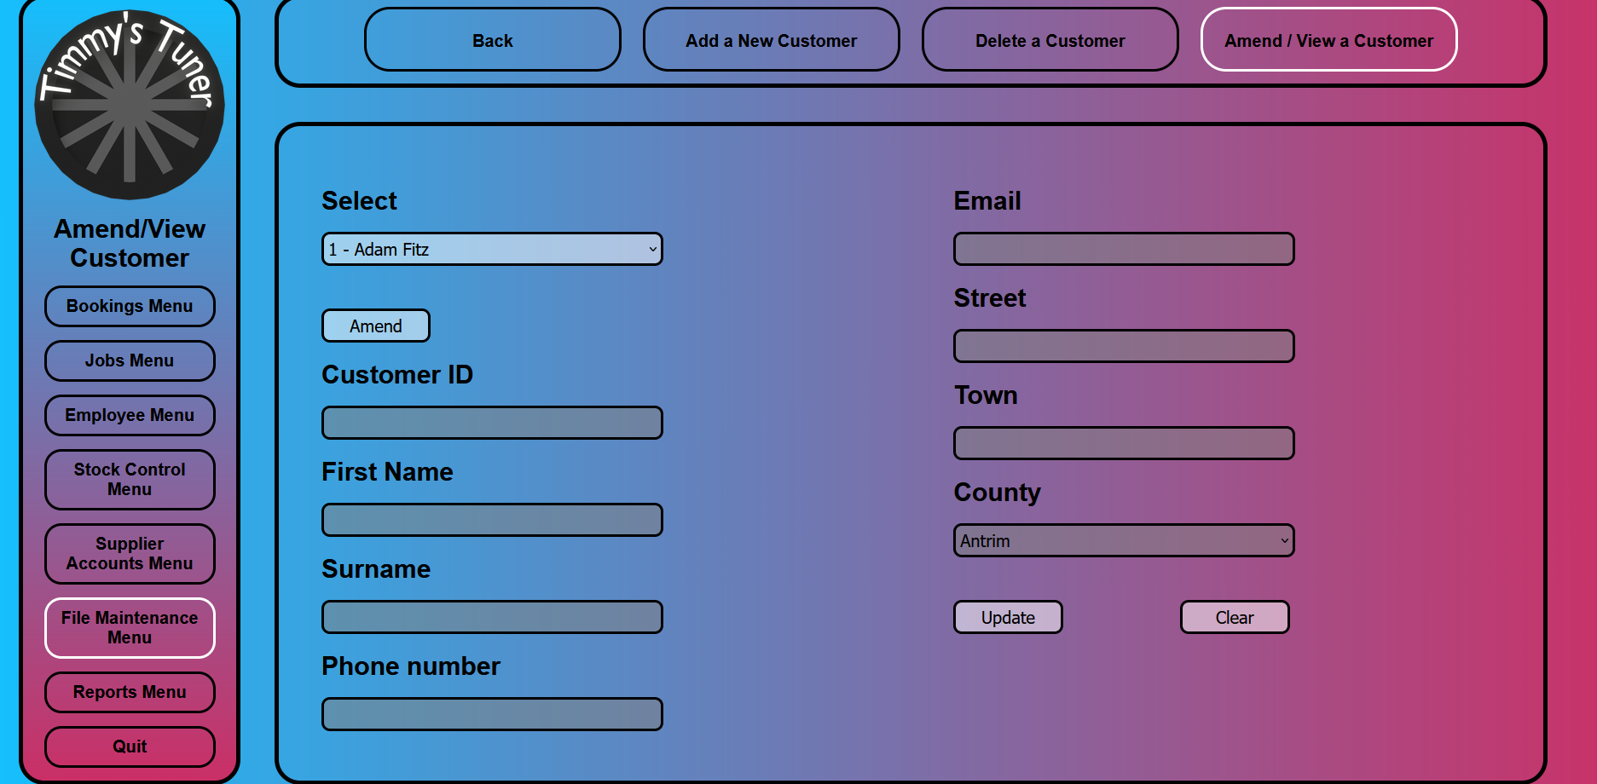

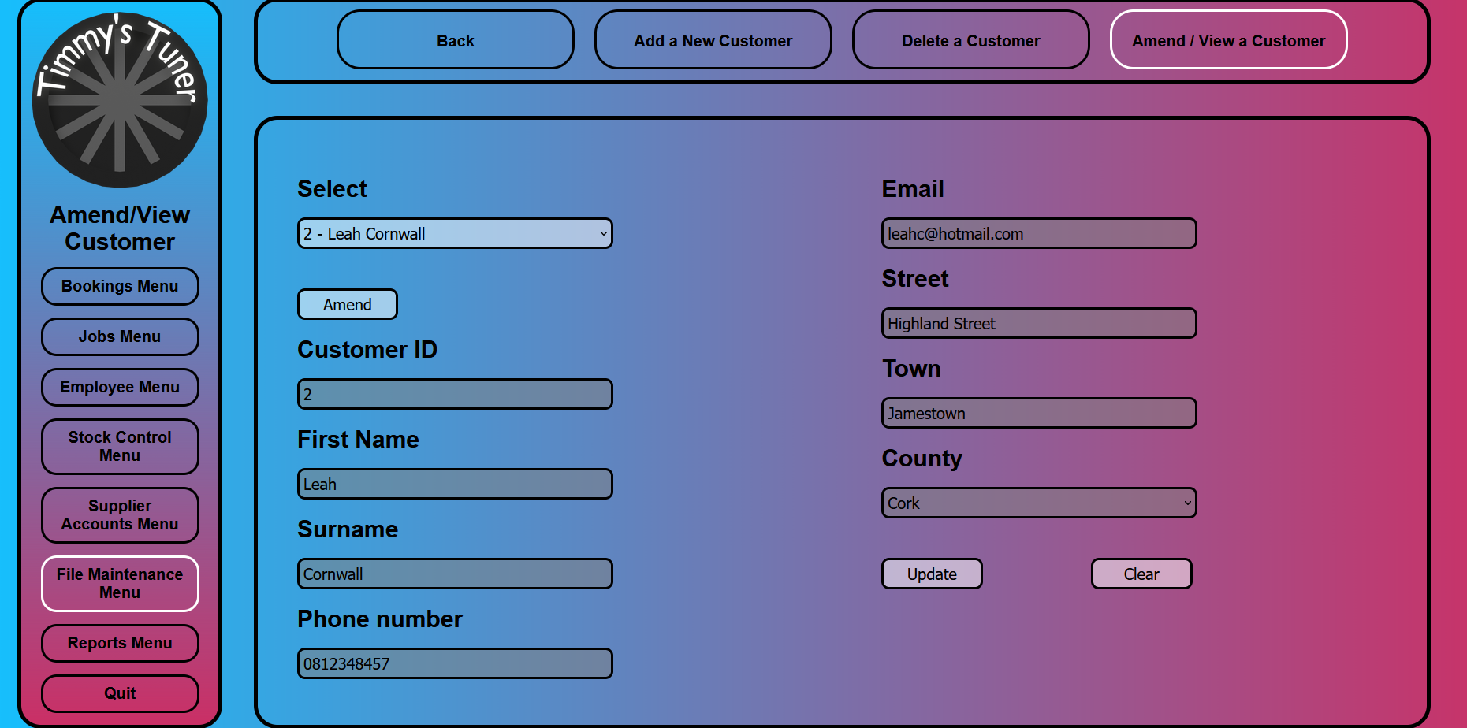

**amend_view_a_customer.html.php**

<!--

    Author: Adam Fitzpatrick

    ID: C00273365

    Date: 2023.02.16

-->

<!DOCTYPE html>

<html lang="en">

    <head>

        <link rel="stylesheet" href="../../Css/default.css">

        <title>Amend/View Customer</title>

        <style>

            /* sets it as there are four buttons */

                .sub_menu_button

                {

                    width: 20%;

                }

                .content_box label

                {

                    margin: 20px 0px 20px 0px;

                }

        </style>

    </head>

    <script>

        <?php

        $counties = array(

        'Antrim', 'Armagh', 'Carlow', 'Cavan', 'Clare', 'Cork',

        'Derry', 'Donegal', 'Down', 'Dublin', 'Fermanagh', 'Galway',

        'Kerry', 'Kildare', 'Kilkenny', 'Laois', 'Leitrim', 'Limerick',

        'Longford', 'Louth', 'Mayo', 'Meath', 'Monaghan', 'Offaly',

        'Roscommon', 'Sligo', 'Tipperary', 'Tyrone', 'Waterford',

        'Westmeath', 'Wexford', 'Wicklow'

        ); // Array of all counties of Ireland

        ?>

        function populate() // Populates text boxes with customer information

            {

                var sel = document.getElementById("customer_listbox");

                var result;

                result = sel.options[sel.selectedIndex].value;

                var customerDetails = result.split(',');

                document.getElementById("customer_id").value = customerDetails[0];

                document.getElementById("customer_name").value = customerDetails[1];

                document.getElementById("customer_surname").value = customerDetails[2];

                document.getElementById("customer_street").value = customerDetails[3];

                document.getElementById("customer_town").value = customerDetails[4];

                document.getElementById("customer_county").value = customerDetails[5];

                document.getElementById("customer_email").value = customerDetails[6];

                document.getElementById("customer_phoneno").value = customerDetails[7];

            }

        function toggleLock() // Locks/unlocks entry of text into text boxes

            {

                if (document.getElementById("amendViewbutton").value == "Amend")

                {

                    document.getElementById("customer_name").disabled = false;

                    document.getElementById("customer_surname").disabled = false;

                    document.getElementById("customer_street").disabled = false;

                    document.getElementById("customer_town").disabled = false;

                    document.getElementById("customer_county").disabled = false;

                    document.getElementById("customer_email").disabled = false;

                    document.getElementById("customer_phoneno").disabled = false;

                    document.getElementById("amendViewbutton").value = "View";

                }

                else

                {

                    document.getElementById("customer_name").disabled = true;

                    document.getElementById("customer_surname").disabled = true;

                    document.getElementById("customer_street").disabled = true;

                    document.getElementById("customer_town").disabled = true;

                    document.getElementById("customer_county").disabled = true;

                    document.getElementById("customer_email").disabled = true;

                    document.getElementById("customer_phoneno").disabled = true;

                    document.getElementById("amendViewbutton").value = "Amend";

                }

    }

        function confirmCheck() // Asks user if they are sure they would like to make changes

            {

                var response;

                response = confirm('Are you sure you want to save these changes?');

                if (response)

                    {

                        document.getElementById("customer_id").disabled = false;

                        document.getElementById("customer_name").disabled = false;

                        document.getElementById("customer_surname").disabled = false;

                        document.getElementById("customer_street").disabled = false;

                        document.getElementById("customer_town").disabled = false;

                        document.getElementById("customer_county").disabled = false;

                        document.getElementById("customer_email").disabled = false;

                        document.getElementById("customer_phoneno").disabled = false;

                        return true;

                    }

                else

                    {

                        populate();

                        toggleLock();

                        return false;

                    }

            }

    </script>

    <body>

        <div class="nav_container">

            <div class="menu_box">

                <!-- this makes it so the logo brings you back to the main menu -->

                <img class="logo" onclick="location.href='../main_menu.php'">

                <div class="menu_title">

                    Amend/View Customer

                </div>

                <div class="menu_button" onclick="location.href='../Bookings/bookings_menu.html'">

                    Bookings Menu

                </div>

                <div class="menu_button" onclick="location.href='../Jobs/jobs_menu.html'">

                    Jobs Menu

                </div>

                <div class="menu_button" onclick="location.href='../Employee/employee_menu.html'">

                    Employee Menu

                </div>

                <div class="menu_button" onclick="location.href='../Stock_Control/stock_control_menu.html'">

                    Stock Control Menu

                </div>

                <div class="menu_button" onclick="location.href='../Supplier_Accounts/supplier_accounts_menu.html'">

                    Supplier Accounts Menu

                </div>

                <div class="menu_button" onclick="location.href='file_maintenance_menu.html'" style="border-color: white;">

                    File Maintenance Menu

                </div>

                <div class="menu_button" onclick="location.href='../Reports/reports_menu.html'">

                    Reports Menu

                </div>

                <div class="menu_button" onclick="location.href='../login_page.html'">

                    Quit

                </div>

            </div>

            <div class="sub_menu_box">

                <div class="sub_menu_button" onclick="location.href='file_maintenance_menu.html'">

                    Back

                </div>

                <div class="sub_menu_button" onclick="location.href='add_a_new_customer.html.php'">

                    Add a New Customer

                </div>

                <div class="sub_menu_button" onclick="location.href='delete_a_customer.html.php'">

                    Delete a Customer

                </div>

                <div class="sub_menu_button" onclick="location.href='amend_view_a_customer.html.php'" style="border-color: white;">

                    Amend / View a Customer

                </div>

            </div>

            <div class="content_box">

                <form class="context_box_form" action="amend_view_a_customer.php" method="POST" onsubmit="return confirmCheck()">

                    <div class="content_box_left">

                        <label>Select</label>

                        <br>

                        <?php

                                include "../connection.php";

                                $sql = "SELECT * FROM Customer WHERE Deleted = 0";

                                if (!$result = mysqli_query($con, $sql))

                                {

                                    die('Error in querying the database' . mysqli_error($con));

                                }

                                // Create listbox

                                echo "<select id='customer_listbox' name='customer_listbox' onclick='populate();'>";

                                while ($row = mysqli_fetch_array($result))

                                {

                                    $CustomerID = $row['CustomerID'];

                                    $FirstName = $row['FirstName'];

                                    $Surname = $row['Surname'];

                                    $Street = $row['Street'];

                                    $Town = $row['Town'];

                                    $County = $row['County'];

                                    $Email = $row['Email'];

                                    $PhoneNo = $row['PhoneNo'];

                                    $allText = "$CustomerID,$FirstName,$Surname,$Street,$Town,$County,$Email,$PhoneNo";

                                    echo "<option value='$allText'>$CustomerID - $FirstName $Surname</option>";

                                }

                                echo "</select>";

                                mysqli_close($con);

                            ?>

                            <input type="button" class="content_box_button" value="Amend" id="amendViewbutton" onclick="toggleLock()">

                            <br>

                            <label>Customer ID</label>

                            <br>

                            <input type="text" id="customer_id" name="customer_id" disabled>

                            <br>

                            <label>First Name</label>

                            <br>

                            <input type="text" id="customer_name" name="customer_name" disabled>

                            <br>

                            <label>Surname</label>

                            <br>

                            <input type="text" id="customer_surname" name="customer_surname" disabled>

                            <br>

                            <label>Phone number</label>

                            <br>

                            <input type="text" id="customer_phoneno" name="customer_phoneno" pattern="^[\+]?[(]?[0-9]{3}[)]?[-\s\.]?[0-9]{3}[-\s\.]?[0-9]{4,6}$" disabled>

                            <br>

                    </div>

                    <div class="content_box_right">

                        <label>Email</label>

                        <br>

                        <input type="email" id="customer_email" name="customer_email" disabled>

                        <br>

                        <label>Street</label>

                        <br>

                        <input type="text" id="customer_street" name="customer_street" disabled>

                        <br>

                        <label>Town</label>

                        <br>

                        <input type="text" id="customer_town" name="customer_town" disabled>

                        <br>

                        <label>County</label>

                        <br>

                        <select id="customer_county" name="customer_county" disabled>

                            <?php

                                foreach ($counties as $county):

                            ?>

                            <option value="<?php echo $county; ?>">

                            <?php

                            echo $county;

                            ?>

                            </option>

                            <?php

                                endforeach;

                            ?>

                            </select>

                        <br>

                        <input class="content_box_button" type="submit" value="Update"></input>

                        <input class="content_box_button" type="reset" value="Clear"></input>

                    </div>

                </form>

            </div>

        </div>

    </body>

</html>

**amend_view_a_customer.php**

<!--

    Author: Adam Fitzpatrick

    ID: C00273365

    Date: 2023.03.07

-->

<?php

    include "../connection.php";

    // Posting values

    $CustomerID = $_POST['customer_id'];

    $FirstName = $_POST['customer_name'];

    $Surname = $_POST['customer_surname'];

    $Street = $_POST['customer_street'];

    $Town = $_POST['customer_town'];

    $County = $_POST['customer_county'];

    $Email = $_POST['customer_email'];

    $PhoneNo = $_POST['customer_phoneno'];

    $sql = "UPDATE Customer SET

    FirstName = '$FirstName',

    Surname = '$Surname',

    Street = '$Street',

    Town = '$Town',

    County = '$County',

    Email = '$Email',

    PhoneNo = '$PhoneNo'

    WHERE CustomerID = $CustomerID

    ";

    if (!mysqli_query($con, $sql))

    {

        echo "Error " . mysqli_error($con);

    }

    else

    {

        // Script to create alert with confirmation of customer creation

        echo "<script>

        alert('Details for $FirstName $Surname have been updated.');

        window.location = 'amend_view_a_customer.html.php';

        </script>";

    }

    mysqli_close($con);

?>

### Make a Booking

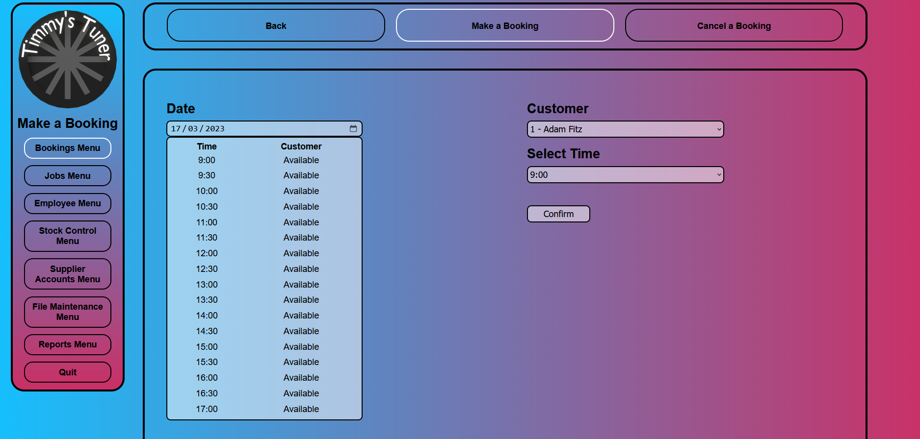

**make_a_booking.html.php**

<!--

    Author: Adam Fitzpatrick

    ID: C00273365

    Date: 2023.03.15

-->

<!DOCTYPE html>

<html lang="en">

    <head>

        <link rel="stylesheet" href="../../Css/default.css">

        <title>Make a Booking</title>

    </head>

    <body>

        <div class="nav_container">

            <div class="menu_box">

                <!-- this makes it so the logo brings you back to the main menu -->

                <img class="logo" onclick="location.href='../main_menu.php'">

                <div class="menu_title">

                    Make a Booking

                </div>

                <div class="menu_button" onclick="location.href='bookings_menu.html'" style="border-color: white;">

                    Bookings Menu

                </div>

                <div class="menu_button" onclick="location.href='../Jobs/jobs_menu.html'">

                    Jobs Menu

                </div>

                <div class="menu_button" onclick="location.href='../Employee/employee_menu.html'">

                    Employee Menu

                </div>

                <div class="menu_button" onclick="location.href='../Stock_Control/stock_control_menu.html'">

                    Stock Control Menu

                </div>

                <div class="menu_button" onclick="location.href='../Supplier_Accounts/supplier_accounts_menu.html'">

                    Supplier Accounts Menu

                </div>

                <div class="menu_button" onclick="location.href='../File_Maintenance/file_maintenance_menu.html'">

                    File Maintenance Menu

                </div>

                <div class="menu_button" onclick="location.href='../Reports/reports_menu.html'">

                    Reports Menu

                </div>

                <div class="menu_button" onclick="location.href='../login_page.html'">

                    Quit

                </div>

            </div>

            <div class="sub_menu_box">

                <div class="sub_menu_button" onclick="location.href='../main_menu.php'">

                    Back

                </div>

                <div class="sub_menu_button" onclick="location.href='make_a_booking.html'" style="border-color: white;">

                    Make a Booking

                </div>

                <div class="sub_menu_button" onclick="location.href='cancel_a_booking.html'">

                    Cancel a Booking

                </div>

            </div>

            <div class="content_box">

                <form class="context_box_form" action="make_a_booking.php" method="post">

                    <!-- Creates form for new Booking -->

                    <div class="content_box_left">

                        <label>Date</label>

                        <br>

                        <input type="date" id="booking_date" name="booking_date" value="<?php echo date('Y-m-d'); ?>" required>

                        <br>

                        <div class="content_box_report">

                            <?php

                                // include the connection file

                                include "../connection.php";

                                // check if the booking date is set in the post request

                                if (isset($_POST['booking_date']))

                                {

                                    // get the booking date from the post request

                                    $bookingDate = $_POST['booking_date'];

                                    // SQL query to retrieve bookings and customer information

                                    $sql = "SELECT Bookings.DateAndTime, Customer.FirstName

                                            FROM Bookings

                                            JOIN Customer ON Customer.CustomerID = Bookings.CustomerID

                                            WHERE Customer.Deleted = 0";

                                    // execute the SQL query and check for errors

                                    $result = mysqli_query($con, $sql);

                                    if (!$result)

                                    {

                                        die('Error in querying the database' . mysqli_error($con));

                                    }

                                    // Create an array of booked times

                                    $bookedTimes = array();

                                    while ($row = mysqli_fetch_assoc($result))

                                    {

                                        // extract the time portion of the date and add it to the array of booked times

                                        $bookedTimes[] = substr($row['DateAndTime'], 11, 5);

                                    }

                                }

                                // Generate the table rows for each time slot

                                echo "<table style='padding: 5px; width: 62%; margin:0px 50px 50px 0px'>

                                        <tr><th>Time</th><th>Customer</th></tr>";

                                // Array of possible timeslots

                                $timeslots = array(

                                    '9:00', '9:30', '10:00', '10:30', '11:00', '11:30', '12:00', '12:30',

                                    '13:00', '13:30', '14:00', '14:30', '15:00', '15:30', '16:00', '16:30', '17:00'

                                );

                                // Loop through each timeslot

                                foreach ($timeslots as $timeslot)

                                {

                                    // Check if the current timeslot has been booked

                                    if (isset($bookedTimes) && in_array($timeslot, $bookedTimes))

                                    {

                                        // If it has been booked, retrieve the booking information from the database

                                        $sql = "SELECT Customer.FirstName

                                                FROM Bookings

                                                JOIN Customer ON Customer.CustomerID = Bookings.CustomerID

                                                WHERE Customer.Deleted = 0 AND Bookings.DateAndTime LIKE '%$timeslot%'";

                                        $result = mysqli_query($con, $sql);

                                        if (!$result)

                                        {

                                            die('Error in querying the database' . mysqli_error($con));

                                        }

                                        // Set customerName to the name of the customer who booked the timeslot

                                        $row = mysqli_fetch_assoc($result);

                                        $customerName = $row['FirstName'];

                                    }

                                    else

                                    {

                                        // Set customerName to 'Available' if the timeslot has not been booked

                                        $customerName = 'Available';

                                    }

                                    // Output the timeslot and customerName in a table row

                                    echo "<tr><td>$timeslot</td><td>$customerName</td></tr>";

                                }

                                echo "</table>";

                            ?>

                        </div>

                    </div>

                    <div class="content_box_right">

                        <label>Customer</label>

                        <br>

                        <?php

                            $sql = "SELECT * FROM Customer WHERE Deleted = 0";

                            if (!$result = mysqli_query($con, $sql))

                            {

                                die('Error in querying the database' . mysqli_error($con));

                            }

                            echo "<select id='booking_customer' name='booking_customer'>";

                            while ($row = mysqli_fetch_array($result))

                            {

                                $CustomerID = $row['CustomerID'];

                                $FirstName = $row['FirstName'];

                                $Surname = $row['Surname'];

                                echo "<option value='$CustomerID'>$CustomerID - $FirstName $Surname</option>";

                            }

                            echo "</select>";

                            mysqli_close($con);

                        ?>

                        <!-- Add a hidden input field to store the selected customer ID -->

                        <input type="hidden" id="customer_id" name="customer_id">

                        <script>

                            // Get the booking customer select element

                            const bookingCustomerSelect = document.getElementById('booking_customer');

                            // Get the customer ID input field

                            const customerIDInput = document.getElementById('customer_id');

                            // Add an event listener to the booking customer select element

                            bookingCustomerSelect.addEventListener('change', (event) =>

                            {

                                // Get the selected option value

                                const selectedOptionValue = event.target.value;

                                // Set the selected customer ID to the input field value

                                customerIDInput.value = selectedOptionValue;

                            });

                        </script>

                        <br>

                        <label>Select Time </label>

                        <br>

                        <select id = "time_select" name="time_select">

                            <option>9:00</option>

                            <option>9:30</option>

                            <option>10:00</option>

                            <option>10:30</option>

                            <option>11:00</option>

                            <option>11:30</option>

                            <option>12:00</option>

                            <option>12:30</option>

                            <option>13:00</option>

                            <option>13:30</option>

                            <option>14:00</option>

                            <option>14:30</option>

                            <option>15:00</option>

                            <option>15:30</option>

                            <option>16:00</option>

                            <option>16:30</option>

                            <option>17:00</option>

                        </select>

                        <input class="content_box_button" type="submit" value="Confirm"></input>

                    </div>

                </form>

                </p>

            </div>

        </div>

    </body>

</html>

**make_a_booking.php**

<?php

    include "../connection.php";

    // Posting Values

    $booking_date = $_POST["booking_date"];

    $time_select = $_POST["time_select"];

    $customer_id = $_POST["customer_id"];

    // Get the maximum Booking ID value from the Bookings table

    echo "$time_select";

    $sql = "SELECT MAX(BookingID) AS prevBookID FROM Bookings";

    $result = mysqli_query($con, $sql);

    $row = mysqli_fetch_assoc($result);

    $prevBookID = $row['prevBookID'];

    // Calculate the new BookingID value

    $booking_id = $prevBookID + 1;

    // Combine the date and time into a single datetime string

    $date_and_time = $booking_date . " " . date('H:i:s', strtotime($time_select));

    // Insert the booking information into the bookings table

    $sql = "INSERT INTO Bookings (BookingID, DateAndTime, CustomerID) VALUES ('$booking_id', '$date_and_time', '$customer_id')";

    if (!mysqli_query($con, $sql))

    {

        echo "Error " . mysqli_error($con);

    }

    else

    {

        // Script to create alert with confirmation of booking creation

        echo "<script>

        alert('Booking $booking_id has been created.');

        window.location = 'make_a_booking.html.php';

        </script>";

    }

?>

### Receive Deliveries

## Gábor Major

### Add a New Stock Item

Unfilled

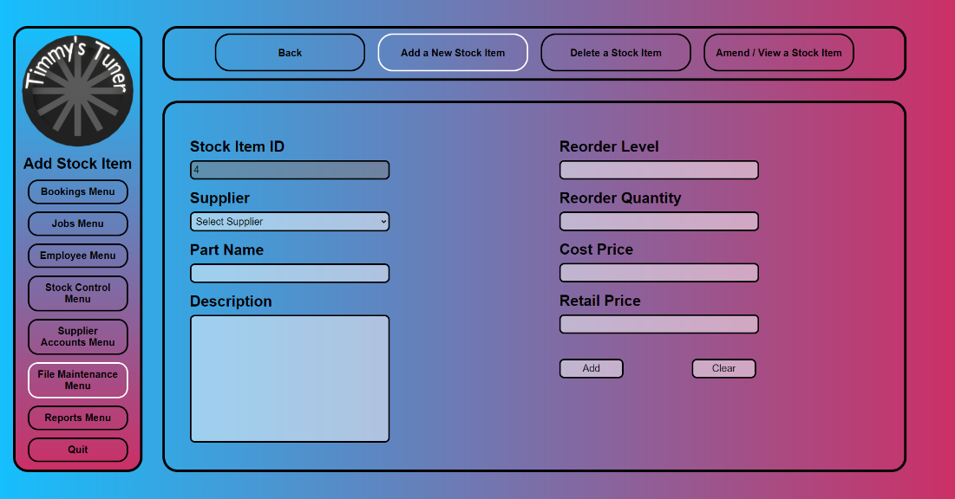

Filled

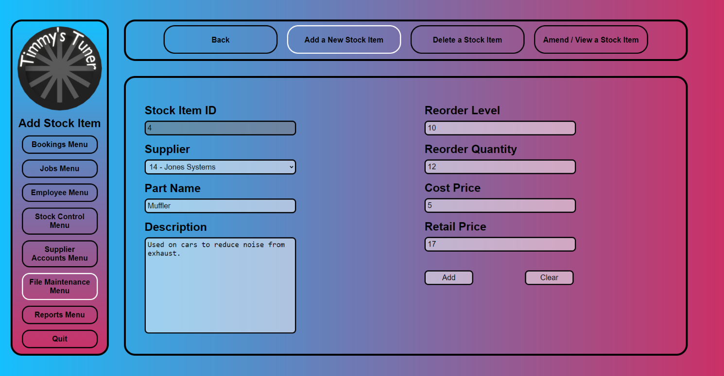

**add_a_new_stock_item.html.php**

<!--

Author: Gábor Major

ID: C00271548

Date: 2023.03.09

-->

<!DOCTYPE html>

<html lang="en">

<head>

<link rel="stylesheet" href="../../Css/default.css">

<title>Add Stock Item</title>

<style>

/* sets it as there are four buttons */

.sub_menu_button

{

width: 20%;

}

</style>

<script>

// runs the function everytime the file is loaded

// <https://developer.mozilla.org/en-US/docs/Learn>

window.onload = async function checkUpload()

{

// checks if redirected from php

if (document.URL.includes('#confirm'))

{

// waits for 100ms

// lets the html load in

await new Promise(resolve => setTimeout(resolve, 100));

alert('Details have been added!');

}

}

// confirms details

function confirmCheck()

{

// checks if the inputs are correct

if (!confirmInputNumbers() || !confirmTextInputs())

{

return false;

}

var response = confirm('Are you sure you want to add this stock item?\n' +

'Stock ID: ' + document.getElementById("stockID").value + '\n' +

'Part Name: ' + document.getElementById("partName").value + '\n' +

'Suplier: ' + document.getElementById("supplierListbox").value);

if (response)

{

return true;

}

else

{

return false;

}

}

// checks if the input numbers have an "e" in it

function confirmInputNumbers()

{

if (document.getElementById("reorderLevel").value.includes("e"))

{

alert('Reorder Level cannot contain: e');

return false;

}

if (document.getElementById("reorderQuantity").value.includes("e"))

{

alert('Reorder Quantity cannot contain: e');

return false;

}

if (document.getElementById("costPrice").value.includes("e"))

{

alert('Cost Price cannot contain: e');

return false;

}

if (document.getElementById("retailPrice").value.includes("e"))

{

alert('Retail Price cannot contain: e');

return false;

}

return true;

}

// checks if the input texts have a "-" in it

function confirmTextInputs()

{

if (document.getElementById("partName").value.includes("-"))

{

alert('Part Name cannot contain: -');

return false;

}

if (document.getElementById("description").value.includes("-"))

{

alert('Description cannot contain: -');

return false;

}

return true;

}

</script>

</head>

<body>

<div class="nav_container">

<div class="menu_box">

<!-- this makes it so the logo brings you back to the main menu -->

<img class="logo" onclick="location.href='../main_menu.php'">

<div class="menu_title">

Add Stock Item

</div>

<div class="menu_button" onclick="location.href='../Bookings/bookings_menu.html'">

Bookings Menu

</div>

<div class="menu_button" onclick="location.href='../Jobs/jobs_menu.html'">

Jobs Menu

</div>

<div class="menu_button" onclick="location.href='../Employee/employee_menu.html'">

Employee Menu

</div>

<div class="menu_button" onclick="location.href='../Stock_Control/stock_control_menu.html'">

Stock Control Menu

</div>

<div class="menu_button" onclick="location.href='../Supplier_Accounts/supplier_accounts_menu.html'">

Supplier Accounts Menu

</div>

<div class="menu_button" onclick="location.href='file_maintenance_menu.html'" style="border-color: white;">

File Maintenance Menu

</div>

<div class="menu_button" onclick="location.href='../Reports/reports_menu.html'">

Reports Menu

</div>

<div class="menu_button" onclick="location.href='../login_page.html'">

Quit

</div>

</div>

<div class="sub_menu_box">

<div class="sub_menu_button" onclick="location.href='file_maintenance_menu.html'">

Back

</div>

<div class="sub_menu_button" onclick="location.href='add_a_new_stock_item.html.php'" style="border-color: white;">

Add a New Stock Item

</div>

<div class="sub_menu_button" onclick="location.href='delete_a_stock_item.html.php'">

Delete a Stock Item

</div>

<div class="sub_menu_button" onclick="location.href='amend_view_a_stock_item.html.php'">

Amend / View a Stock Item

</div>

</div>

<div class="content_box">

<form class="content_box_form" action="add_a_new_stock_item.php" onsubmit="return confirmCheck();" method="post">

<div class="content_box_left">

<!-- shows the next valid ID -->

<label for="stockID">Stock Item ID</label><br>

<?php

include "../connection.php";

$sql = "SELECT StockID FROM Stock WHERE Deleted = 0";

if (!$result = mysqli_query($con, $sql))

{

die('Error in querying the database' . mysqli_error($con));

}

if (mysqli_affected_rows($con) == 0)

{

echo "<input type='text' name='stockID' id='stockID' value='1' required readonly><br>";

}

else

{

$previousID = 0;

while ($row = mysqli_fetch_array($result))

{

$previousID = $row['StockID'];

}

$currentID = $previousID + 1;

echo "<input type='text' name='stockID' id='stockID' value='$currentID' required readonly><br>";

}

mysqli_close($con);

?>

<!-- gets a selectable list of suppliers -->

<label for="supplierListbox">Supplier</label><br>

<?php

include "../connection.php";

$sql = "SELECT SupplierID, SupplierName FROM Supplier WHERE Deleted = 0";

if (!$result = mysqli_query($con, $sql))

{

die('Error in querying the database' . mysqli_error($con));

}

echo "<select name='supplierListbox' id='supplierListbox' required>";

echo "<option value=''>Select Supplier</option>";

while ($row = mysqli_fetch_array($result))

{

$supplierID = $row['SupplierID'];

$supplierName = $row['SupplierName'];

$allText = "$supplierID - $supplierName";

echo "<option value='$allText'>$allText</option>";

}

echo "</select><br>";

mysqli_close($con);

?>

<label for="partName">Part Name</label><br>

<input type="text" name="partName" id="partName" maxlength="39" required><br>

<label for="description">Description</label><br>

<textarea name="description" id="description" maxlength="340" required></textarea>

</div>

<div class="content_box_right">

<label for="reorderLevel">Reorder Level</label><br> <!-- Matches one to eleven digits -->

<input type="number" name="reorderLevel" id="reorderLevel" min="0" maxlength="11" pattern="\d" required><br>

<label for="reorderQuantity">Reorder Quantity</label><br>

<input type="number" name="reorderQuantity" id="reorderQuantity" min="1" maxlength="11" pattern="\d" required><br>

<label for="costPrice">Cost Price</label><br> <!-- Matches one or more digit, dot, and two digits -->

<input type="number" name="costPrice" id="costPrice" min="0" step="0.01" maxlength="11" pattern="\d+\.\d{2}" required><br>

<label for="retailPrice">Retail Price</label><br>

<input type="number" name="retailPrice" id="retailPrice" min="0" step="0.01" maxlength="11" pattern="\d+\.\d{2}" required><br>

<input class="content_box_button" type="submit" value="Add"/>

<input class="content_box_button" type="reset" value="Clear"/>

</div>

</form>

</div>

</div>

</body>

</html>

**add_a_new_stock_item.php**

<!--

Author: Gábor Major

ID: C00271548

Date: 2023.03.09

-->

<?php

include "../connection.php";

// insert new row into Stock table

$sql = "INSERT INTO Stock (StockID, PartName, Description, ReorderLevel, ReorderQuantity, CostPrice, RetailPrice)

VALUES ('$_POST[stockID]',

'$_POST[partName]',

'$_POST[description]',

'$_POST[reorderLevel]',

'$_POST[reorderQuantity]',

'$_POST[costPrice]',

'$_POST[retailPrice]');";

if (!mysqli_query($con, $sql))

{

echo "Error " . mysqli_error($con);

mysqli_close($con);

}

else

{

$supplierID = explode(' - ', $_POST['supplierListbox'])[0];

// insert new row into Stock/Supplier table

$sql = "INSERT INTO `Stock/Supplier` (StockID, SupplierID)

VALUES ('$_POST[stockID]', '$supplierID');";

if (!mysqli_query($con, $sql))

{

echo "Error " . mysqli_error($con);

mysqli_close($con);

}

else

{

mysqli_close($con);

// return to previous page with confirm variable

header('Location: add_a_new_stock_item.html.php#confirm');

}

}

?>

### Delete a Stock Item

Unfilled

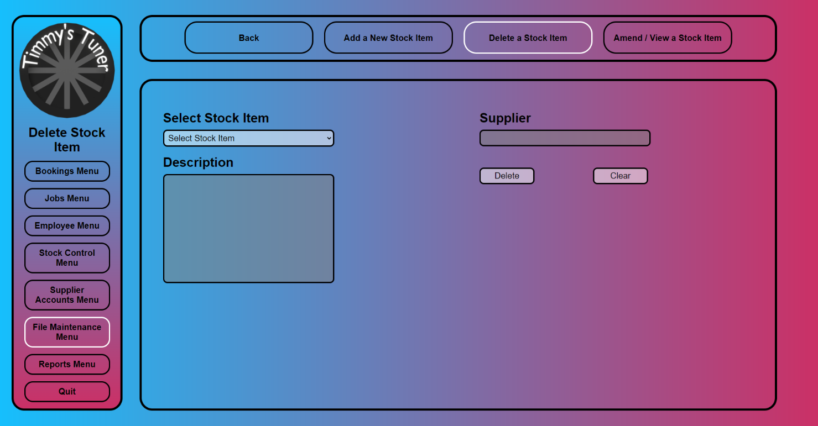

Filled

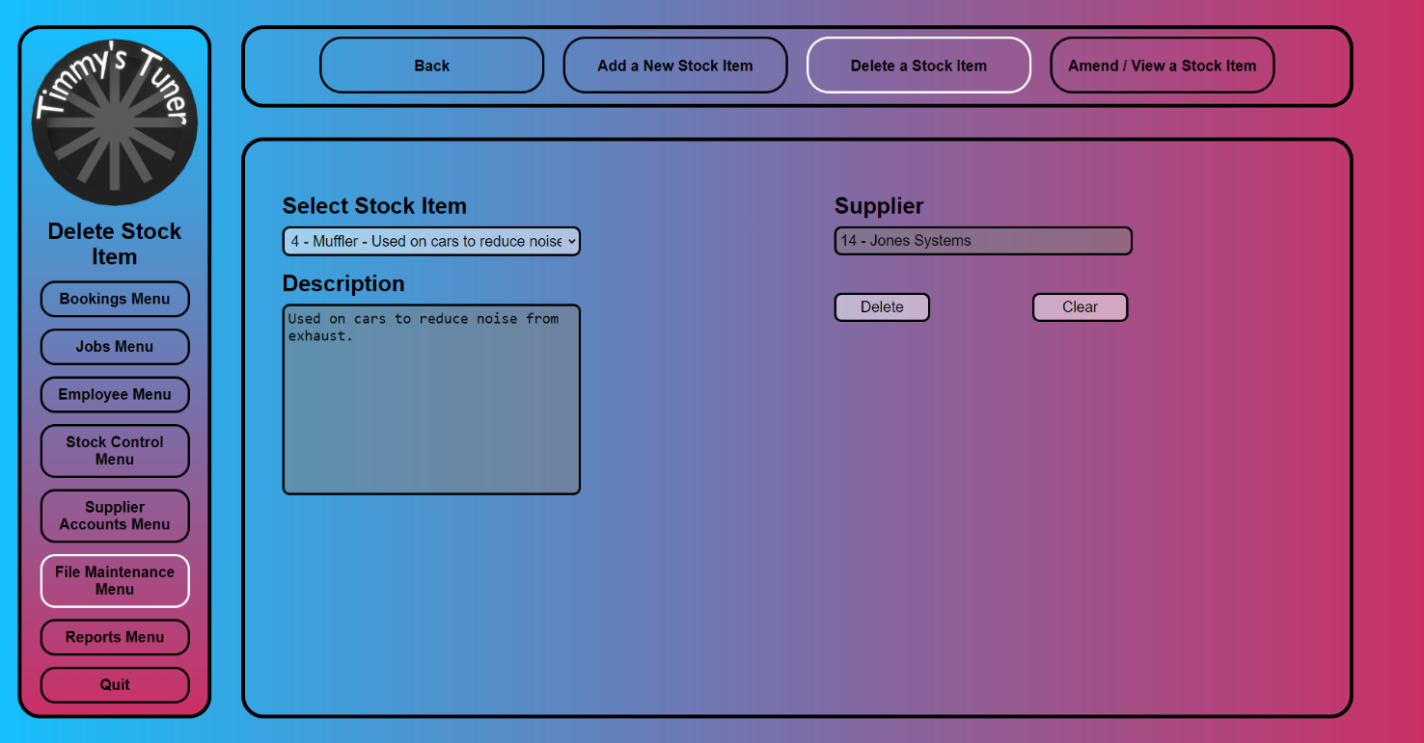

**delete_a_stock_item.html.php**

<!--

Author: Gábor Major

ID: C00271548

Date: 2023.03.09

-->

<!DOCTYPE html>

<html lang="en">

<head>

<link rel="stylesheet" href="../../Css/default.css">

<title>Delete Stock Item</title>

<style>

/* sets it as there are four buttons */

.sub_menu_button

{

width: 20%;

}

</style>

<script>

// runs the function everytime the file is loaded

// <https://developer.mozilla.org/en-US/docs/Learn>

window.onload = async function checkUpload()

{

// checks if redirected from php

if (document.URL.includes('#confirm'))

{

// waits for 100ms

// lets the html load in

await new Promise(resolve => setTimeout(resolve, 100));

alert('Stock Item has been deleted!');

}

}

// confirms details

function confirmCheck()

{

var quantityInStock = document.getElementById("quantityInStock").value;

var quantityOnOrder = document.getElementById("quantityOnOrder").value;

// checks whether quantity in stock and on order are not 0

if (quantityInStock != '0' || quantityOnOrder != '0')

{

alert('Stock Item cannot be deleted!\nQuantity in stock: ' + quantityInStock + '\nQuantity on order: ' + quantityOnOrder);

return false;

}

else

{

var response = confirm('Are you sure you want to delete this stock item?\n' +

'Stock ID: ' + document.getElementById("stockID").value + '\n' +

'Part Name: ' + document.getElementById("partName").value);

if (response)

{

return true;

}

else

{

return false;

}

}

}

// populate details in fields

function populate()

{

var sel = document. getElementById("stockItemListbox");

var result = sel.options[sel.selectedIndex].value;

var stockDetails = result.split('-');

if (stockDetails.length == 7)

{

document.getElementById("description").value = stockDetails[3];

document.getElementById("supplierData").value = stockDetails[5] + ' - ' + stockDetails[6];

document.getElementById("stockID").value = stockDetails[0];

document.getElementById("partName").value = stockDetails[2];

document.getElementById("quantityInStock").value = stockDetails[1];

document.getElementById("quantityOnOrder").value = stockDetails[4];

}

else

{

document.getElementById("description").value = "";

document.getElementById("supplierData").value = "";

document.getElementById("stockID").value = "";

document.getElementById("partName").value = "";

document.getElementById("quantityInStock").value = "";

document.getElementById("quantityOnOrder").value = "";

}

}

</script>

</head>

<body>

<div class="nav_container">

<div class="menu_box">

<!-- this makes it so the logo brings you back to the main menu -->

<img class="logo" onclick="location.href='../main_menu.php'">

<div class="menu_title">

Delete Stock Item

</div>

<div class="menu_button" onclick="location.href='../Bookings/bookings_menu.html'">

Bookings Menu

</div>

<div class="menu_button" onclick="location.href='../Jobs/jobs_menu.html'">

Jobs Menu

</div>

<div class="menu_button" onclick="location.href='../Employee/employee_menu.html'">

Employee Menu

</div>

<div class="menu_button" onclick="location.href='../Stock_Control/stock_control_menu.html'">

Stock Control Menu

</div>

<div class="menu_button" onclick="location.href='../Supplier_Accounts/supplier_accounts_menu.html'">

Supplier Accounts Menu

</div>

<div class="menu_button" onclick="location.href='file_maintenance_menu.html'" style="border-color: white;">

File Maintenance Menu

</div>

<div class="menu_button" onclick="location.href='../Reports/reports_menu.html'">

Reports Menu

</div>

<div class="menu_button" onclick="location.href='../login_page.html'">

Quit

</div>

</div>

<div class="sub_menu_box">

<div class="sub_menu_button" onclick="location.href='file_maintenance_menu.html'">

Back

</div>

<div class="sub_menu_button" onclick="location.href='add_a_new_stock_item.html.php'">

Add a New Stock Item

</div>

<div class="sub_menu_button" onclick="location.href='delete_a_stock_item.html.php'" style="border-color: white;">

Delete a Stock Item

</div>

<div class="sub_menu_button" onclick="location.href='amend_view_a_stock_item.html.php'">

Amend / View a Stock Item

</div>

</div>

<div class="content_box">

<form class="content_box_form" action="delete_a_stock_item.php" onsubmit="return confirmCheck();" method="post">

<div class="content_box_left">

<!-- shows all available stock items -->

<label for="stockItemListbox">Select Stock Item</label><br>

<?php

include "../connection.php";

$sql = "SELECT * FROM ((Stock

INNER JOIN `Stock/Supplier` ON `Stock/Supplier`.StockID = Stock.StockID)

INNER JOIN Supplier ON `Stock/Supplier`.SupplierID = Supplier.SupplierID)

WHERE Stock.Deleted = 0;";

if (!$result = mysqli_query($con, $sql))

{

die('Error in querying the database' . mysqli_error($con));

}

echo "<select name='stockItemListbox' id='stockItemListbox' onclick='populate();' required>";

echo "<option value=''>Select Stock Item</option>";

while ($row = mysqli_fetch_array($result))

{

$stockID = $row['StockID'];

$quantityInStock = $row['QuantityInStock'];

$partName = $row['PartName'];

$description = $row['Description'];

$quantityOnOrder = $row['QuantityOnOrder'];

$supplierID = $row['SupplierID'];

$supplierName = $row['SupplierName'];

$allText = "$stockID-$quantityInStock-$partName-$description-$quantityOnOrder-$supplierID-$supplierName";

echo "<option value='$allText'>$stockID - $partName - $description</option>";

}

echo "</select><br>";

mysqli_close($con);

?>

<label for="description">Description</label><br>

<textarea name="description" id="description" required readonly></textarea>

<!-- hiddens used for javascript checking -->

<input type='hidden' name='stockID' id='stockID' required readonly>

<input type='hidden' name='partName' id='partName' required readonly>

<input type='hidden' name='quantityInStock' id='quantityInStock' required readonly>

<input type='hidden' name='quantityOnOrder' id='quantityOnOrder' required readonly>

</div>

<div class="content_box_right">

<label for="supplierData">Supplier</label><br>

<input type='text' name='supplierData' id='supplierData' required readonly><br>

<input class="content_box_button" type="submit" value="Delete"/>

<input class="content_box_button" type="reset" value="Clear"/>

</div>

</form>

</div>

</div>

</body>

</html>

**delete_a_stock_item.php**

<!--

Author: Gábor Major

ID: C00271548

Date: 2023.03.09

-->

<?php

include "../connection.php";

$stockID = explode('-', $_POST['stockItemListbox'])[0];

// update Stock table

$sql = "UPDATE Stock SET Deleted = 1

WHERE StockID = $stockID;";

if (!mysqli_query($con, $sql))

{

echo "Error " . mysqli_error($con);

mysqli_close($con);

}

else

{

mysqli_close($con);

// return to previous page with confirm variable

header('Location: delete_a_stock_item.html.php#confirm');

}

?>

### Amend/View a Stock Item

Unfilled

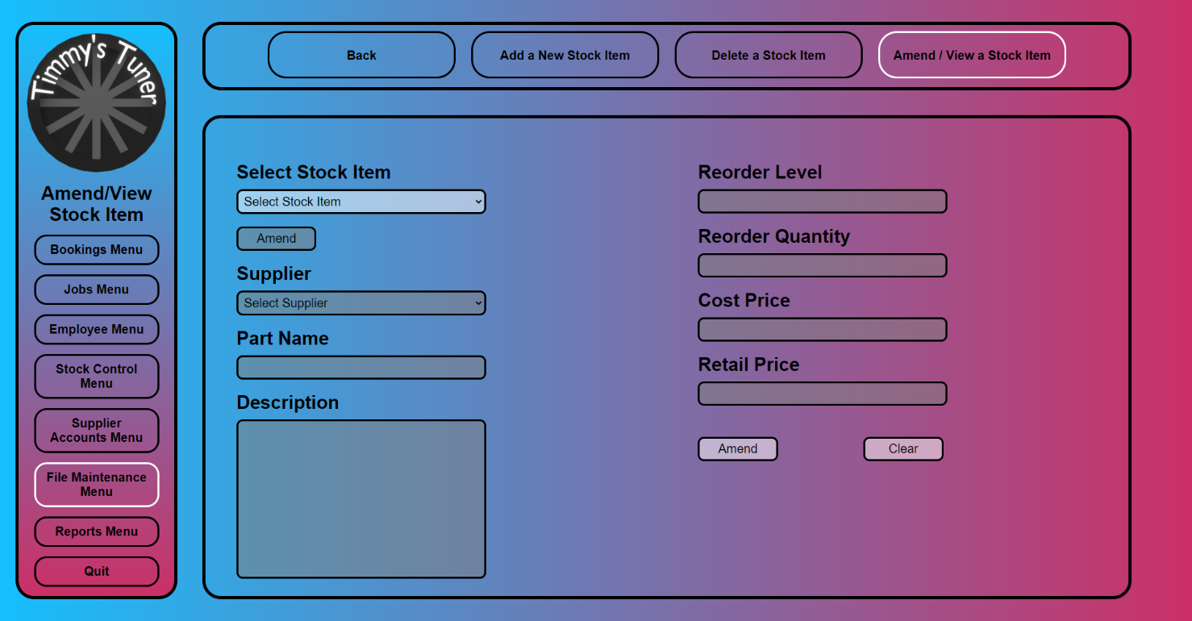

Filled

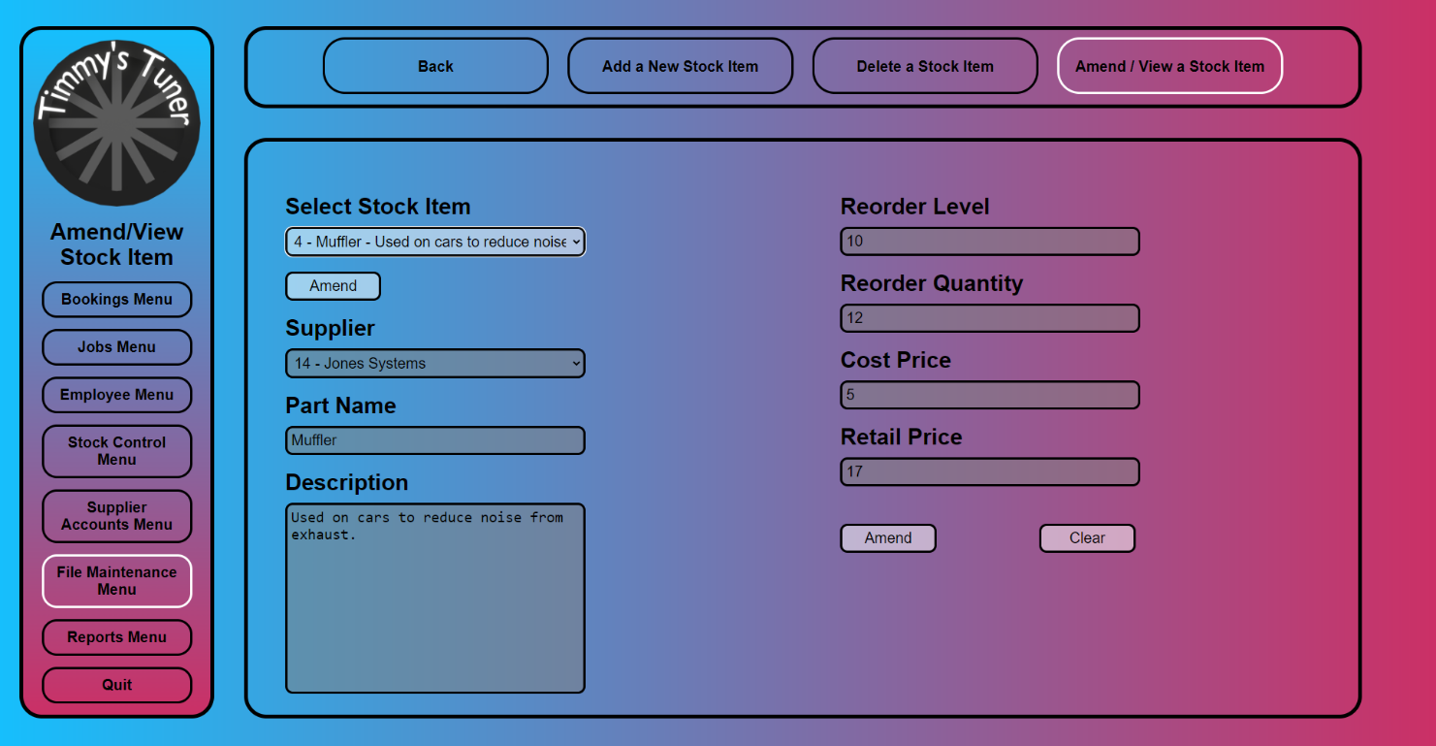

**amend_view_a_stock_item.html.php**

<!--

Author: Gábor Major

ID: C00271548

Date: 2023.03.09

-->

<!DOCTYPE html>

<html lang="en">

<head>

<link rel="stylesheet" href="../../Css/default.css">

<title>Amend/View Stock Item</title>

<style>

/* sets it as there are four buttons */

.sub_menu_button

{

width: 20%;

}

</style>

<script>

// runs the function everytime the file is loaded

// <https://developer.mozilla.org/en-US/docs/Learn>

window.onload = async function checkUpload()

{

document.getElementById("toggleButton").disabled = true;

document.getElementById("supplierListbox").disabled = true;

// checks if redirected from php

if (document.URL.includes('#confirm'))

{

// waits for 100ms

// lets the html load in

await new Promise(resolve => setTimeout(resolve, 100));

alert('Details have been amended!');

}

}

// confirms details

function confirmCheck()

{

// checks if the inputs are correct

if (!confirmInputNumbers() || !confirmTextInputs())

{

return false;

}

var response = confirm('Are you sure you want to change this stock item?\n' +

'Stock ID: ' + document.getElementById("stockID").value + '\n' +

'Part Name: ' + document.getElementById("partName").value);

if (response)

{

document.getElementById("supplierListbox").disabled = false;

return true;

}

else

{

return false;

}

}

// checks if the input numbers have an "e" in it

function confirmInputNumbers()

{

if (document.getElementById("reorderLevel").value.includes("e"))

{

alert('Reorder Level cannot contain: e');

return false;

}

if (document.getElementById("reorderQuantity").value.includes("e"))

{

alert('Reorder Quantity cannot contain: e');

return false;

}

if (document.getElementById("costPrice").value.includes("e"))

{

alert('Cost Price cannot contain: e');

return false;

}

if (document.getElementById("retailPrice").value.includes("e"))

{

alert('Retail Price cannot contain: e');

return false;

}

return true;

}

// checks if the input texts have a "-" in it

function confirmTextInputs()

{

if (document.getElementById("partName").value.includes("-"))

{

alert('Part Name cannot contain: -');

return false;

}

if (document.getElementById("description").value.includes("-"))

{

alert('Description cannot contain: -');

return false;

}

return true;

}

// populate details in fields

function populate()

{

var sel = document. getElementById("stockItemListbox");

var result = sel.options[sel.selectedIndex].value;

var stockDetails = result.split('-');

console.log(stockDetails.length);

if (stockDetails.length == 9)

{

document.getElementById("toggleButton").disabled = false;

document.getElementById("stockID").value = stockDetails[0];

document.getElementById("partName").value = stockDetails[1];

document.getElementById("supplierListbox").value = stockDetails[7] + ' - ' + stockDetails[8];

document.getElementById("description").value = stockDetails[2];

document.getElementById("reorderLevel").value = stockDetails[3];

document.getElementById("reorderQuantity").value = stockDetails[4];

document.getElementById("costPrice").value = stockDetails[5];

document.getElementById("retailPrice").value = stockDetails[6];

}

else

{

document.getElementById("toggleButton").disabled = true;

document.getElementById("stockID").value = "";

document.getElementById("partName").value = "";

document.getElementById("supplierListbox").value = "";

document.getElementById("description").value = "";

document.getElementById("reorderLevel").value = "";

document.getElementById("reorderQuantity").value = "";

document.getElementById("costPrice").value = "";

document.getElementById("retailPrice").value = "";

document.getElementById("toggleButton").value = "View";

toggleLock();

}

}

// toggles the availability of input fields

function toggleLock()

{

if (document.getElementById("toggleButton").value == "Amend")

{

document.getElementById("partName").readOnly = false;

document.getElementById("supplierListbox").disabled = false;

document.getElementById("description").readOnly = false;

document.getElementById("reorderLevel").readOnly = false;

document.getElementById("reorderQuantity").readOnly = false;

document.getElementById("costPrice").readOnly = false;

document.getElementById("retailPrice").readOnly = false;

document.getElementById("toggleButton").value = "View";

}

else

{

document.getElementById("partName").readOnly = true;

document.getElementById("supplierListbox").disabled = true;

document.getElementById("description").readOnly = true;

document.getElementById("reorderLevel").readOnly = true;

document.getElementById("reorderQuantity").readOnly = true;

document.getElementById("costPrice").readOnly = true;

document.getElementById("retailPrice").readOnly = true;

document.getElementById("toggleButton").value = "Amend";

}

}

</script>

</head>

<body>

<div class="nav_container">

<div class="menu_box">

<!-- this makes it so the logo brings you back to the main menu -->

<img class="logo" onclick="location.href='../main_menu.php'">

<div class="menu_title">

Amend/View Stock Item

</div>

<div class="menu_button" onclick="location.href='../Bookings/bookings_menu.html'">

Bookings Menu

</div>

<div class="menu_button" onclick="location.href='../Jobs/jobs_menu.html'">

Jobs Menu

</div>

<div class="menu_button" onclick="location.href='../Employee/employee_menu.html'">

Employee Menu

</div>

<div class="menu_button" onclick="location.href='../Stock_Control/stock_control_menu.html'">

Stock Control Menu

</div>

<div class="menu_button" onclick="location.href='../Supplier_Accounts/supplier_accounts_menu.html'">

Supplier Accounts Menu

</div>

<div class="menu_button" onclick="location.href='file_maintenance_menu.html'" style="border-color: white;">

File Maintenance Menu

</div>

<div class="menu_button" onclick="location.href='../Reports/reports_menu.html'">

Reports Menu

</div>

<div class="menu_button" onclick="location.href='../login_page.html'">

Quit

</div>

</div>

<div class="sub_menu_box">

<div class="sub_menu_button" onclick="location.href='file_maintenance_menu.html'">

Back

</div>

<div class="sub_menu_button" onclick="location.href='add_a_new_stock_item.html.php'">

Add a New Stock Item

</div>

<div class="sub_menu_button" onclick="location.href='delete_a_stock_item.html.php'">

Delete a Stock Item

</div>

<div class="sub_menu_button" onclick="location.href='amend_view_a_stock_item.html.php'" style="border-color: white;">

Amend / View a Stock Item

</div>

</div>

<div class="content_box">

<form class="content_box_form" action="amend_view_a_stock_item.php" onsubmit="return confirmCheck();" method="post">

<div class="content_box_left">

<!-- shows all available stock items -->

<label for="stockItemListbox">Select Stock Item</label><br>

<?php

include "../connection.php";

$sql = "SELECT * FROM ((Stock

INNER JOIN `Stock/Supplier` ON `Stock/Supplier`.StockID = Stock.StockID)

INNER JOIN Supplier ON `Stock/Supplier`.SupplierID = Supplier.SupplierID)

WHERE Stock.Deleted = 0;";

if (!$result = mysqli_query($con, $sql))

{

die('Error in querying the database' . mysqli_error($con));

}

echo "<select name='stockItemListbox' id='stockItemListbox' onclick='populate();' required>";

echo "<option value=''>Select Stock Item</option>";

while ($row = mysqli_fetch_array($result))

{

$stockID = $row['StockID'];

$partName = $row['PartName'];

$description = $row['Description'];

$reorderLevel = $row['ReorderLevel'];

$reorderQuantity = $row['ReorderQuantity'];

$costPrice = $row['CostPrice'];

$retailPrice = $row['RetailPrice'];

$supplierID = $row['SupplierID'];

$supplierName = $row['SupplierName'];

$allText = "$stockID-$partName-$description-$reorderLevel-$reorderQuantity-$costPrice-$retailPrice-$supplierID-$supplierName";

echo "<option value='$allText'>$stockID - $partName - $description</option>";

}

echo "</select><br>";

mysqli_close($con);

?>

<input type="button" class="content_box_button" name="toggleButton" id="toggleButton" value="Amend" onclick="toggleLock();" style="margin-top: 20px;"/><br>

<!-- gets a selectable list of suppliers -->

<label for="supplierListbox">Supplier</label><br>

<?php

include "../connection.php";

$sql = "SELECT SupplierID, SupplierName FROM Supplier WHERE Deleted = 0";

if (!$result = mysqli_query($con, $sql))

{

die('Error in querying the database' . mysqli_error($con));

}

echo "<select name='supplierListbox' id='supplierListbox' required disabled>";

echo "<option value=''>Select Supplier</option>";

while ($row = mysqli_fetch_array($result))

{

$supplierID = $row['SupplierID'];

$supplierName = $row['SupplierName'];

$allText = "$supplierID - $supplierName";

echo "<option value='$allText'>$allText</option>";

}

echo "</select><br>";

mysqli_close($con);

?>

<label for="partName">Part Name</label><br>

<input type="text" name="partName" id="partName" maxlength="39" required readonly><br>

<label for="description">Description</label><br>

<textarea name="description" id="description" maxlength="340" required readonly></textarea>

<!-- hidden for popup -->

<input type='hidden' name='stockID' id='stockID' required readonly>

</div>

<div class="content_box_right">

<label for="reorderLevel">Reorder Level</label><br> <!-- Matches one to eleven digits -->

<input type="number" name="reorderLevel" id="reorderLevel" min="0" maxlength="11" pattern="\d" required readonly><br>

<label for="reorderQuantity">Reorder Quantity</label><br>

<input type="number" name="reorderQuantity" id="reorderQuantity" min="1" maxlength="11" pattern="\d" required readonly><br>

<label for="costPrice">Cost Price</label><br> <!-- Matches one or more digit, dot, and two digits -->

<input type="number" name="costPrice" id="costPrice" min="0" step="0.01" maxlength="11" pattern="\d+\.\d{2}" required readonly><br>

<label for="retailPrice">Retail Price</label><br>

<input type="number" name="retailPrice" id="retailPrice" min="0" step="0.01" maxlength="11" pattern="\d+\.\d{2}" required readonly><br>

<input class="content_box_button" type="submit" value="Amend"/>

<input class="content_box_button" type="reset" value="Clear"/>

</div>

</form>

</div>

</div>

</body>

</html>

**amend_view_a_stock_item.php**

<!--

Author: Gábor Major

ID: C00271548

Date: 2023.03.09

-->

<?php

include "../connection.php";

$stockID = explode('-', $_POST['stockItemListbox'])[0];

$supplierID = explode(' - ', $_POST['supplierListbox'])[0];

// update Stock table

$sql = "UPDATE Stock

SET PartName = '$_POST[partName]',

Description = '$_POST[description]',

ReorderLevel = '$_POST[reorderLevel]',

ReorderQuantity = '$_POST[reorderQuantity]',

CostPrice = '$_POST[costPrice]',

RetailPrice = '$_POST[retailPrice]'

WHERE StockID = $stockID;";

if (!mysqli_query($con, $sql))

{

echo "Error " . mysqli_error($con);

mysqli_close($con);

}

else

{

// update Stock/Supplier table

$sql = "UPDATE `Stock/Supplier` SET SupplierID = $supplierID

WHERE StockID = $stockID;";

if (!mysqli_query($con, $sql))

{

echo "Error " . mysqli_error($con);

mysqli_close($con);

}

else

{

mysqli_close($con);

// return to previous page with confirm variable

header('Location: amend_view_a_stock_item.html.php#confirm');

}

}

?>

### Stock Status Report

Stock Description Order

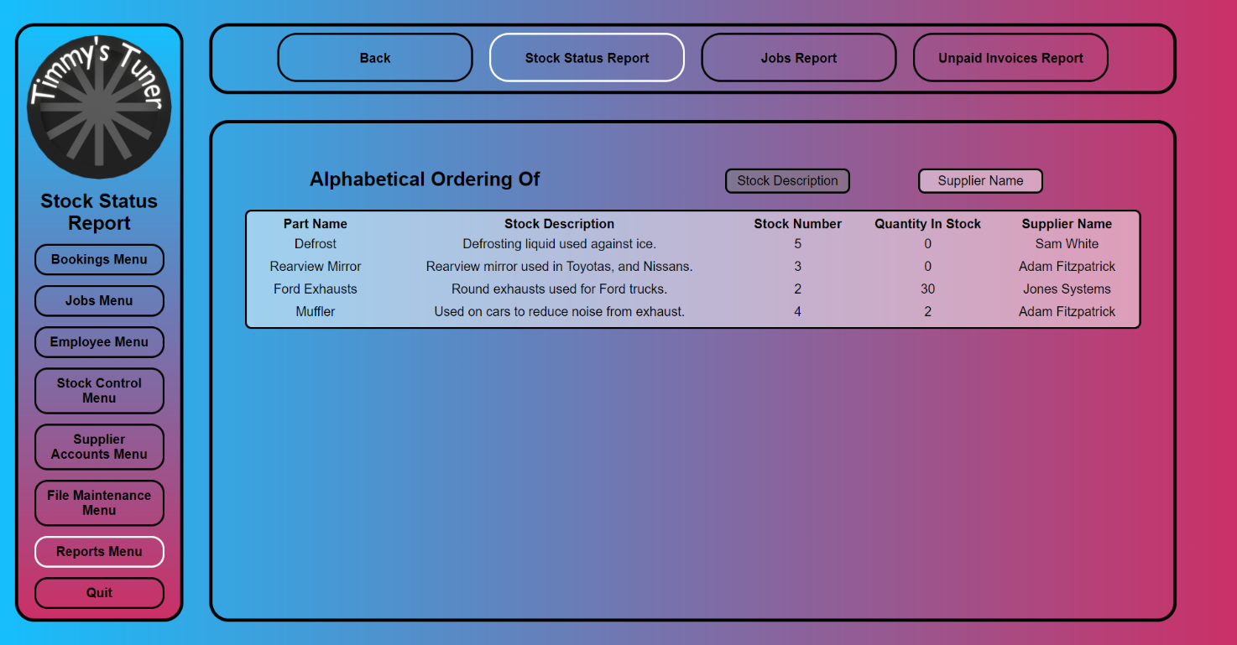

Supplier Name Order

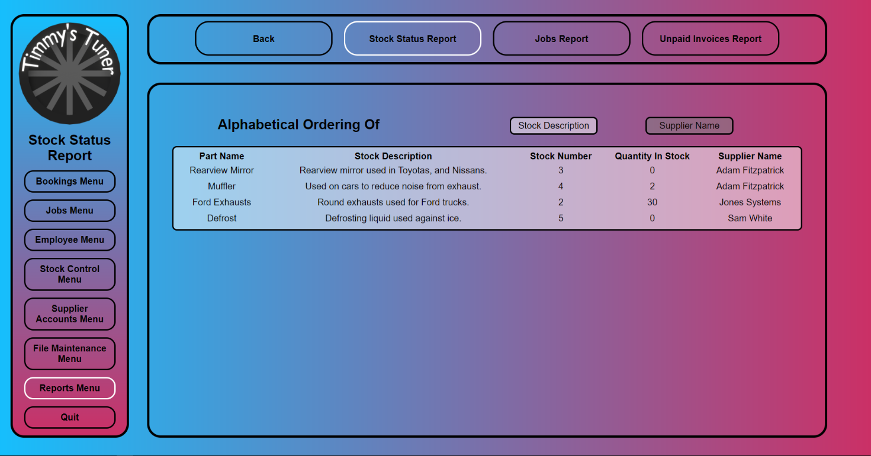

**stock_status_report.html.php**

<!--

Author: Gábor Major

ID: C00271548

Date: 2023.03.09

-->

<!DOCTYPE html>

<html lang="en">

<head>

<link rel="stylesheet" href="../../Css/default.css">

<title>Stock Status Report</title>

<style>

/* sets it as there are four buttons */

.sub_menu_button

{

width: 20%;

}

/* changes the width to be bigger for text in it */

input.content_box_button

{

width: 30%;

margin: 20px calc(15% + 5px) 0px 0px;

}

</style>

<script>

function stockDescriptionOrder()

{

document.reportForm.choice.value="StockDescription";

document.reportForm.submit();

}

function supplierNameOrder()

{

document.reportForm.choice.value="SupplierName";

document.reportForm.submit();

}

</script>

</head>

<body>

<div class="nav_container">

<div class="menu_box">

<!-- this makes it so the logo brings you back to the main menu -->

<img class="logo" onclick="location.href='../main_menu.php'">

<div class="menu_title">

Stock Status Report

</div>

<div class="menu_button" onclick="location.href='../Bookings/bookings_menu.html'">

Bookings Menu

</div>

<div class="menu_button" onclick="location.href='../Jobs/jobs_menu.html'">

Jobs Menu

</div>

<div class="menu_button" onclick="location.href='../Employee/employee_menu.html'">

Employee Menu

</div>

<div class="menu_button" onclick="location.href='../Stock_Control/stock_control_menu.html'">

Stock Control Menu

</div>

<div class="menu_button" onclick="location.href='../Supplier_Accounts/supplier_accounts_menu.html'">

Supplier Accounts Menu

</div>

<div class="menu_button" onclick="location.href='../File_Maintenance/file_maintenance_menu.html'">

File Maintenance Menu

</div>

<div class="menu_button" onclick="location.href='reports_menu.html'" style="border-color: white;">

Reports Menu

</div>

<div class="menu_button" onclick="location.href='../login_page.html'">

Quit

</div>

</div>

<div class="sub_menu_box">

<div class="sub_menu_button" onclick="location.href='../main_menu.php'">

Back

</div>

<div class="sub_menu_button" onclick="location.href='stock_status_report.html.php'" style="border-color: white;">

Stock Status Report

</div>

<div class="sub_menu_button" onclick="location.href='jobs_report.html'">

Jobs Report

</div>

<div class="sub_menu_button" onclick="location.href='unpaid_invoices_report.html'">

Unpaid Invoices Report

</div>

</div>

<div class="content_box">

<!-- hidden input for php -->

<form action="stock_status_report.html.php" method="post" name="reportForm">

<input type="hidden" name="choice">

</form>

<!-- holds the text and title -->

<div style="height: 20%;">

<div class="content_box_left">

<label style="margin-left: 100px;">Alphabetical Ordering Of</label>

</div>

<div class="content_box_right">

<input class="content_box_button" id="stockDescriptionButton" value="Stock Description" type="button" onclick="stockDescriptionOrder();"/>

<input class="content_box_button" id="supplierNameButton" value="Supplier Name" type="button" onclick="supplierNameOrder();"/>

</div>

</div>

<!-- actual report table container -->

<div class="content_box_report">

<?php

include "../connection.php";

$choice = "StockDescription";

if (ISSET($_POST['choice']))

{

$choice = $_POST['choice'];

}

if ($choice == "StockDescription")

{

?>

<script>

document.getElementById("stockDescriptionButton").disabled = true;

document.getElementById("supplierNameButton").disabled = false;

</script>

<?php

$sql = "SELECT * FROM ((Stock

INNER JOIN `Stock/Supplier` ON `Stock/Supplier`.StockID = Stock.StockID)

INNER JOIN Supplier ON `Stock/Supplier`.SupplierID = Supplier.SupplierID)

WHERE Stock.Deleted = 0

ORDER BY Description;";

produceReport($con, $sql);

}

else

{

?>

<script>

document.getElementById("stockDescriptionButton").disabled = false;

document.getElementById("supplierNameButton").disabled = true;

</script>

<?php

$sql = "SELECT * FROM ((Stock

INNER JOIN `Stock/Supplier` ON `Stock/Supplier`.StockID = Stock.StockID)

INNER JOIN Supplier ON `Stock/Supplier`.SupplierID = Supplier.SupplierID)

WHERE Stock.Deleted = 0

ORDER BY SupplierName;";

produceReport($con, $sql);

}

function produceReport($con, $sql)

{

$result = mysqli_query($con, $sql);

echo "<table>

<tr>

<th>Part Name</th>

<th>Stock Description</th>

<th>Stock Number</th>

<th>Quantity In Stock</th>

<th>Supplier Name</th>

</tr>";

while ($row = mysqli_fetch_array($result))

{

echo "<tr>

<td>".$row['PartName']."</td>

<td>".$row['Description']."</td>

<td>".$row['StockID']."</td>

<td>".$row['QuantityInStock']."</td>

<td>".$row['SupplierName']."</td>

</tr>";

}

echo "</table>";

}

mysqli_close($con);

?>

</div>

</div>

</div>

</body>

</html>

## Kelan Morgan

### Add a New Employee

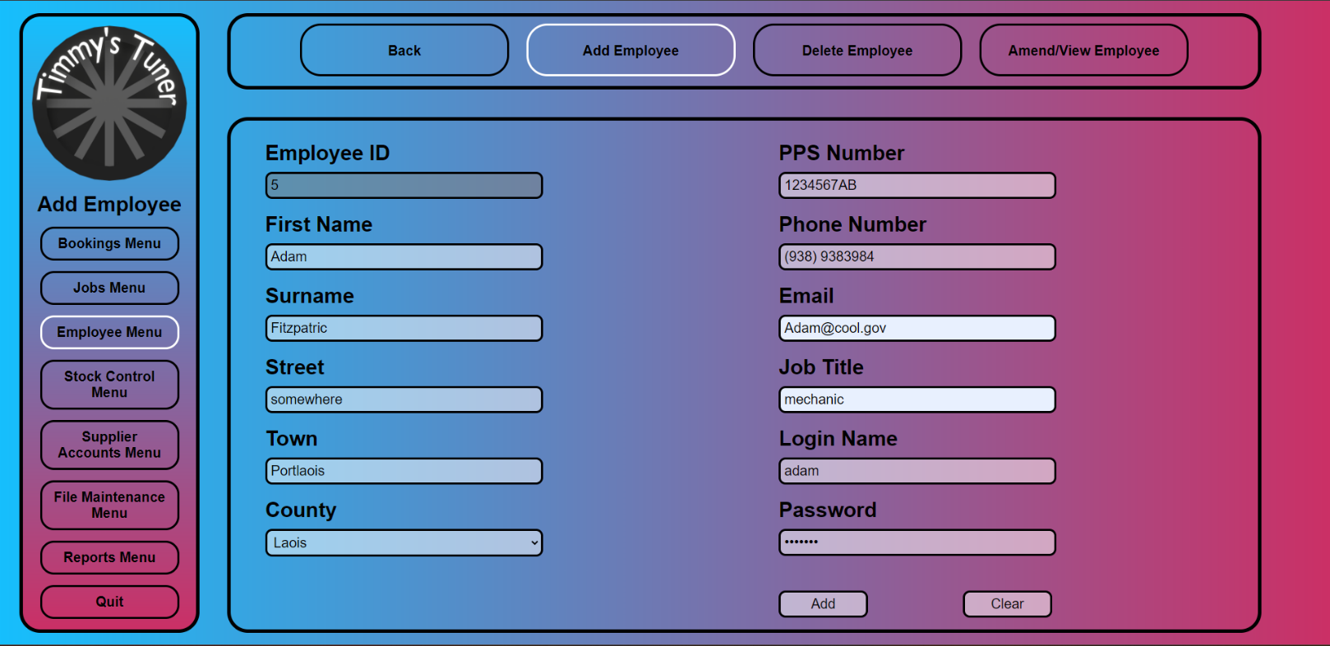

**add_new_employee.html.php**

<!--

    Author: Kelan Morgan

    ID:     C00262090

    Date:   2023.03.14

-->

<!DOCTYPE html>

<html lang="en">

    <head>

        <link rel="stylesheet" href="../../Css/default.css">

        <title>Add Employee</title>

        <style>

            /* sets it as there are four buttons */

            .sub_menu_button

            {

                width: 20%;

            }

            .content_box_right

            {

                margin: 10px 50px 10px 50px;

            }

            .content_box_left

            {

                margin: 10px 50px 10px 50px;

            }

        </style>

        <script>

            function confirmCheck()

            {

                var response = confirm('Are you sure you want to add a new employee?\nEmployee ID: ' + document.getElementById("employeeID").value);

                if (response)

                {

                    return true;

                }

                else

                {

                    return false;

                }

            }

        </script>

    </head>

    <body>

        <div class="nav_container">

            <div class="menu_box">

                <!-- this makes it so the logo brings you back to the main menu -->

                <img class="logo" onclick="location.href='../main_menu.php'">

                <div class="menu_title">

                    Add Employee

                </div>

                <div class="menu_button" onclick="location.href='../Bookings/bookings_menu.html'">

                    Bookings Menu

                </div>

                <div class="menu_button" onclick="location.href='../Jobs/jobs_menu.html'">

                    Jobs Menu

                </div>

                <div class="menu_button" onclick="location.href='employee_menu.html'" style="border-color: white;">

                    Employee Menu

                </div>

                <div class="menu_button" onclick="location.href='../Stock_Control/stock_control_menu.html'">

                    Stock Control Menu

                </div>

                <div class="menu_button" onclick="location.href='../Supplier_Accounts/supplier_accounts_menu.html'">

                    Supplier Accounts Menu

                </div>

                <div class="menu_button" onclick="location.href='../File_Maintenance/file_maintenance_menu.html'">

                    File Maintenance Menu

                </div>

                <div class="menu_button" onclick="location.href='../Reports/reports_menu.html'">

                    Reports Menu

                </div>

                <div class="menu_button" onclick="location.href='../login_page.html'">

                    Quit

                </div>

            </div>

            <div class="sub_menu_box">

                <div class="sub_menu_button" onclick="location.href='../main_menu.php'">

                    Back

                </div>

                <div class="sub_menu_button" onclick="location.href='add_new_employee.html.php'" style="border-color: white;">

                    Add Employee

                </div>

                <div class="sub_menu_button" onclick="location.href='delete_employee.html.php'">

                    Delete Employee

                </div>

                <div class="sub_menu_button" onclick="location.href='amend_view_employee.html.php'">

                    Amend/View Employee

                </div>

            </div>

            <!-- box for contents of the page -->

            <div class="content_box">

                <form action="add_new_employee.php" method="post" onsubmit="return confirmCheck()">

                    <!-- left side of content box -->

                    <div class="content_box_left">

                        <!-- input for employee ID (disabled) -->

                        <label for="employeeID">Employee ID</label><br>

                        <?php

                            include "../connection.php";

                            $sql = "SELECT MAX(employeeID) FROM Employee;";

                            if (!$result = mysqli_query($con, $sql))

                            {

                                die('Error ' . mysqli_error($con));

                            }

                            if (mysqli_affected_rows($con) == 0)

                            {

                                echo "<input type='number' name='employeeID' id='employeeID' value='1' required readonly><br>";

                            }

                            else

                            {

                                $previousID = mysqli_fetch_array($result)[0];

                                $newID = $previousID + 1;

                                echo "<input type='text' name='employeeID' id='employeeID' value='$newID' required readonly><br>";

                            }

                            mysqli_close($con);

                        ?>

                        <!-- input for first name (required) -->

                        <label for="firstName">First Name</label><br>

                        <input type="text" name="firstName" id="firstName" required maxlength="32"><br>

                        <!-- input for surname (required) -->

                        <label for="surname">Surname</label><br>

                        <input type="text" name="surname" id="surname" required maxlength="32"><br>

                        <!-- input for street (required) -->

                        <label for="street">Street</label><br>

                        <input type="text" name="street" id="street" required maxlength="32"><br>

                        <!-- input for town (required) -->

                        <label for="town">Town</label><br>

                        <input type="text" name="town" id="town" required maxlength="32"><br>

                        <!-- input for county (required) -->

                        <label for="county">County</label><br>

                        <select name="county">

                            <option value="Antrim">Antrim</option>

                            <option value="Armagh">Armagh</option>

                            <option value="Carlow">Carlow</option>

                            <option value="Cavan">Cavan</option>

                            <option value="Clare">Clare</option>

                            <option value="Cork">Cork</option>

                            <option value="Derry">Derry</option>

                            <option value="Donegal">Donegal</option>

                            <option value="Down">Down</option>

                            <option value="Dublin">Dublin</option>

                            <option value="Fermanagh">Fermanagh</option>

                            <option value="Galway">Galway</option>

                            <option value="Kerry">Kerry</option>

                            <option value="Kildare">Kildare</option>

                            <option value="Kilkenny">Kilkenny</option>

                            <option value="Laois">Laois</option>

                            <option value="Leitrim">Leitrim</option>

                            <option value="Limerick">Limerick</option>

                            <option value="Longford">Longford</option>

                            <option value="Louth">Louth</option>

                            <option value="Mayo">Mayo</option>

                            <option value="Meath">Meath</option>

                            <option value="Monaghan">Monaghan</option>

                            <option value="Offaly">Offaly</option>

                            <option value="Roscommon">Roscommon</option>

                            <option value="Sligo">Sligo</option>

                            <option value="Tipperary">Tipperary</option>

                            <option value="Tyrone">Tyrone</option>

                            <option value="Waterford">Waterford</option>

                            <option value="Westmeath">Westmeath</option>

                            <option value="Wexford">Wexford</option>

                            <option value="Wicklow">Wicklow</option>

                        </select>

                    </div>

                    <!-- right side of content box -->

                    <div class="content_box_right">

                        <!-- input for pps number (required) -->

                        <label for="ppsNumber">PPS Number</label><br>

                        <input type="text" name="ppsNumber" id="ppsNumber" required pattern="^\d{7}[A-Za-z]{1,2}$" title="Your PPS number should consist of 7 digits followed by 1 or 2 letters."><br>

                        <!-- input for phone number (required) -->

                        <label for="phoneNumber">Phone Number</label><br>

                        <input type="text" name="phoneNumber" id="phoneNumber" required pattern="^\(?\d{3}\)?[- ]?\d{7}$" title="Please enter a valid phone number."><br>

                        <!-- input for email (required) -->

                        <label for="email">Email</label><br>

                        <input type="email" name="email" id="email" required><br>

                        <!-- job title (required) -->

                        <label for="jobTitle">Job Title</label><br>

                        <input type="text" name="jobTitle" id="jobTitle" required maxlength="32"><br>

                        <!-- login name (required) -->

                        <label for="loginName">Login Name</label><br>

                        <input type="text" name="loginName" id="loginName" required maxlength="32"><br>

                        <!-- password (required) -->

                        <label for="password">Password</label><br>

                        <input type="password" name="password" id="password" required maxlength="32">

                        <!-- buttons for submit and clear -->

                        <input class="content_box_button" type="submit" value="Add"/>

                        <input class="content_box_button" type="reset" value="Clear"/>

                    </div>

                </form>

            </div>

        </div>

    </body>

</html>

**add_new_employee.php**

<!--

    Author: Kelan Morgan

    ID:     C00262090

    Date:   2023.03.14

-->

<?php

include "../connection.php";

// get values from form

$employeeID = $_POST['employeeID'];

$firstName = $_POST['firstName'];

$surname = $_POST['surname'];

$street = $_POST['street'];

$town = $_POST['town'];

$county = $_POST['county'];

$ppsNumber = $_POST['ppsNumber'];

$phoneNumber = $_POST['phoneNumber'];

$email = $_POST['email'];

$jobTitle = $_POST['jobTitle'];

$loginName = $_POST['loginName'];

$password = $_POST['password'];

// create sql query to insert a new row to the table

$sql = "INSERT INTO Employee (employeeID, FirstName,Surname,Street,Town,County,PPSNumber,PhoneNo,Email,JobTitle,LoginName,Password)

VALUES ('$employeeID', '$firstName', '$surname', '$street', '$town', '$county', '$ppsNumber', '$phoneNumber', '$email', '$jobTitle', '$loginName', '$password')";

// check for errors

if (!mysqli_query($con, $sql)){

    echo "Error " . mysqli_error($con);

    mysqli_close($con);

}

else{

    mysqli_close($con);

    header('Location: add_new_employee.html.php');

}

?>

### Delete an Employee

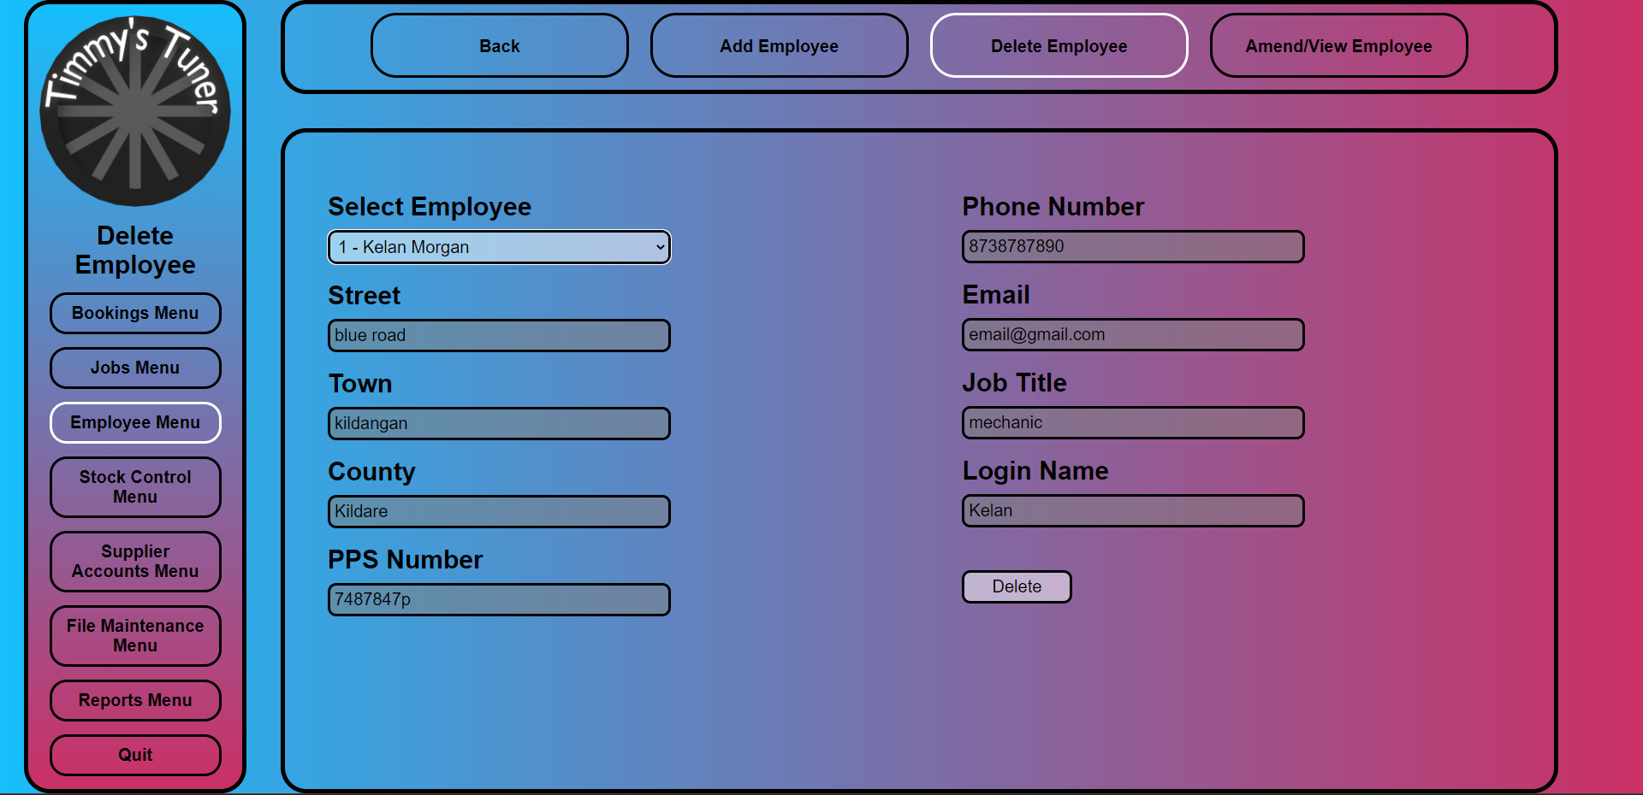

**select_employee.php**

<!--

    Author: Kelan Morgan

    ID:     C00262090

    Date:   2023.03.14

-->

<?php

include "../connection.php";

//selects all fields of the employee table for a drop down menu

$sql = "SELECT EmployeeID, FirstName, Surname, Street, Town, County, PPSNumber, PhoneNo, Email, JobTitle, LoginName, Password FROM Employee WHERE Deleted = 0";

if (!$result = mysqli_query($con, $sql)){

    die('Error in querying the database' . mysqli_error($con));

}

echo "<br><select name = 'selectEmployee' id = 'selectEmployee' onclick = 'populate()'>";

//create the options with a string seperated by ", "

while ($row = mysqli_fetch_array($result)){

    $id = $row['EmployeeID'];

    $firstName = $row['FirstName'];

    $surname = $row['Surname'];

    $street = $row['Street'];

    $town = $row['Town'];

    $county = $row['County'];

    $ppsNumber = $row['PPSNumber'];

    $phoneNo = $row['PhoneNo'];

    $email = $row['Email'];

    $jobTitle = $row['JobTitle'];

    $loginName = $row['LoginName'];

    $password = $row['Password'];

    $Text = "$id, $firstName, $surname, $street, $town, $county, $ppsNumber, $phoneNo, $email, $jobTitle, $loginName, $password";

    echo "<option value='$Text'>$id - $firstName $surname</option>";

}

echo "</select>";

mysqli_close($con);

?>

**delete_employee.html.php**

<!--

    Author: Kelan Morgan

    ID:     C00262090

    Date:   2023.03.13

-->

<!DOCTYPE html>

<html lang="en">

    <head>

        <link rel="stylesheet" href="../../Css/default.css">

        <title>Delete Employee</title>

        <style>

            /* sets it as there are four buttons */

            .sub_menu_button

            {

                width: 20%;

            }

        </style>

        <script>

            function confirmCheck()

            {

                var select = document.getElementById("selectEmployee");

                var result = select.options[select.selectedIndex].value;

                var details = result.split(", ");

                var response = confirm('Are you sure you want to delete this employee?\nEmployee: ' + details[0] + " - " + details[1] + " " + details[2]);

                if (response)

                {

                    return true;

                }

                else

                {

                    return false;

                }

            }

        </script>

    </head>

    <body>

        <div class="nav_container">

            <div class="menu_box">

                <!-- this makes it so the logo brings you back to the main menu -->

                <img class="logo" onclick="location.href='../main_menu.php'">

                <div class="menu_title">

                    Delete Employee

                </div>

                <div class="menu_button" onclick="location.href='../Bookings/bookings_menu.html'">

                    Bookings Menu

                </div>

                <div class="menu_button" onclick="location.href='../Jobs/jobs_menu.html'">

                    Jobs Menu

                </div>

                <div class="menu_button" onclick="location.href='employee_menu.html'" style="border-color: white;">

                    Employee Menu

                </div>

                <div class="menu_button" onclick="location.href='../Stock_Control/stock_control_menu.html'">

                    Stock Control Menu

                </div>

                <div class="menu_button" onclick="location.href='../Supplier_Accounts/supplier_accounts_menu.html'">

                    Supplier Accounts Menu

                </div>

                <div class="menu_button" onclick="location.href='../File_Maintenance/file_maintenance_menu.html'">

                    File Maintenance Menu

                </div>

                <div class="menu_button" onclick="location.href='../Reports/reports_menu.html'">

                    Reports Menu

                </div>

                <div class="menu_button" onclick="location.href='../login_page.html'">

                    Quit

                </div>

            </div>

            <div class="sub_menu_box">

                <div class="sub_menu_button" onclick="location.href='../main_menu.php'">

                    Back

                </div>

                <div class="sub_menu_button" onclick="location.href='add_new_employee.html.php'">

                    Add Employee

                </div>

                <div class="sub_menu_button" onclick="location.href='delete_employee.html.php'" style="border-color: white;">

                    Delete Employee

                </div>

                <div class="sub_menu_button" onclick="location.href='amend_view_employee.html.php'">

                    Amend/View Employee

                </div>

            </div>

            <div class="content_box">

            <form action="delete_employee.php" method="post" onsubmit="return confirmCheck()">

                    <!-- left side of content box -->

                    <div class="content_box_left">

                        <!-- dropdown for employee ID and name -->

                        <label for="employeeIDAndName">Select Employee</label>

                        <?php include "select_employee.php" ?>

                        <script>

                            // populates the form

                            function populate(){

                                var select = document.getElementById("selectEmployee");

                                var result = select.options[select.selectedIndex].value;

                                var details = result.split(", ");

                                document.getElementById("street").value = details[3];

                                document.getElementById("town").value = details[4];

                                document.getElementById("county").value = details[5];

                                document.getElementById("ppsNumber").value = details[6];

                                document.getElementById("phoneNumber").value = details[7];

                                document.getElementById("email").value = details[8];

                                document.getElementById("jobTitle").value = details[9];

                                document.getElementById("loginName").value = details[10];

                            }

                        </script>

                        <br>

                        <!-- display street -->

                        <label for="street">Street</label><br>

                        <input type="text" name="street" id="street" readonly><br>

                        <!-- display town -->

                        <label for="town">Town</label><br>

                        <input type="text" name="town" id="town" readonly><br>

                        <!-- display county -->

                        <label for="county">County</label><br>

                        <input type="text" name="county" id="county" readonly><br>

                        <!-- display ppsn -->

                        <label for="ppsNumber">PPS Number</label><br>

                        <input type="text" name="ppsNumber" id="ppsNumber" readonly><br>

                    </div>

                    <!-- right side of content box -->

                    <div class="content_box_right">

                        <!-- display phone number -->

                        <label for="phoneNumber">Phone Number</label><br>

                        <input type="text" name="phoneNumber" id="phoneNumber" readonly><br>

                        <!-- display email -->

                        <label for="email">Email</label><br>

                        <input type="email" name="email" id="email" readonly><br>

                        <!-- display job title -->

                        <label for="jobTitle">Job Title</label><br>

                        <input type="text" name="jobTitle" id="jobTitle" readonly><br>

                        <!-- display login name -->

                        <label for="loginName">Login Name</label><br>

                        <input type="text" name="loginName" id="loginName" readonly><br>

                        <!-- buttons for DELETE -->

                        <input class="content_box_button" type="submit" value="Delete">

                    </div>

                </form>

            </div>

        </div>

    </body>

</html>

**delete_employee.php**

<!--

    Author: Kelan Morgan

    ID:     C00262090

    Date:   2023.03.14

-->

<?php

include "../connection.php";

$id = explode(", ", $_POST['selectEmployee'])[0];

//set the deleted flag to 1 on the selected id

$sql = "UPDATE Employee SET Deleted = 1 WHERE EmployeeID = $id";

if (!mysqli_query($con, $sql)){

    echo "Error " . mysqli_error($con);

    mysqli_close($con);

}

else{

    mysqli_close($con);

    header('Location: delete_employee.html.php');

}

?>

### Amend/View an Employee

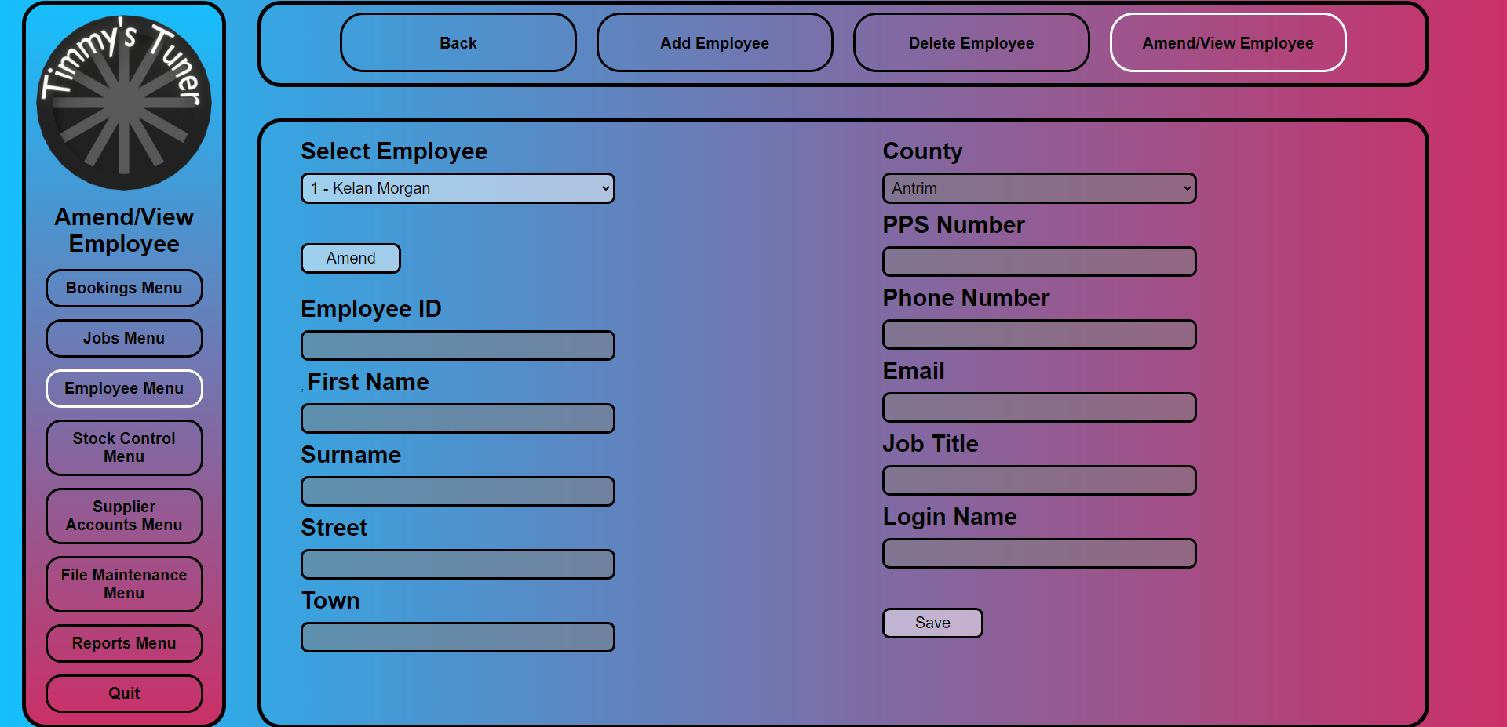

**amend_view_employee.html.php**

<!--

    Author: Kelan Morgan

    ID:     C00262090

    Date:   2023.03.13

-->

<!DOCTYPE html>

<html lang="en">

    <head>

        <link rel="stylesheet" href="../../Css/default.css">

        <title>Amend/View Employee</title>

        <style>

            /* sets it as there are four buttons */

            .sub_menu_button

            {

                width: 20%;

            }

            .content_box_right

            {

                margin: 10px 50px 10px 50px;

            }

            .content_box_left

            {

                margin: 10px 50px 10px 50px;

            }

            .content_box label

            {

                margin: 10px 0px 10px 0px;

            }

        </style>

    </head>

    <body>

        <div class="nav_container">

            <div class="menu_box">

                <!-- this makes it so the logo brings you back to the main menu -->

                <img class="logo" onclick="location.href='../main_menu.php'">

                <div class="menu_title">

                    Amend/View Employee

                </div>

                <div class="menu_button" onclick="location.href='../Bookings/bookings_menu.html'">

                    Bookings Menu

                </div>

                <div class="menu_button" onclick="location.href='../Jobs/jobs_menu.html'">

                    Jobs Menu

                </div>

                <div class="menu_button" onclick="location.href='employee_menu.html'" style="border-color: white;">

                    Employee Menu

                </div>

                <div class="menu_button" onclick="location.href='../Stock_Control/stock_control_menu.html'">

                    Stock Control Menu

                </div>

                <div class="menu_button" onclick="location.href='../Supplier_Accounts/supplier_accounts_menu.html'">

                    Supplier Accounts Menu

                </div>

                <div class="menu_button" onclick="location.href='../File_Maintenance/file_maintenance_menu.html'">

                    File Maintenance Menu

                </div>

                <div class="menu_button" onclick="location.href='../Reports/reports_menu.html'">

                    Reports Menu

                </div>

                <div class="menu_button" onclick="location.href='../login_page.html'">

                    Quit

                </div>

            </div>

            <div class="sub_menu_box">

                <div class="sub_menu_button" onclick="location.href='../main_menu.php'">

                    Back

                </div>

                <div class="sub_menu_button" onclick="location.href='add_new_employee.html.php'">

                    Add Employee

                </div>

                <div class="sub_menu_button" onclick="location.href='delete_employee.html.php'">

                    Delete Employee

                </div>

                <div class="sub_menu_button" onclick="location.href='amend_view_employee.html.php'" style="border-color: white;">

                    Amend/View Employee

                </div>

            </div>

            <div class="content_box">

                <form action="amend_view_employee.php" method="post" onsubmit="return confirmCheck()">

                    <!-- left side of content box -->

                    <div class="content_box_left">

                        <!-- dropdown for employee ID and name -->

                        <label for="employeeIDAndName">Select Employee</label>

                        <?php include "select_employee.php" ?>

                        <input type="button" id="amendViewbutton" value="Amend" onclick = "toggleLock()" class="content_box_button"><br>

                        <script>

                            // populates the form

                            function populate(){

                                var select = document.getElementById("selectEmployee");

                                var result = select.options[select.selectedIndex].value;

                                var details = result.split(", ");

                                document.getElementById("employeeID").value = details[0];

                                document.getElementById("firstName").value = details[1];

                                document.getElementById("surname").value = details[2];

                                document.getElementById("street").value = details[3];

                                document.getElementById("town").value = details[4];

                                document.getElementById("county").value = details[5];

                                document.getElementById("ppsNumber").value = details[6];

                                document.getElementById("phoneNumber").value = details[7];

                                document.getElementById("email").value = details[8];

                                document.getElementById("jobTitle").value = details[9];

                                document.getElementById("loginName").value = details[10];

                            }

                            function toggleLock(){

                                if(document.getElementById("amendViewbutton").value == "Amend"){

                                    document.getElementById("amendViewbutton").value = "View";

                                    document.getElementById("firstName").disabled = false;

                                    document.getElementById("surname").disabled = false;

                                    document.getElementById("street").disabled = false;

                                    document.getElementById("town").disabled = false;

                                    document.getElementById("county").disabled = false;

                                    document.getElementById("ppsNumber").disabled = false;

                                    document.getElementById("phoneNumber").disabled = false;

                                    document.getElementById("email").disabled = false;

                                    document.getElementById("jobTitle").disabled = false;

                                    document.getElementById("loginName").disabled = false;

                                }

                                else{

                                    document.getElementById("amendViewbutton").value = "Amend";

                                    document.getElementById("firstName").disabled = true;

                                    document.getElementById("surname").disabled = true;

                                    document.getElementById("street").disabled = true;

                                    document.getElementById("town").disabled = true;

                                    document.getElementById("county").disabled = true;

                                    document.getElementById("ppsNumber").disabled = true;

                                    document.getElementById("phoneNumber").disabled = true;

                                    document.getElementById("email").disabled = true;

                                    document.getElementById("jobTitle").disabled = true;

                                    document.getElementById("loginName").disabled = true;

                                }

                            }

                            function confirmCheck(){

                                var response;

                                response = confirm('Are you sure you want to save these changes?');

                                if (response){

                                    document.getElementById("firstName").disabled = false;

                                    document.getElementById("surname").disabled = false;

                                    document.getElementById("street").disabled = false;

                                    document.getElementById("town").disabled = false;

                                    document.getElementById("county").disabled = false;

                                    document.getElementById("ppsNumber").disabled = false;

                                    document.getElementById("phoneNumber").disabled = false;

                                    document.getElementById("email").disabled = false;

                                    document.getElementById("jobTitle").disabled = false;

                                    document.getElementById("loginName").disabled = false;

                                    return true;

                                }

                                else{

                                    populate();

                                    toggleLock();

                                    return false;

                                }

                            }

                        </script>

                        <br>

                        <!-- input for employee ID (disabled) -->

                        <label for="employeeID">Employee ID</label><br>

                        <input type='number' name='employeeID' id='employeeID' required readonly><br>;

                        <!-- input for first name (required) -->

                        <label for="firstName">First Name</label><br>

                        <input type="text" name="firstName" id="firstName" required disabled maxlength="32"><br>

                        <!-- input for surname (required) -->

                        <label for="surname">Surname</label><br>

                        <input type="text" name="surname" id="surname" required disabled maxlength="32"><br>

                        <!-- input for street (required) -->

                        <label for="street">Street</label><br>

                        <input type="text" name="street" id="street" required disabled maxlength="32"><br>

                        <!-- input for town (required) -->

                        <label for="town">Town</label><br>

                        <input type="text" name="town" id="town" required disabled maxlength="32"><br>

                    </div>

                    <!-- right side of content box -->

                    <div class="content_box_right">

                        <!-- input for county (required) -->

                        <label for="county">County</label><br>

                        <select name="county" id="county" disabled>

                            <option value="Antrim">Antrim</option>

                            <option value="Armagh">Armagh</option>

                            <option value="Carlow">Carlow</option>

                            <option value="Cavan">Cavan</option>

                            <option value="Clare">Clare</option>

                            <option value="Cork">Cork</option>

                            <option value="Derry">Derry</option>

                            <option value="Donegal">Donegal</option>

                            <option value="Down">Down</option>

                            <option value="Dublin">Dublin</option>

                            <option value="Fermanagh">Fermanagh</option>

                            <option value="Galway">Galway</option>

                            <option value="Kerry">Kerry</option>

                            <option value="Kildare">Kildare</option>

                            <option value="Kilkenny">Kilkenny</option>

                            <option value="Laois">Laois</option>

                            <option value="Leitrim">Leitrim</option>

                            <option value="Limerick">Limerick</option>

                            <option value="Longford">Longford</option>

                            <option value="Louth">Louth</option>

                            <option value="Mayo">Mayo</option>

                            <option value="Meath">Meath</option>

                            <option value="Monaghan">Monaghan</option>

                            <option value="Offaly">Offaly</option>

                            <option value="Roscommon">Roscommon</option>

                            <option value="Sligo">Sligo</option>

                            <option value="Tipperary">Tipperary</option>

                            <option value="Tyrone">Tyrone</option>

                            <option value="Waterford">Waterford</option>

                            <option value="Westmeath">Westmeath</option>

                            <option value="Wexford">Wexford</option>

                            <option value="Wicklow">Wicklow</option>

                        </select><br>

                        <!-- input for pps number (required) -->

                        <label for="ppsNumber">PPS Number</label><br>

                        <input type="text" name="ppsNumber" id="ppsNumber" required disabled pattern="^\d{7}[A-Za-z]{1,2}$" title="Your PPS number should consist of 7 digits followed by 1 or 2 letters."><br>

                        <!-- input for phone number (required) -->

                        <label for="phoneNumber">Phone Number</label><br>

                        <input type="text" name="phoneNumber" id="phoneNumber" required disabled pattern="^\(?\d{3}\)?[- ]?\d{7}$" title="Please enter a valid phone number."><br>

                        <!-- input for email (required) -->

                        <label for="email">Email</label><br>

                        <input type="email" name="email" id="email" required disabled disabled><br>

                        <!-- job title (required) -->

                        <label for="jobTitle">Job Title</label><br>

                        <input type="text" name="jobTitle" id="jobTitle" required disabled maxlength="32"><br>

                        <!-- login name (required) -->

                        <label for="loginName">Login Name</label><br>

                        <input type="text" name="loginName" id="loginName" required disabled maxlength="32"><br>

                        <!-- buttons for submit and clear -->

                        <input class="content_box_button" type="submit" value="Save"/>

                    </div>

                </form>

            </div>

        </div>

    </body>

</html>

**amend_view_employee.php**

<!--

    Author: Kelan Morgan

    ID:     C00262090

    Date:   2023.03.13

-->

<?php

include "../connection.php";

// update the table with the ammended data

$sql = "UPDATE Employee SET

        FirstName = '$_POST[firstName]',

        Surname = '$_POST[surname]',

        Street = '$_POST[street]',

        Town = '$_POST[town]',

        County = '$_POST[county]',

        PPSNumber = '$_POST[ppsNumber]',

        PhoneNo = '$_POST[phoneNumber]',

        Email = '$_POST[email]',

        JobTitle = '$_POST[jobTitle]',

        LoginName = '$_POST[loginName]'

        WHERE EmployeeID = '$_POST[employeeID]'";

if (!mysqli_query($con, $sql)){

    echo "Error" . mysqli_error($con);

    mysqli_close($con);

}

else{

    mysqli_close($con);

    // send the user to back to amend view screen

    header("Location: amend_view_employee.html.php");

}

?>

### Login/Change Password

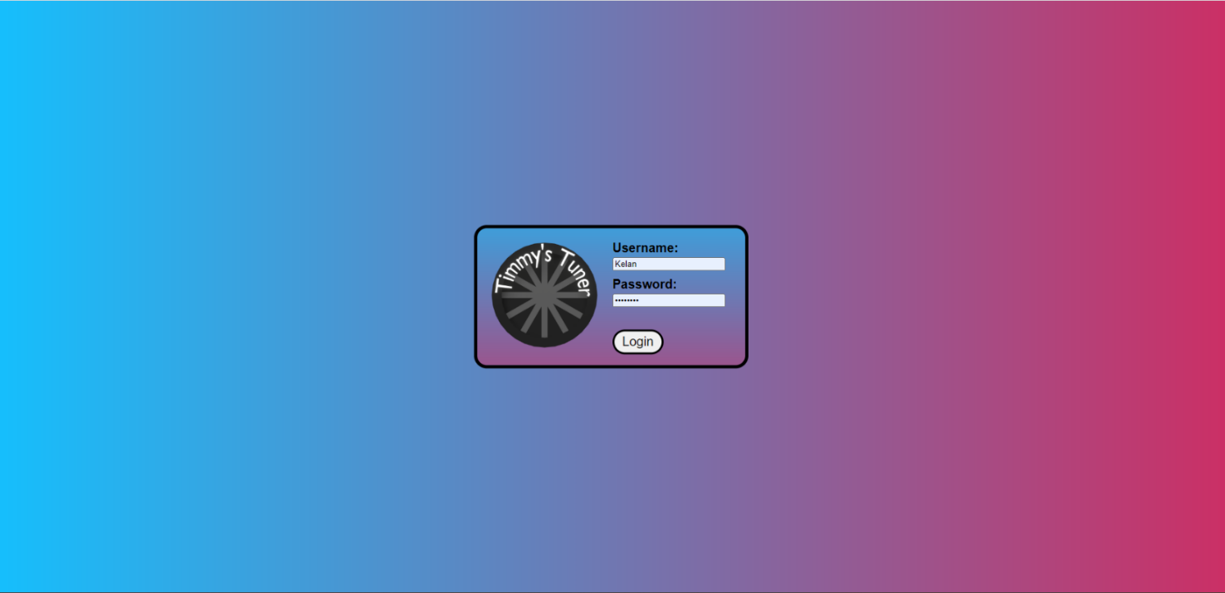

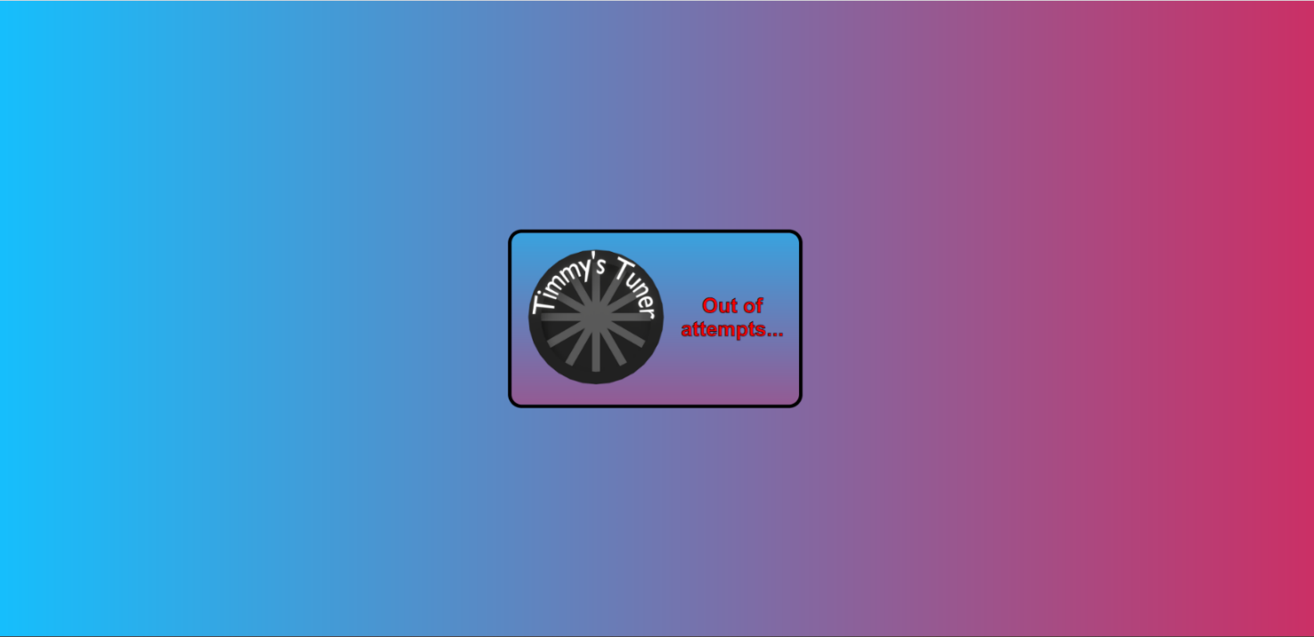

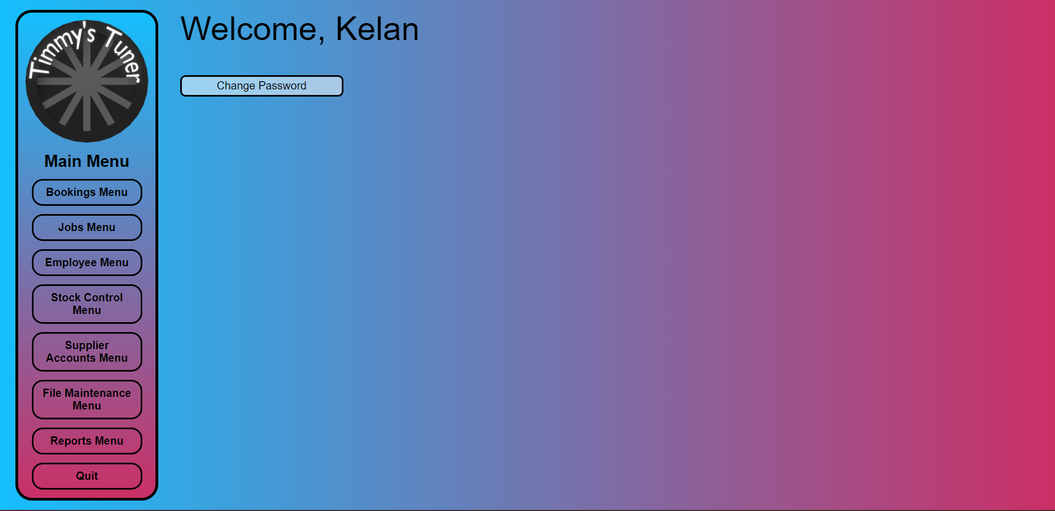

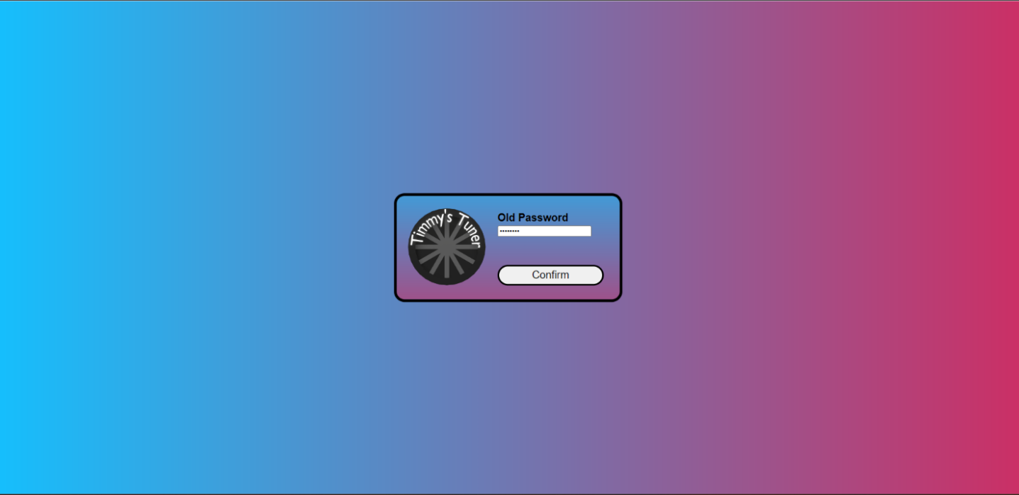

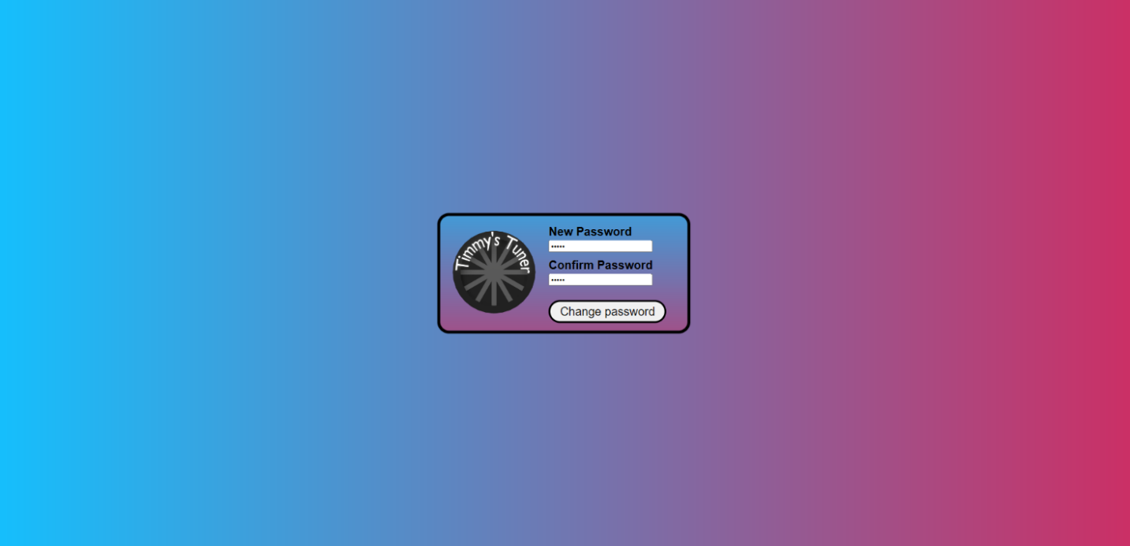

**login_page.html**

<!--

    Author: Kelan Morgan

    ID:     C00262090

    Date:   2023.03.13

-->

<!DOCTYPE html>

<html lang="en">

    <head>

        <link rel="stylesheet" href="../Css/default.css">

        <title>Login</title>

        <style>

            .login_box

            {

                background-image:  url("../Css/images/gradient_turned.png");

                background-size: 100% 200%;

                background-position: 0px -100px;

                margin: auto;

                width: 400px;

                border: 5px black solid;

                border-radius: 20px;

                padding: 10px;

                font-weight: bold;

                font-size: 20px;

            }

            .logo

            {

                cursor: auto;

            }

            .input_div

            {

                margin-left: 10px;

            }

            .input_div > input

            {

                margin-bottom: 10px;

            }

            .login_button

            {

                font-size: 20px;

                width: 80px;

                margin: auto;

                margin-top: 10px;

                margin-left: 10px;

                border: 3px black solid;

                border-radius: 20px;

                padding: 5px;

            }

        </style>

    </head>

    <body>

        <div class="nav_container">

            <div class ="login_box">

                <table>

                    <form action="login.php" method="post">

                        <tr>

                            <td rowspan="2">

                                <img class="logo">

                            </td>

                            <td>

                                <!-- allow the user to enter their username and password -->

                                <div class="input_div">

                                    <label for="username">Username:</label>

                                    <input type="text" id="username" name="username" autofocus required>

                                    <br>

                                    <label for="password">Password:</label>

                                    <input type="password" id="password" name="password" required>

                                </div>

                            </td>

                        </tr>

                        <tr>

                            <td>

                                <input class="login_button" id="loginButton" name="loginButton" type="Submit" value="Login"></input>

                            </td>

                        </tr>

                    </form>

                </table>

            </div>

        </div>

    </body>

</html>

**login_page_error.html.php**

<!--

    Author: Kelan Morgan

    ID:     C00262090

    Date:   2023.03.13

-->

<!DOCTYPE html>

<html lang="en">

    <head>

        <link rel="stylesheet" href="../Css/default.css">

        <title>Login</title>

        <style>

            .login_box

            {

                background-image:  url("../Css/images/gradient_turned.png");

                background-size: 100% 200%;

                background-position: 0px -100px;

                margin: auto;

                width: 400px;

                border: 5px black solid;

                border-radius: 20px;

                padding: 10px;

                font-weight: bold;

                font-size: 20px;

            }

            .logo

            {

                cursor: auto;

            }

            .input_div

            {

                margin-left: 10px;

            }

            .input_div > input

            {

                margin-bottom: 10px;

            }

            .login_button

            {

                font-size: 20px;

                width: 80px;

                margin: auto;

                margin-top: 10px;

                margin-left: 10px;

                border: 3px black solid;

                border-radius: 20px;

                padding: 5px;

            }

        </style>

    </head>

    <body>

        <?php

        session_start();

        // check if the user is out of attempts

        if($_SESSION['attempts'] >= 3){

            // go to out of attempts page

            header("Location: out_of_attempts.html");

            exit();

        }

        ?>

        <div class="nav_container">

            <div class ="login_box">

                <table>

                    <form action="login.php" method="post">

                        <tr>

                            <!-- display the error message -->

                            <div style="color: red; font-size: 30px; font-style: bold; text-align: center; -webkit-text-stroke: 1px black;">

                                Username or password is incorrect!

                            </div>

                        </tr>

                        <tr>

                            <td rowspan="2">

                                <img class="logo">

                            </td>

                            <td>

                                <!-- allow the user to input username and password -->

                                <div class="input_div">

                                    <label for="username">Username:</label>

                                    <input type="text" id="username" name="username" autofocus required>

                                    <br>

                                    <label for="password">Password:</label>

                                    <input type="password" id="password" name="password" required>

                                </div>

                            </td>

                        </tr>

                        <tr>

                            <td>

                                <input class="login_button" id="loginButton" name="loginButton" type="Submit" value="Login"></input>

                            </td>

                        </tr>

                    </form>

                </table>

            </div>

        </div>

    </body>

</html>

**out_of_attempts.html**

<!--

    Author: Kelan Morgan

    ID:     C00262090

    Date:   2023.03.13

-->

<!DOCTYPE html>

<html lang="en">

    <head>

        <link rel="stylesheet" href="../Css/default.css">

        <title>Login</title>

        <style>

            .login_box

            {

                background-image:  url("../Css/images/gradient_turned.png");

                background-size: 100% 200%;

                background-position: 0px -100px;

                margin: auto;

                width: 400px;

                border: 5px black solid;

                border-radius: 20px;

                padding: 10px;

                font-weight: bold;

                font-size: 20px;

            }

            .logo

            {

                cursor: auto;

            }

        </style>

    </head>

    <body>

        <div class="nav_container">

            <div class ="login_box">

                <table>

                    <tr>

                        <td rowspan="2">

                            <img class="logo">

                        </td>

                        <td>

                            <p>

                                <!-- display the out of attempts message -->

                                <div style="color: red; font-size: 30px; font-style: bold; text-align: center; -webkit-text-stroke: 1px black;">

                                    Out of attempts...

                                </div>

                            </p>

                        </td>

                    </tr>

                    <tr>

                    </tr>

                </table>

            </div>

        </div>

    </body>

</html>

**main_menu.php**

<!--

    Author: Group

    Date: 2023.02.16

-->

<?php session_start(); ?>

<!DOCTYPE html>

<html lang="en">

    <head>

        <link rel="stylesheet" href="../Css/default.css">

        <title>Main Menu</title>

        <style>

            .content_box

            {

                border: 0px;

            }

        </style>

    </head>

    <body>

        <div class="nav_container">

            <div class="menu_box">

                <!-- this makes it so the logo brings you back to the main menu -->

                <img class="logo" onclick="location.href='main_menu.php'">

                <div class="menu_title">

                    Main Menu

                </div>

                <div class="menu_button" onclick="location.href='Bookings/bookings_menu.html'">

                    Bookings Menu

                </div>

                <div class="menu_button" onclick="location.href='Jobs/jobs_menu.html'">

                    Jobs Menu

                </div>

                <div class="menu_button" onclick="location.href='Employee/employee_menu.html'">

                    Employee Menu

                </div>

                <div class="menu_button" onclick="location.href='Stock_Control/stock_control_menu.html'">

                    Stock Control Menu

                </div>

                <div class="menu_button" onclick="location.href='Supplier_Accounts/supplier_accounts_menu.html'">

                    Supplier Accounts Menu

                </div>

                <div class="menu_button" onclick="location.href='File_Maintenance/file_maintenance_menu.html'">

                    File Maintenance Menu

                </div>

                <div class="menu_button" onclick="location.href='Reports/reports_menu.html'">

                    Reports Menu

                </div>

                <div class="menu_button" onclick="location.href='login_page.html'">

                    Quit

                </div>

            </div>

            <div class="content_box" style="font-size: 60px; position: absolute; left: 320px; top: 0px;">

                <?php if (ISSET($_SESSION['username'])) echo "Welcome, " . $_SESSION['username'] ?>

                <br>

                <input class="content_box_button" type="button" value="Change Password" onclick="location.href= 'old_password.html.php'">

            </div>

        </div>

    </body>

</html>

**old_password.html.php**

<!--

    Author: Kelan Morgan

    ID:     C00262090

    Date:   2023.03.13

-->

<!DOCTYPE html>

<html lang="en">

    <head>

        <link rel="stylesheet" href="../Css/default.css">

        <title>Login</title>

        <style>

            .login_box

            {

                background-image:  url("../Css/images/gradient_turned.png");

                background-size: 100% 200%;

                background-position: 0px -100px;

                margin: auto;

                width: 400px;

                border: 5px black solid;

                border-radius: 20px;

                padding: 10px;

                font-weight: bold;

                font-size: 20px;

            }

            .logo

            {

                cursor: auto;

            }

            .input_div

            {

                margin-left: 10px;

            }

            .input_div > input

            {

                margin-bottom: 10px;

            }

            .login_button

            {

                font-size: 20px;

                width: 200px;

                margin: auto;

                margin-top: 10px;

                margin-left: 10px;

                border: 3px black solid;

                border-radius: 20px;

                padding: 5px;

            }

        </style>

    </head>

    <body>

        <div class="nav_container">

            <div class ="login_box">

                <table>

                    <form action="old_password_check.php" method="post">

                        <tr>

                            <?php

                                session_start();

                                // if the users password is wrong display the error message

                                if (isset($_SESSION['old_wrong'])){

                                    if($_SESSION['old_wrong'])

                                    {

                                        echo '<div style="color: red; font-size: 30px; font-style: bold; text-align: center; -webkit-text-stroke: 1px black;">

                                            Incorect Password

                                            </div>';

                                    }

                                }

                            ?>

                        </tr>

                        <tr>

                            <td rowspan="2">

                                <img class="logo">

                            </td>

                            <td>

                                <div class="input_div">

                                    <label for="old_password">Old Password</label>

                                    <input type="password" id="old_password" name="old_password" autofocus required>

                                </div>

                            </td>

                        </tr>

                        <tr>

                            <td>

                                <input class="login_button" id="confirm_password" name="confirm_password" type="Submit" value="Confirm"></input>

                            </td>

                        </tr>

                    </form>

                </table>

            </div>

        </div>

    </body>

</html>

**old_password_check.php**

<!--

    Author: Kelan Morgan

    ID:     C00262090

    Date:   2023.03.13

-->

<?php

include "connection.php";

session_start();

$login_password = $_POST['old_password'];

// check if the old password is correct

$sql = "SELECT * FROM Employee WHERE LoginName = '{$_SESSION["username"]}' AND Password = '$login_password'";

if (!$result = mysqli_query($con, $sql))

{

    die('Error in the SQL Query: ' . mysqli_error($con));

}

$rowcount = mysqli_num_rows($result);

if ($rowcount >= 1)

{

    // if it is correct let the user change their password

    mysqli_close($con);

    $_SESSION['old_wrong'] = false;

    header('Location: change_password.html.php');

}

else

{

    // if the password is wrong allow the usser to enter the password again

    mysqli_close($con);

    $_SESSION['old_wrong'] = true;

    header('Location: old_password.html.php');

    exit();

}

?>

**change_password.html.php**

<!--

    Author: Kelan Morgan

    ID:     C00262090

    Date:   2023.03.13

-->

<!DOCTYPE html>

<html lang="en">

    <head>

        <link rel="stylesheet" href="../Css/default.css">

        <title>Login</title>

        <style>

            .login_box

            {

                background-image:  url("../Css/images/gradient_turned.png");

                background-size: 100% 200%;

                background-position: 0px -100px;

                margin: auto;

                width: 400px;

                border: 5px black solid;

                border-radius: 20px;

                padding: 10px;

                font-weight: bold;

                font-size: 20px;

            }

            .logo

            {

                cursor: auto;

            }

            .input_div

            {

                margin-left: 10px;

            }

            .input_div > input

            {

                margin-bottom: 10px;

            }

            .login_button

            {

                font-size: 20px;

                width: 200px;

                margin: auto;

                margin-top: 10px;

                margin-left: 10px;

                border: 3px black solid;

                border-radius: 20px;

                padding: 5px;

            }

        </style>

    </head>

    <body>

        <div class="nav_container">

            <div class ="login_box">

                <table>

                    <form action="change_password.php" method="post">

                        <tr>

                        <?php

                                session_start();

                                // check if the session variable is set, if it is display an error when the passwords dont match

                                if (ISSET($_SESSION['match'])){

                                    if (!$_SESSION['match']){

                                        echo '<div style="color: red; font-size: 30px; font-style: bold; text-align: center; -webkit-text-stroke: 1px black;">

                                            Passwords must match

                                            </div>';

                                    }

                                }

                                ?>

                        </tr>

                        <tr>

                            <td rowspan="2">

                                <img class="logo">

                            </td>

                            <td>

                                <!-- allow the user to input their new password  -->

                                <div class="input_div">

                                    <label for="new_password">New Password</label>

                                    <input type="password" id="new_password" name="new_password" required>

                                    <br>

                                    <label for="confirm_password">Confirm Password</label>

                                    <input type="password" name="confirm_password" id="confirm_password" required>

                                </div>

                            </td>

                        </tr>

                        <tr>

                            <td>

                                <!-- button to submit the form -->

                                <input class="login_button" id="loginButton" name="loginButton" type="Submit" value="Change password"></input>

                            </td>

                        </tr>

                    </form>

                </table>

            </div>

        </div>

    </body>

</html>

**change_password.php**

<!--

    Author: Kelan Morgan

    ID:     C00262090

    Date:   2023.03.13

-->

<?php

include "connection.php";

session_start();

$password1 = $_POST['new_password'];

$password2 = $_POST['confirm_password'];

// check if the passwords match

if ($password1 != $password2){

    //set the match variable to false and move to the change password page

    $_SESSION['match'] = false;

    mysqli_close($con);

    header("Location: change_password.html.php");

}

else{

    //set the match variable to true

    $_SESSION['match'] = true;

    // update the password on the employee account

    $sql = "UPDATE Employee SET Password = '$password1' WHERE LoginName = '{$_SESSION["username"]}'";

    if (!mysqli_query($con, $sql)){

        echo "Error " . mysqli_error($con);

        mysqli_close($con);

    }

    else{

        //allow access to the main menu

        mysqli_close($con);

        header("Location: main_menu.php");

    }

}

?>

## Qadeer Hussain

### Add a New Supplier

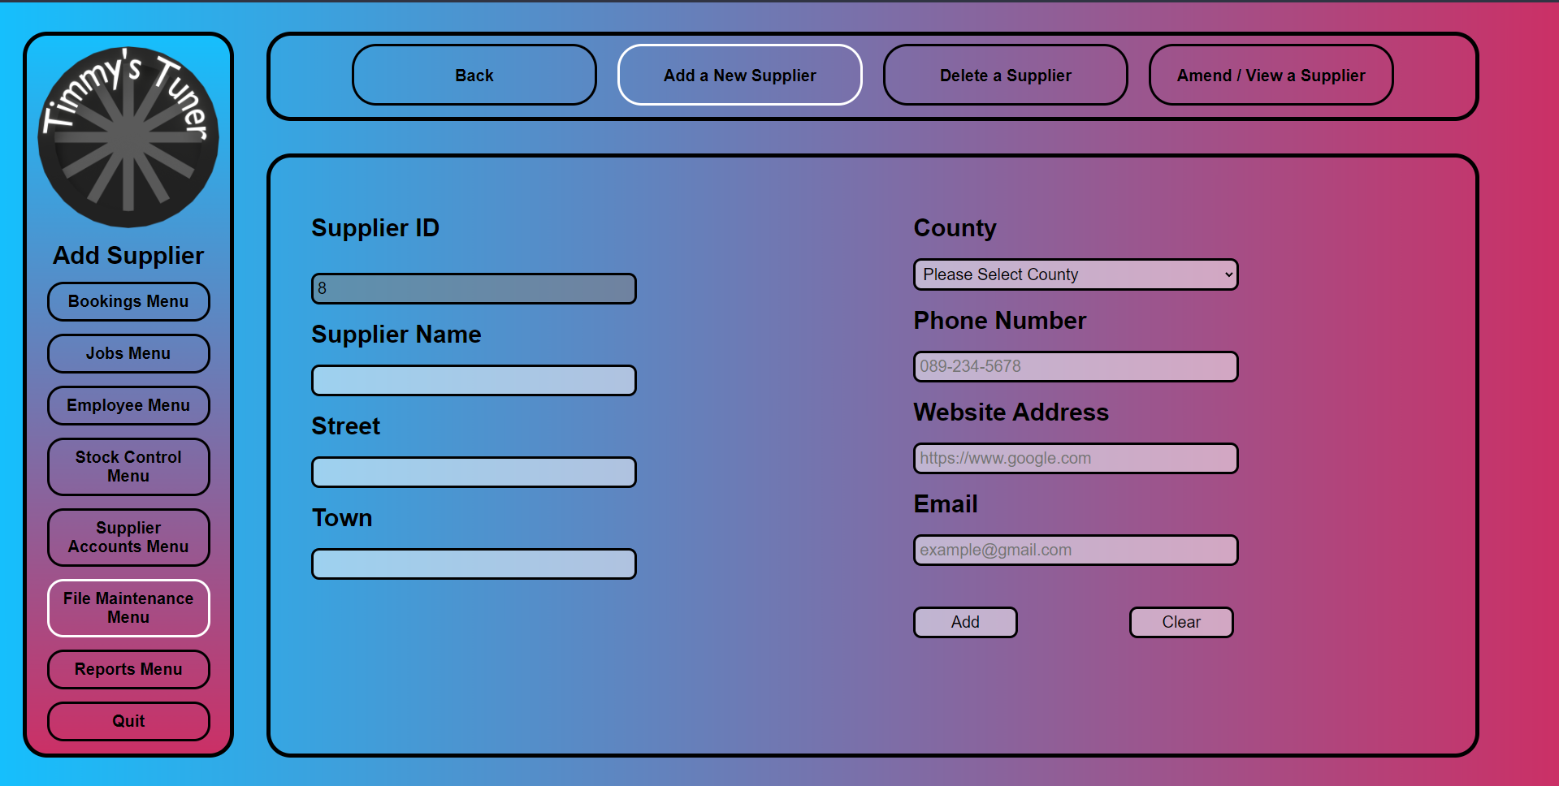

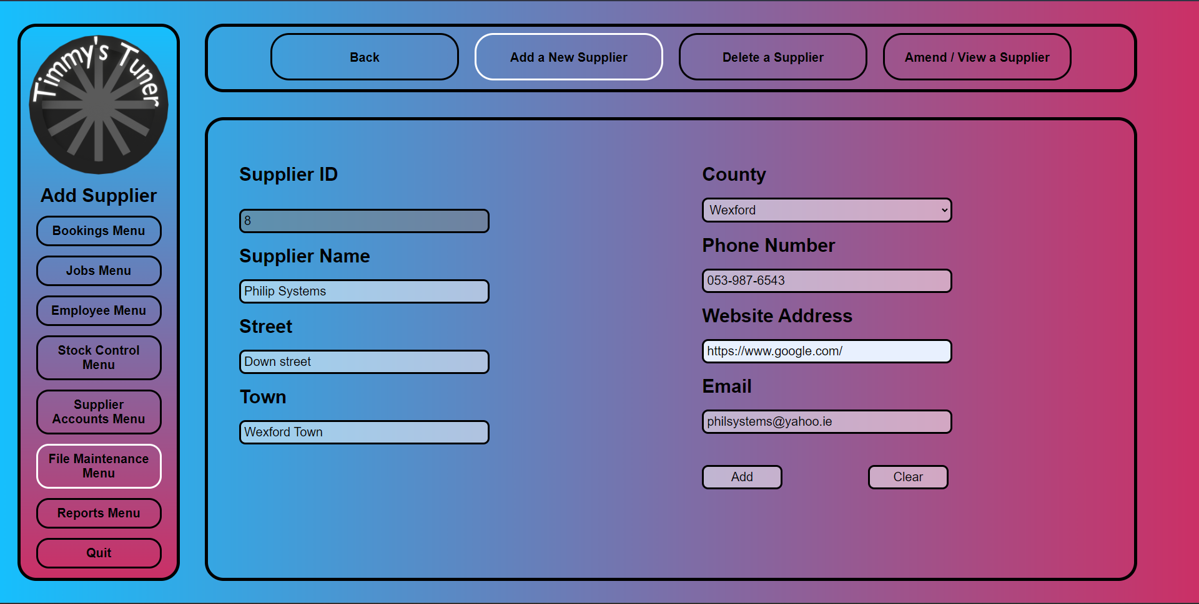

**add_a_new_supplier.html.php**

<!--

    Author: Qadeer Hussain

    ID: C00270632

    Date: 2023.03.16

-->

<!DOCTYPE html>

<html lang="en">

    <head>

        <link rel="stylesheet" href="../../Css/default.css">

        <title>Add Supplier</title>

        <style>

            /* sets it as there are four buttons */

            .sub_menu_button

            {

                width: 20%;

            }

            .content_box label

            {

                margin: 20px 0px 20px 0px;

            }

        </style>

        <script>

            // Confirmation

            function confirmCheck()

            {

                var response;

                response = confirm('Are you sure you want to add a new supplier?');

                if(response){

                    return true;

                }

                else{

                    return false;

                }

            }

        </script>

    </head>

    <body>

        <div class="nav_container">

            <div class="menu_box">

                <!-- this makes it so the logo brings you back to the main menu -->

                <img class="logo" onclick="location.href='../main_menu.php'">

                <div class="menu_title">

                    Add Supplier

                </div>

                <div class="menu_button" onclick="location.href='../Bookings/bookings_menu.html'">

                    Bookings Menu

                </div>

                <div class="menu_button" onclick="location.href='../Jobs/jobs_menu.html'">

                    Jobs Menu

                </div>

                <div class="menu_button" onclick="location.href='../Employee/employee_menu.html'">

                    Employee Menu

                </div>

                <div class="menu_button" onclick="location.href='../Stock_Control/stock_control_menu.html'">

                    Stock Control Menu

                </div>

                <div class="menu_button" onclick="location.href='../Supplier_Accounts/supplier_accounts_menu.html'">

                    Supplier Accounts Menu

                </div>

                <div class="menu_button" onclick="location.href='file_maintenance_menu.html'" style="border-color: white;">

                    File Maintenance Menu

                </div>

                <div class="menu_button" onclick="location.href='../Reports/reports_menu.html'">

                    Reports Menu

                </div>

                <div class="menu_button" onclick="location.href='../login_page.html'">

                    Quit

                </div>

            </div>

            <div class="sub_menu_box">

                <div class="sub_menu_button" onclick="location.href='file_maintenance_menu.html'">

                    Back

                </div>

                <div class="sub_menu_button" onclick="location.href='add_a_new_supplier.html.php'" style="border-color: white;">

                    Add a New Supplier

                </div>

                <div class="sub_menu_button" onclick="location.href='delete_a_supplier.html'">

                    Delete a Supplier

                </div>

                <div class="sub_menu_button" onclick="location.href='amend_view_a_supplier.html'">

                    Amend / View a Supplier

                </div>

            </div>

            <div class="content_box">

                <div form="content_box_form">

                    <form action="add_a_new_supplier.php" onsubmit="return confirmCheck()" method="post">

                        <!-- Left box with content -->

                        <div class="content_box_left">

                            <label for="supplierID">Supplier ID</label>

                            <br>

                            <?php

                                include "../connection.php";

                                //Checks the SupplierID value and increases it by one

                                $sql = "SELECT MAX(SupplierID) as maxID FROM Supplier";

                                $result = mysqli_query($con,$sql);

                                $row = mysqli_fetch_assoc($result);

                                $maxID = $row['maxID'] + 1;

                                $SupplierID=$maxID;

                                echo "<br>";

                                echo "<input type='text' name='SupplierID' id='SupplierID' value='$SupplierID' required disabled>";

                                mysqli_close($con)

                            ?>

                            <br>

                            <!-- Supplier  -->

                            <label for="supplierName">Supplier Name</label>

                            <br>

                            <input type="text" id="supplierName" name="supplierName" required>

                            <br>

                            <!-- Street -->

                            <label for="street">Street</label>

                            <br>

                            <input type="text" id="street" name="street" required>

                            <br>

                            <!-- Town -->

                            <label for="town">Town</label>

                            <br>

                            <input type="text" id="town" name="town" required>

                        </div>

                        <!-- Right box with content -->

                        <div class="content_box_right">

                            <!-- County -->

                            <label for="county">County:</label>

                            <br>

                            <!-- Dropdown for Counties -->

                            <select id="county" name="county" required>

                            <option value="">Select County</option>

                            <option value="Antrim">Antrim</option>

                            <option value="Armagh">Armagh</option>

                            <option value="Carlow">Carlow</option>

                            <option value="Cavan">Cavan</option>

                            <option value="Clare">Clare</option>

                            <option value="Cork">Cork</option>

                            <option value="Derry">Derry</option>

                            <option value="Donegal">Donegal</option>

                            <option value="Down">Down</option>

                            <option value="Dublin">Dublin</option>

                            <option value="Fermanagh">Fermanagh</option>

                            <option value="Galway">Galway</option>

                            <option value="Kerry">Kerry</option>

                            <option value="Kildare">Kildare</option>

                            <option value="Kilkenny">Kilkenny</option>

                            <option value="Laois">Laois</option>

                            <option value="Leitrim">Leitrim</option>

                            <option value="Limerick">Limerick</option>

                            <option value="Longford">Longford</option>

                            <option value="Louth">Louth</option>

                            <option value="Mayo">Mayo</option>

                            <option value="Meath">Meath</option>

                            <option value="Monaghan">Monaghan</option>

                            <option value="Offaly">Offaly</option>

                            <option value="Roscommon">Roscommon</option>

                            <option value="Sligo">Sligo</option>

                            <option value="Tipperary">Tipperary</option>

                            <option value="Tyrone">Tyrone</option>

                            <option value="Waterford">Waterford</option>

                            <option value="Westmeath">Westmeath</option>

                            <option value="Wexford">Wexford</option>

                            <option value="Wicklow">Wicklow</option>

                            </select>

                            <br>

                            <!-- Phone Number -->

                            <label for="phoneNo">Phone Number</label>

                            <br>

                            <input type="text" id="phoneNo" name="phoneNo" pattern="[0-9]{3}-[0-9]{3}-[0-9]{4}" placeholder="089-234-5678" required>

                            <br>

                            <!-- Website -->

                            <label for="websiteAddress">Website Address</label>

                            <br>

                            <input type="url" id="websiteAddress" name="websiteAddress" placeholder="https://www.google.com" required>

                            <br>

                            <!-- Email -->

                            <label for="email">Email</label>

                            <br>

                            <input type="email" id="email" name="email" placeholder="example@gmail.com" required>

                            <br>

                            <!-- Add button -->

                            <input class ="content_box_button" type="submit" value="Add">

                            <!-- Clear button -->

                            <input class ="content_box_button" type="reset" value="Clear"/>

                        </div>

                    </form>

                </div>

            </div>

        </div>

    </body>

</html>

**add_a_new_supplier.php**

<!--

    Author: Qadeer Hussain

    ID: C00270632

    Date: 2023.03.16

-->

<?php

    include "../connection.php";

    //Posting values

    $SupplierName=$_POST['supplierName'];

    $Street=$_POST['street'];

    $Town=$_POST['town'];

    $County=$_POST['county'];

    $PhoneNo=$_POST['phoneNo'];

    $WebsiteAddress=$_POST['websiteAddress'];

    $Email=$_POST['email'];

    //Checks the SupplierID value and increases it by one

    $sql = "SELECT MAX(SupplierID) as maxID FROM Supplier";

    $result = mysqli_query($con,$sql);

    $row = mysqli_fetch_assoc($result);

    $maxID = $row['maxID'] + 1;

    $SupplierID=$maxID;

    //Inserts data into supplier table

    $sql = "INSERT INTO Supplier (SupplierID, SupplierName, Street, Town, County, PhoneNo, WebsiteAddress, Email)

    VALUES ('$SupplierID',

            '$SupplierName',

            '$Street',

            '$Town',

            '$County',

            '$PhoneNo',

            '$WebsiteAddress',

            '$Email')";

    if (!mysqli_query($con,$sql))

    {

        echo "Error ".mysqli_error($con);

    }

    else

    {

        header('Location: add_a_new_supplier.html.php');

    }

mysqli_close($con);

?>

</form>

### Delete a Customer

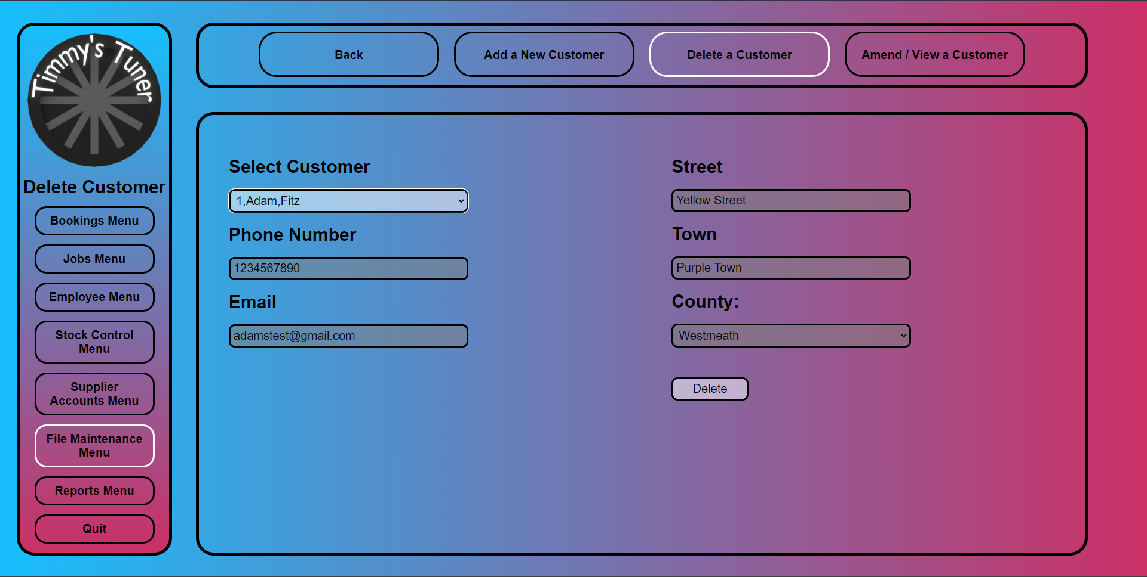

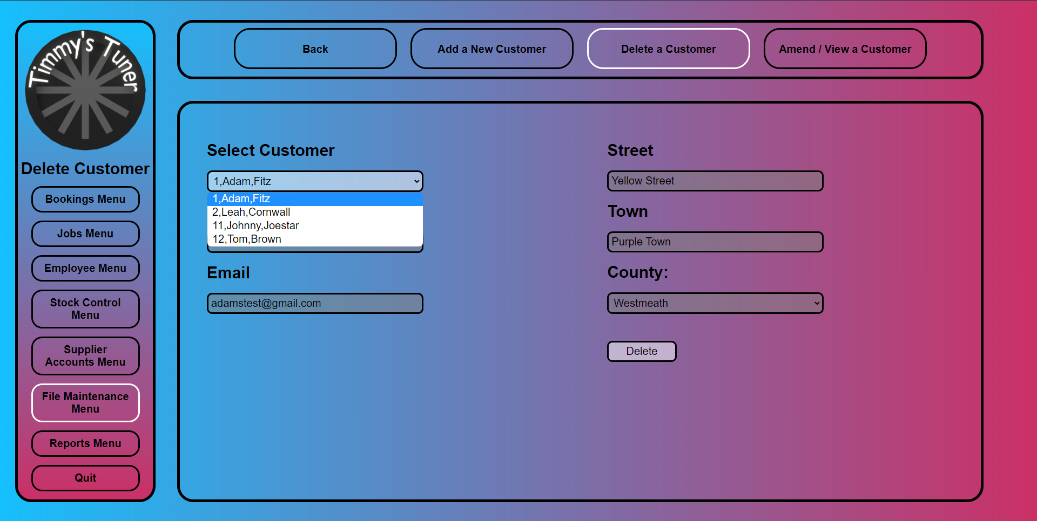

**delete_a_customer.html.php**

<!--

    Author: Qadeer Hussain

    ID: C00270632

    Date: 2023.03.16

-->

<!DOCTYPE html>

<html lang="en">

    <head>

        <link rel="stylesheet" href="../../Css/default.css">

        <title>Delete Customer</title>

        <style>

            /* sets it as there are four buttons */

            .sub_menu_button

            {

                width: 20%;

            }

            .content_box label

            {

                margin: 20px 0px 20px 0px;

            }

        </style>

        <script>

            // Confirmation

            function confirmCheck()

            {

                var sel=document.getElementById("select_customer");

                var result;

                result=sel.options[sel.selectedIndex].value;

                var details=result.split(',');

                var response;

                response = confirm('Are you sure you want to delete this customer ' + details[0] + " - " + details[1] + " " + details[2]);

                if(response){

                    return true;

                }

                else{

                    return false;

                }

            }

        </script>

</head>

    <body>

        <div class="nav_container">

            <div class="menu_box">

                <!-- this makes it so the logo brings you back to the main menu -->

                <img class="logo" onclick="location.href='../main_menu.php'">

                <div class="menu_title">

                    Delete Customer

                </div>

                <div class="menu_button" onclick="location.href='../Bookings/bookings_menu.html'">

                    Bookings Menu

                </div>

                <div class="menu_button" onclick="location.href='../Jobs/jobs_menu.html'">

                    Jobs Menu

                </div>

                <div class="menu_button" onclick="location.href='../Employee/employee_menu.html'">

                    Employee Menu

                </div>

                <div class="menu_button" onclick="location.href='../Stock_Control/stock_control_menu.html'">

                    Stock Control Menu

                </div>

                <div class="menu_button" onclick="location.href='../Supplier_Accounts/supplier_accounts_menu.html'">

                    Supplier Accounts Menu

                </div>

                <div class="menu_button" onclick="location.href='file_maintenance_menu.html'" style="border-color: white;">

                    File Maintenance Menu

                </div>

                <div class="menu_button" onclick="location.href='../Reports/reports_menu.html'">

                    Reports Menu

                </div>

                <div class="menu_button" onclick="location.href='../login_page.html'">

                    Quit

                </div>

            </div>

            <div class="sub_menu_box">

                <div class="sub_menu_button" onclick="location.href='file_maintenance_menu.html'">

                    Back

                </div>

                <div class="sub_menu_button" onclick="location.href='add_a_new_customer.html.php'">

                    Add a New Customer

                </div>

                <div class="sub_menu_button" onclick="location.href='delete_a_customer.html.php'" style="border-color: white;">

                    Delete a Customer

                </div>

                <div class="sub_menu_button" onclick="location.href='amend_view_a_customer.html.php'">

                    Amend / View a Customer

                </div>

            </div>

            <div class="content_box">

                <div form="content_box_form">

                    <form action="delete_a_customer.php" method="post" onsubmit="return confirmCheck()">

                        <!-- Left box with content -->

                        <div class="content_box_left">

                            <!-- Select Customer  -->

                            <label for="Customer">Select Customer</label>

                                <?php include "select_customer.php" ?>

                                <script>

                                    // Populate the Customer information into there text boxes

                                    function populate()

                                    {

                                        var sel=document.getElementById("select_customer");

                                        var result;

                                        result=sel.options[sel.selectedIndex].value;

                                        var details=result.split(',');

                                        document.getElementById("street").value=details[3];

                                        document.getElementById("town").value=details[4];

                                        document.getElementById("county").value=details[5];

                                        document.getElementById("phoneNo").value=details[6];

                                        document.getElementById("email").value=details[7];

                                    }

                                </script>

                            <br>

                            <!-- Phone Number -->

                            <label for="phoneNo">Phone Number</label>

                            <br>

                            <input type="number" id="phoneNo" name="phoneNo" placeholder="089-234-5678" readonly>

                            <br>

                            <!-- Email -->

                            <label for="email">Email</label>

                            <br>

                            <input type="email" id="email" name="email" placeholder="example@gmail.com" readonly>

                        </div>

                        <!-- Right box with content -->

                        <div class="content_box_right">

                            <!-- Street -->

                            <label for="street">Street</label>

                            <br>

                            <input type="text" id="street" name="street" readonly>

                            <br>

                            <!-- Town -->

                            <label for="town">Town</label>

                            <br>

                            <input type="text" id="town" name="town" readonly>

                            <br>

                            <!-- County -->

                            <label for="county">County:</label>

                            <br>

                            <select id="county" name="county" disabled>

                            <option value="">Select County</option>

                            <option value="Antrim">Antrim</option>

                            <option value="Armagh">Armagh</option>

                            <option value="Carlow">Carlow</option>

                            <option value="Cavan">Cavan</option>

                            <option value="Clare">Clare</option>

                            <option value="Cork">Cork</option>

                            <option value="Derry">Derry</option>

                            <option value="Donegal">Donegal</option>

                            <option value="Down">Down</option>

                            <option value="Dublin">Dublin</option>

                            <option value="Fermanagh">Fermanagh</option>

                            <option value="Galway">Galway</option>

                            <option value="Kerry">Kerry</option>

                            <option value="Kildare">Kildare</option>

                            <option value="Kilkenny">Kilkenny</option>

                            <option value="Laois">Laois</option>

                            <option value="Leitrim">Leitrim</option>

                            <option value="Limerick">Limerick</option>

                            <option value="Longford">Longford</option>

                            <option value="Louth">Louth</option>

                            <option value="Mayo">Mayo</option>

                            <option value="Meath">Meath</option>

                            <option value="Monaghan">Monaghan</option>

                            <option value="Offaly">Offaly</option>

                            <option value="Roscommon">Roscommon</option>

                            <option value="Sligo">Sligo</option>

                            <option value="Tipperary">Tipperary</option>

                            <option value="Tyrone">Tyrone</option>

                            <option value="Waterford">Waterford</option>

                            <option value="Westmeath">Westmeath</option>

                            <option value="Wexford">Wexford</option>

                            <option value="Wicklow">Wicklow</option>

                            </select>

                            <br>

                            <!-- Delete Button -->

                            <input class ="content_box_button" type="submit" value="Delete">

                        </div>

                    </form>

                </div>

            </div>

        </div>

    </body>

</html>

**delete_a_customer.php**

<!--

    Author: Qadeer Hussain

    ID: C00270632

    Date: 2023.03.16

-->

<?php

    include "../connection.php";

    // Explodes splits into an array the first item of the array is gotten which is the CustomerID then set to deleted = 1

    $customerID = explode(",", $_POST['select_customer'])[0];

    $sql = "UPDATE Customer SET Deleted = 1 WHERE CustomerID = $customerID";

    if (!mysqli_query($con,$sql)){

        echo "Error ".mysqli_error($con);

    }

    else{

        mysqli_close($con);

        header('Location: delete_a_customer.html.php');

    }

?>

**select_customer.php**

<!--

    Author: Qadeer Hussain

    ID: C00270632

    Date: 2023.03.16

-->

<?php

include "../connection.php";//database connections

date_default_timezone_set('UTC');

// Select the Customer details

$sql = "SELECT customerID,firstName,surName,street,town,county,phoneNo,email FROM Customer WHERE Deleted=0";

if (!$result=mysqli_query($con,$sql))

{

    die('Error in querying the database' . mysqli_error($con));

}

echo "<br><select name='select_customer' id ='select_customer' onclick='populate()'>";

while ($row=mysqli_fetch_array($result))

{

    // Customer details

    $CustomerID=$row['customerID'];

    $FirstName=$row['firstName'];

    $Surname=$row['surName'];

    $Street=$row['street'];

    $Town=$row['town'];

    $County=$row['county'];

    $PhoneNo=$row['phoneNo'];

    $Email=$row['email'];

    $allText = "$CustomerID,$FirstName,$Surname,$Street,$Town,$County,$PhoneNo,$Email";

    echo "<option value='$allText'>$CustomerID,$FirstName,$Surname</option>";

}

echo "</select>";

mysqli_close($con);

?>

### Commencement of Job

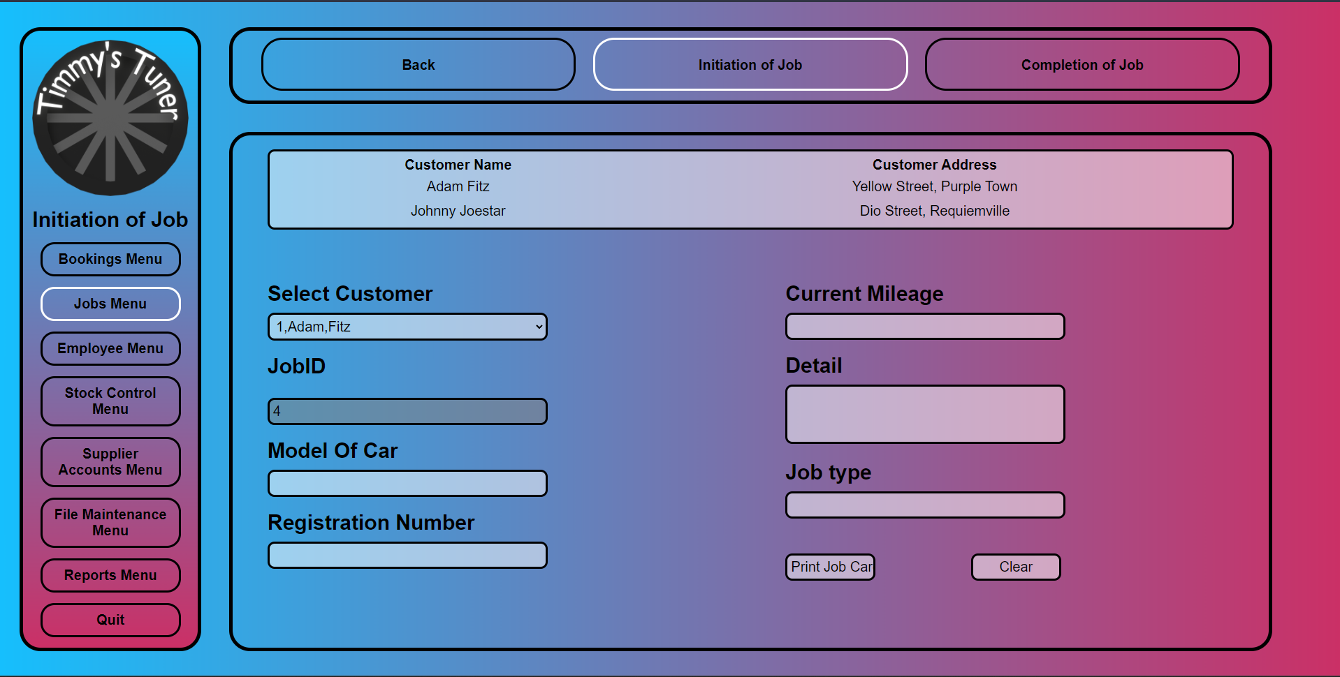

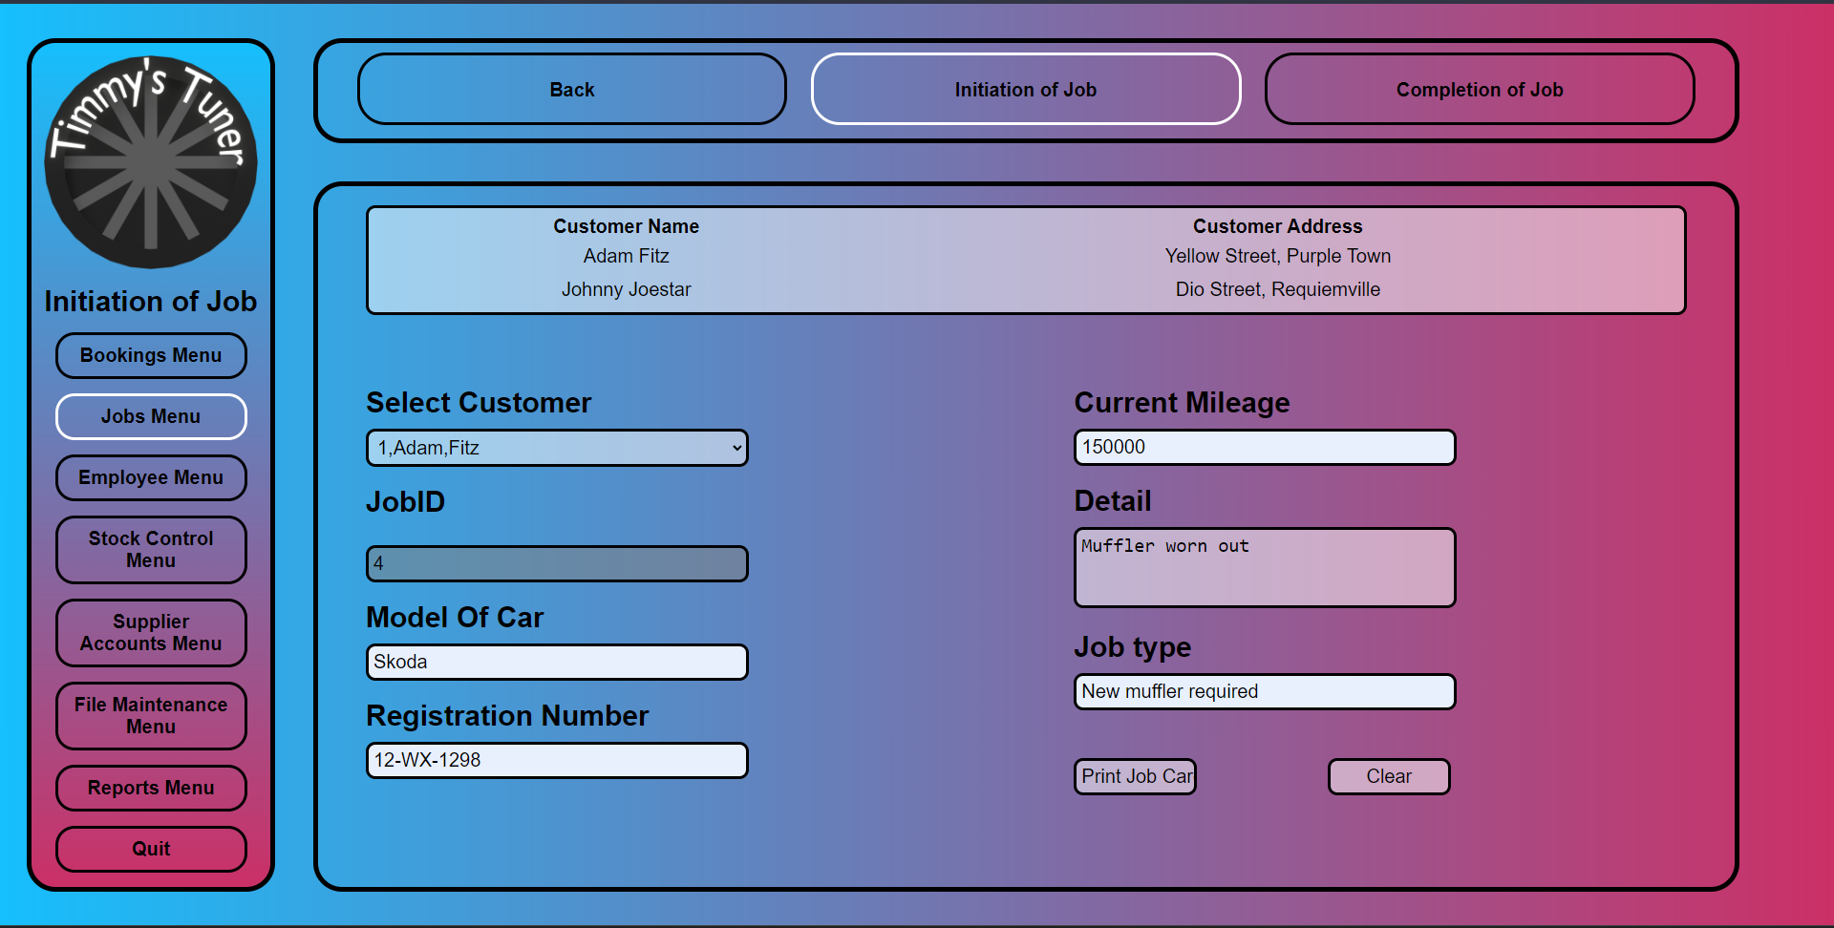

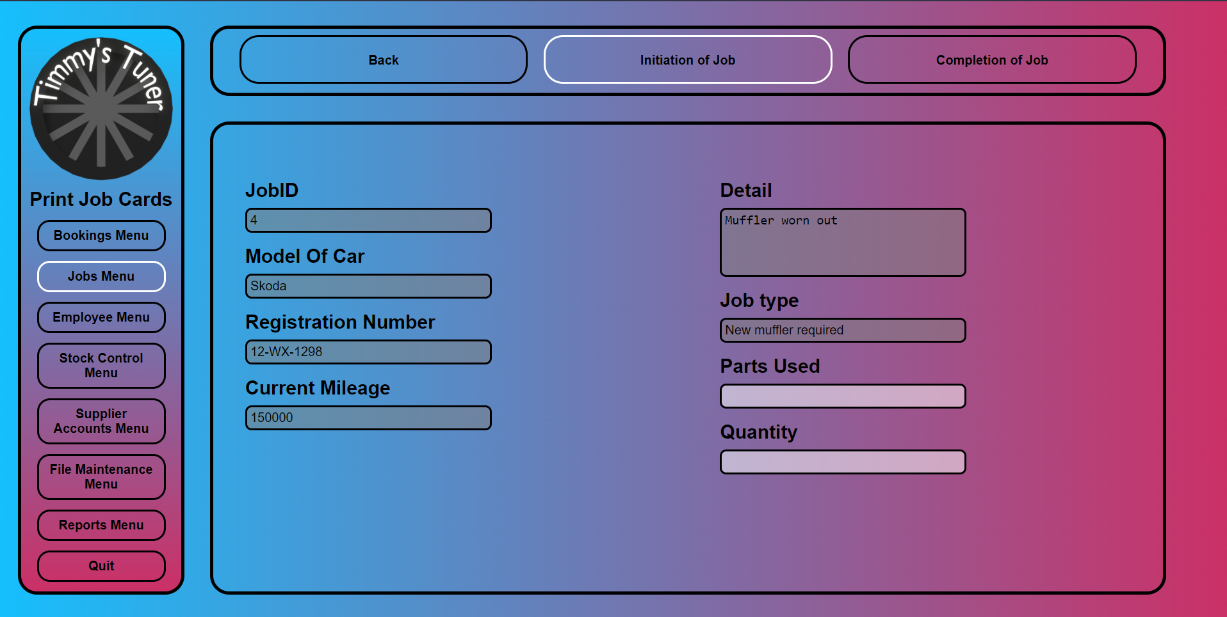

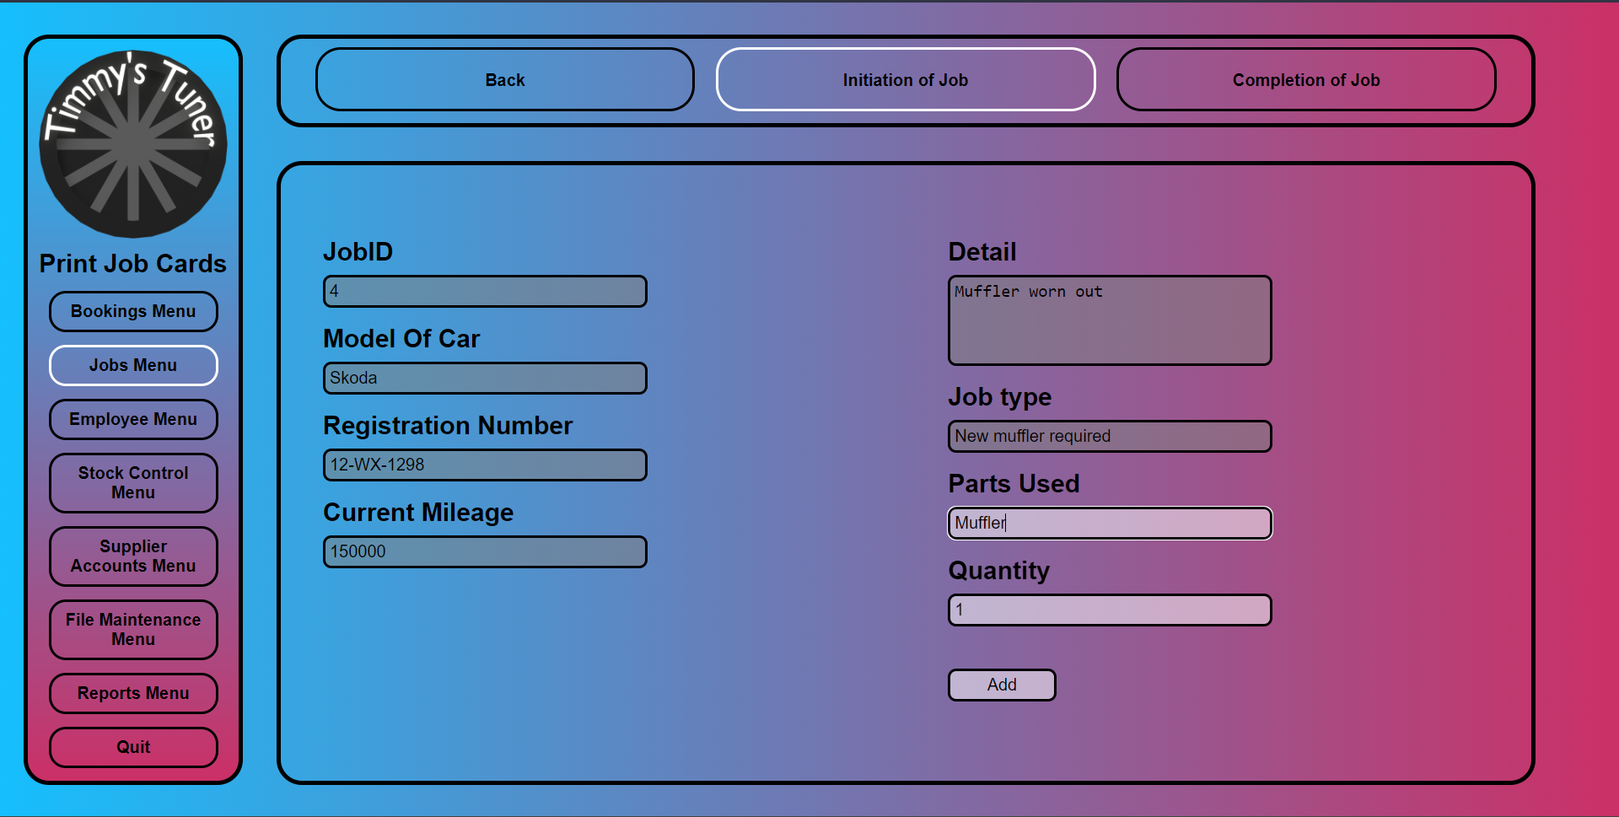

**initiation_of_job.html.php**

<!--

    Author: Qadeer Hussain

    ID: C00270632

    Date: 2023.03.18

-->

<!DOCTYPE html>

<html lang="en">

    <head>

        <link rel="stylesheet" href="../../Css/default.css">

        <title>Initiation of Job</title>

        <style>

            /* Top margin for the table */

            .content_box_report

            {

                margin: 20px 0px 0px 0px;

            }

            /* Move the content box left up closer to the table leaving a small gap of 5 pixels */

            .content_box_left

            {

                margin-top: 5px;

            }

              /* Move the content box right up closer to the table leaving a small gap of 5 pixels */

            .content_box_right

            {

                margin-top: 5px;

            }

        </style>

        <script>

            // Confirmation

            function confirmCheck()

            {

                response = confirm('Are you sure you want to add this record ');

                if(response){

                    return true;

                }

                else{

                    return false;

                }

            }

        </script>

    </head>

    <body>

        <div class="nav_container">

            <div class="menu_box">

                <!-- this makes it so the logo brings you back to the main menu -->

                <img class="logo" onclick="location.href='../main_menu.php'">

                <div class="menu_title">

                    Initiation of Job

                </div>

                <div class="menu_button" onclick="location.href='../Bookings/bookings_menu.html'">

                    Bookings Menu

                </div>

                <div class="menu_button" onclick="location.href='jobs_menu.html'" style="border-color: white;">

                    Jobs Menu

                </div>

                <div class="menu_button" onclick="location.href='../Employee/employee_menu.html'">

                    Employee Menu

                </div>

                <div class="menu_button" onclick="location.href='../Stock_Control/stock_control_menu.html'">

                    Stock Control Menu

                </div>

                <div class="menu_button" onclick="location.href='../Supplier_Accounts/supplier_accounts_menu.html'">

                    Supplier Accounts Menu

                </div>

                <div class="menu_button" onclick="location.href='../File_Maintenance/file_maintenance_menu.html'">

                    File Maintenance Menu

                </div>

                <div class="menu_button" onclick="location.href='../Reports/reports_menu.html'">

                    Reports Menu

                </div>

                <div class="menu_button" onclick="location.href='../login_page.html'">

                    Quit

                </div>

            </div>

            <div class="sub_menu_box">

                <div class="sub_menu_button" onclick="location.href='../main_menu.php'">

                    Back

                </div>

                <div class="sub_menu_button" onclick="location.href='initiation_of_job.html.php'" style="border-color: white;">

                    Initiation of Job

                </div>

                <div class="sub_menu_button" onclick="location.href='completion_of_job.html.php'">

                    Completion of Job

                </div>

            </div>

            <div class="content_box">

                <div form="content_box_form">

                    <form action="print_job_cards.html.php" method="post" onsubmit="return confirmCheck()">

                        <!-- Report box with content -->

                        <div class="content_box_report">

                            <?php

                                include "../connection.php";

                                // Selectr the Customer ID from Customer table and Inner join it with Bookings table Customer ID and and get the customer for todays date

                                $sql = "SELECT * FROM Customer INNER JOIN Bookings ON Bookings.CustomerID = Customer.CustomerID AND DATE(Bookings.DateAndTime)=CURDATE();";

                                $result = mysqli_query($con, $sql);

                                if (!$result) {

                                    echo "Error: " . mysqli_error($con);

                                } else {

                                    // Table generation

                                    echo "<table>";

                                    echo "<tr><th>Customer Name</th><th>Customer Address</th></tr>";

                                    while ($row = mysqli_fetch_assoc($result)) {

                                        $FirstName = $row['FirstName'];

                                        $Surname = $row['Surname'];

                                        $Street = $row['Street'];

                                        $Town = $row['Town'];

                                        echo "<tr><td>" . $FirstName . " " . $Surname . "</td><td>" . $Street . ", " . $Town . "</td></tr>";

                                    }

                                    echo "</table>";

                                }

                            ?>

                        </div>

                        <!-- Left box with content -->

                        <div class="content_box_left">

                            <!-- Drop down for the customer -->

                            <label for="Customer">Select Customer</label>

                            <?php include "select_customer_bookings.php" ?>

                            <br>

                            <!-- Job ID increment it by 1 everytime a new entry is entered -->

                            <label for="JobID">JobID</label>

                            <br>

                            <?php

                                include "../connection.php";

                                //Checks the SupplierID value and increases it by one

                                $sql = "SELECT MAX(JobID) as maxID FROM Jobs";

                                $result = mysqli_query($con,$sql);

                                $row = mysqli_fetch_assoc($result);

                                $maxID = $row['maxID'] + 1;

                                $JobID=$maxID;

                                echo "<br>";

                                echo "<input type='text' name='JobID' id='JobID' value='$JobID' required disabled>";

                                mysqli_close($con)

                            ?>

                            <br>

                            <!-- Model of Car -->

                            <label for="modelOfCar">Model Of Car</label>

                            <br>

                            <input type="text" id="modelOfCar" name="modelOfCar" required>

                            <br>

                            <!-- Reg number -->

                            <label for="regNumber">Registration Number</label>

                            <br>

                            <input type="text" id="regNumber" name="regNumber" required>

                        </div>

                         <!-- Right box with content -->

                        <div class="content_box_right">

                            <!-- Current Mileage -->

                            <label for="currentMileage">Current Mileage</label>

                            <br>

                            <input type="number" id="currentMileage" name="currentMileage" required>

                            <br>

                            <!-- Details -->

                            <label for="details">Detail</label>

                            <br>

                            <textarea name="details" id="details" rows="3" cols="25" required></textarea>

                            <br>

                            <!-- Job Type -->

                            <label for="jobType">Job type</label>

                            <br>

                            <input type="text" id="jobType" name="jobType" required>

                            <!-- Print Job cards add the infirmation to table and goes to the Print jobcards page -->

                            <input class ="content_box_button" type="submit" value="Print Job Card" >

                            <!-- Clear text box fields -->

                            <input class ="content_box_button" type="reset" value="Clear">

                        </div>

                    </form>

                </div>

            </div>

        </div>

    </body>

</html>

**print_job_cards.html.php**

<!--

    Author: Qadeer Hussain

    ID: C00270632

    Date: 2023.03.18

-->

<?php

    include "../connection.php";

    //Posting values

    $ModelOfCar=$_POST['modelOfCar'];

    $RegNumber=$_POST['regNumber'];

    $CurrentMileage=$_POST['currentMileage'];

    $Details=$_POST['details'];

    $JobType=$_POST['jobType'];

    //Checks the JobID value and increases it by one

    $sql = "SELECT MAX(JobID) as maxID FROM Jobs";

    $result = mysqli_query($con,$sql);

    $row = mysqli_fetch_assoc($result);

    $maxID = $row['maxID'] + 1;

    $JobID=$maxID;

    //Inserts data into Jobs table

    $sql = "INSERT INTO Jobs (JobID, ModelOfCar, RegNumber, CurrentMileage, Details, JobType)

    VALUES ('$JobID',

            '$ModelOfCar',

            '$RegNumber',

            '$CurrentMileage',

            '$Details',

            '$JobType')";

if (!mysqli_query($con,$sql))

{

    echo "Error ".mysqli_error($con);

}

else

{

    if(mysqli_affected_rows($con)!=0)

    {

        echo

            "<script>

                alert ('A new record has been added to the Jobs table');

            </script>";

    }

}

mysqli_close($con);

?>

</form>

<!DOCTYPE html>

<html lang="en">

    <head>

        <link rel="stylesheet" href="../../Css/default.css">

        <title>Print Job Cards</title>

        <script>

            // Confirmation

            function confirmCheck()

            {

                response = confirm('Are you sure you want to add this record ');

                if(response){

                    return true;

                }

                else{

                    return false;

                }

            }

        </script>

    </head>

    <body>

        <div class="nav_container">

            <div class="menu_box">

                <!-- this makes it so the logo brings you back to the main menu -->

                <img class="logo" onclick="location.href='../main_menu.php'">

                <div class="menu_title">

                    Print Job Cards

                </div>

                <div class="menu_button" onclick="location.href='../Bookings/bookings_menu.html'">

                    Bookings Menu

                </div>

                <div class="menu_button" onclick="location.href='jobs_menu.html'" style="border-color: white;">

                    Jobs Menu

                </div>

                <div class="menu_button" onclick="location.href='../Employee/employee_menu.html'">

                    Employee Menu

                </div>

                <div class="menu_button" onclick="location.href='../Stock_Control/stock_control_menu.html'">

                    Stock Control Menu

                </div>

                <div class="menu_button" onclick="location.href='../Supplier_Accounts/supplier_accounts_menu.html'">

                    Supplier Accounts Menu

                </div>

                <div class="menu_button" onclick="location.href='../File_Maintenance/file_maintenance_menu.html'">

                    File Maintenance Menu

                </div>

                <div class="menu_button" onclick="location.href='../Reports/reports_menu.html'">

                    Reports Menu

                </div>

                <div class="menu_button" onclick="location.href='../login_page.html'">

                    Quit

                </div>

            </div>

            <div class="sub_menu_box">

                <div class="sub_menu_button" onclick="location.href='initiation_of_job.html.php'">

                    Back

                </div>

                <div class="sub_menu_button" onclick="location.href='initiation_of_job.html.php'" style="border-color: white;">

                    Initiation of Job

                </div>

                <div class="sub_menu_button" onclick="location.href='completion_of_job.html.php'">

                    Completion of Job

                </div>

            </div>

            <div class="content_box">

                <div form="content_box_form">

                    <form action="initiation_of_job.html.php" method="post" onsubmit="return confirmCheck()">

                        <!-- Left box with content -->

                        <div class="content_box_left">

                            <!-- Jobs and generate the information after it was entered from previous screen-->

                            <label for="JobID">JobID</label>

                            <br>

                            <input type="text" id="JobID" name="JobID" value="<?php echo $JobID; ?>" disabled>

                            <br>

                            <!-- Model Of Car and generate the information after it was entered from previous screen-->

                            <label for="modelOfCar">Model Of Car</label>

                            <br>

                            <input type="text" id="modelOfCar" name="modelOfCar" value="<?php echo $ModelOfCar; ?>"  disabled>

                            <br>

                            <!-- Reg Number and generate the information after it was entered from previous screen-->

                            <label for="regNumber">Registration Number</label>

                            <br>

                            <input type="text" id="regNumber" name="regNumber" value="<?php echo $RegNumber; ?>" disabled>

                            <br>

                            <!-- Current Mileage and generate the information after it was entered from previous screen-->

                            <label for="currentMileage">Current Mileage</label>

                            <br>

                            <input type="text" id="currentMileage" name="currentMileage" value="<?php echo $CurrentMileage; ?>" disabled>

                        </div>

                         <!-- Right box with content -->

                        <div class="content_box_right">

                            <!-- Details and generate the information after it was entered from previous screen-->

                            <label for="details">Detail</label>

                            <br>

                            <textarea name="details" id="details" rows="4" cols="30" disabled><?php echo $Details; ?></textarea>

                            <br>

                            <!-- Job Type and generate the information after it was entered from previous screen-->

                            <label for="jobType">Job type</label>

                            <br>

                            <input type="text" id="jobType" name="jobType" value="<?php echo $JobType; ?>" disabled>

                            <br>

                            <!-- Parts Used -->

                            <label for="partsUsed">Parts Used</label>

                            <br>

                            <input type="text" id="partsUsed" name="partsUsed">

                            <br>

                            <!-- Quantity -->

                            <label for="quantity">Quantity</label>

                            <br>

                            <input type="text" id="quantity" name="quantity">

                            <input class ="content_box_button" type="submit" value="Add">

                        </div>

                    </form>

                </div>

            </div>

        </div>

    </body>

</html>

**select_customer_bookings.php**

<!--

    Author: Qadeer Hussain

    ID: C00270632

    Date: 2023.03.18

-->

<?php

    include "../connection.php";//database connections

    // Select the customer ID, Name and Date and Time from both tables and Inner Join the Bookings table Customer ID and Customer table Customer ID And only select the customer which is from todays date

    $sql = "SELECT Bookings.CustomerID, Customer.FirstName, Customer.Surname, Bookings.DateAndTime

    FROM Bookings, Customer

    WHERE Bookings.CustomerID = Customer.CustomerID

    AND DATE(Bookings.DateAndTime) = CURDATE()";

    if (!$result=mysqli_query($con,$sql))

    {

        die('Error in querying the database' . mysqli_error($con));

    }

    echo "<br><select name='select_customer_bookings' id ='select_customer_bookings'>";

    while ($row=mysqli_fetch_array($result))

    {

        // Customer Details

        $CustomerID=$row['CustomerID'];

        $FirstName=$row['FirstName'];

        $Surname=$row['Surname'];

        $allText = "$CustomerID,$FirstName,$Surname";

        echo "<option value='$allText'>$CustomerID,$FirstName,$Surname</option>";

    }

    echo "</select>";

    mysqli_close($con);

?>

### Completion of Job

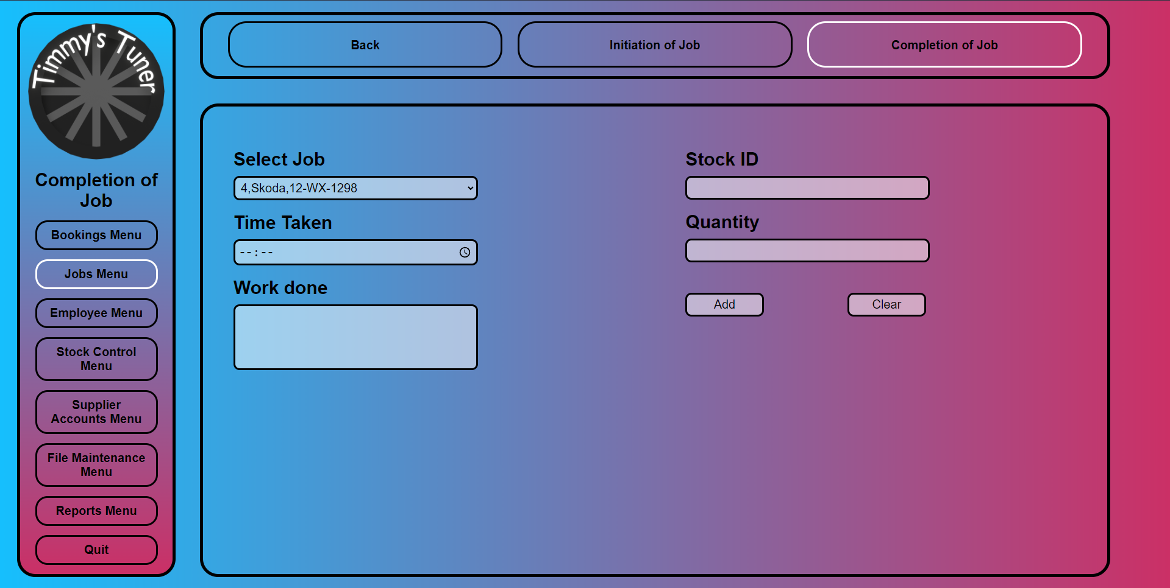

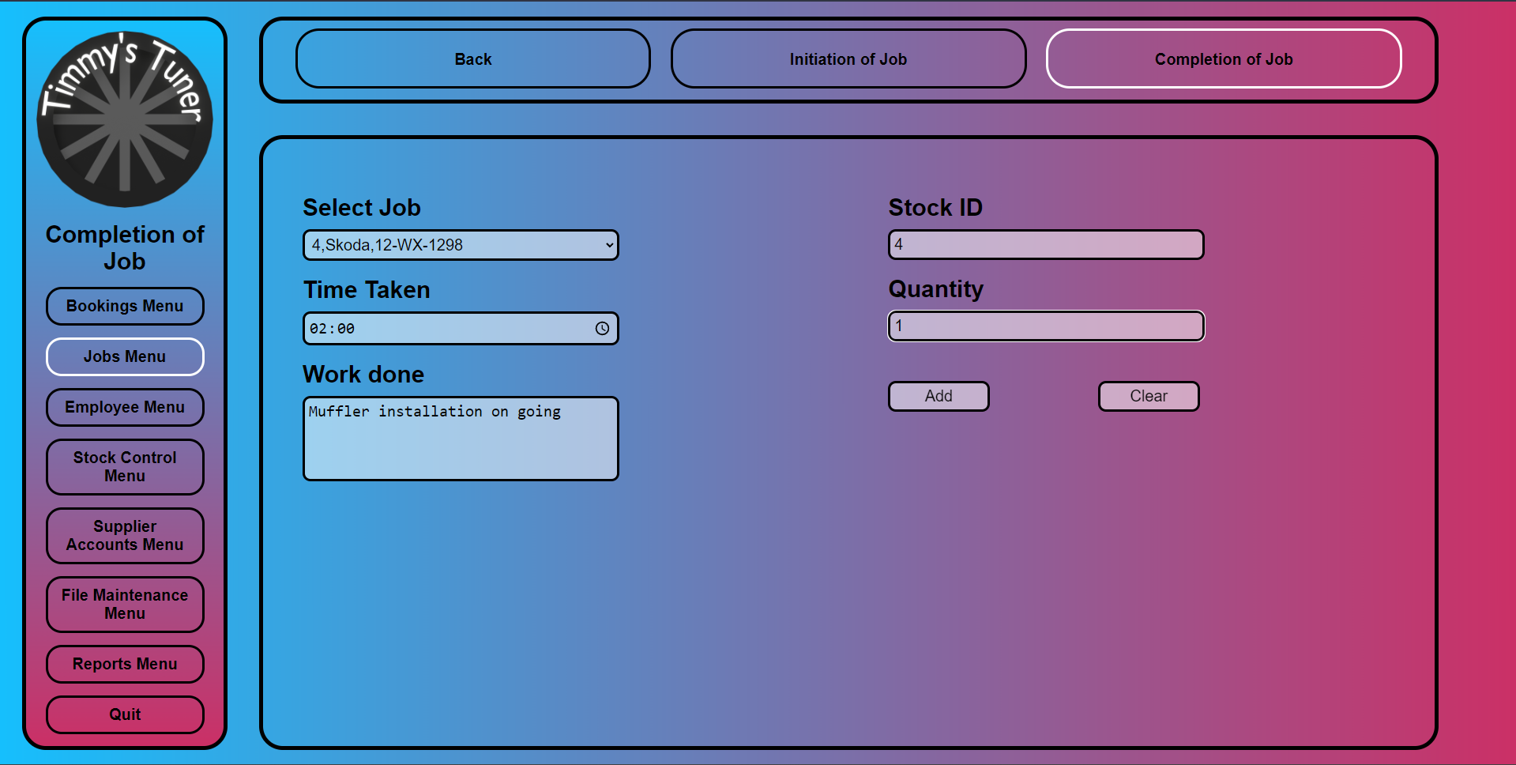

**completion_of_job.html.php**

<!--

    Author: Qadeer Hussain

    ID: C00270632

    Date: 2023.03.18

-->

<!DOCTYPE html>

<html lang="en">

    <head>

        <link rel="stylesheet" href="../../Css/default.css">

        <title>Completion of Job</title>

        <script>

            // Confirmation

            function confirmCheck()

            {

                response = confirm('Are you sure you want to add this record ');

                if(response){

                    return true;

                }

                else{

                    return false;

                }

            }

        </script>

    </head>

    <body>

        <div class="nav_container">

            <div class="menu_box">

                <!-- this makes it so the logo brings you back to the main menu -->

                <img class="logo" onclick="location.href='../main_menu.php'">

                <div class="menu_title">

                    Completion of Job

                </div>

                <div class="menu_button" onclick="location.href='../Bookings/bookings_menu.html'">

                    Bookings Menu

                </div>

                <div class="menu_button" onclick="location.href='jobs_menu.html'" style="border-color: white;">

                    Jobs Menu

                </div>

                <div class="menu_button" onclick="location.href='../Employee/employee_menu.html'">

                    Employee Menu

                </div>

                <div class="menu_button" onclick="location.href='../Stock_Control/stock_control_menu.html'">

                    Stock Control Menu

                </div>

                <div class="menu_button" onclick="location.href='../Supplier_Accounts/supplier_accounts_menu.html'">

                    Supplier Accounts Menu

                </div>

                <div class="menu_button" onclick="location.href='../File_Maintenance/file_maintenance_menu.html'">

                    File Maintenance Menu

                </div>

                <div class="menu_button" onclick="location.href='../Reports/rereports_menu.html'">

                    Reports Menu

                </div>

                <div class="menu_button" onclick="location.href='../login_page.html'">

                    Quit

                </div>

            </div>

            <div class="sub_menu_box">

                <div class="sub_menu_button" onclick="location.href='../main_menu.php'">

                    Back

                </div>

                <div class="sub_menu_button" onclick="location.href='initiation_of_job.html.php'">

                    Initiation of Job

                </div>

                <div class="sub_menu_button" onclick="location.href='completion_of_job.html.php'" style="border-color: white;">

                    Completion of Job

                </div>

            </div>

            <div class="content_box">

                <div form="content_box_form">

                    <form action="completion_of_job.php" method="post" onsubmit="return confirmCheck()">

                         <!-- Left box with content -->

                         <div class="content_box_left">

                            <!-- Dropdown for Customer/Job -->

                            <label for="Customer">Select Job</label>

                            <?php include "select_job.php" ?>

                            <br>

                            <!-- Time Taken -->

                            <label for="timeTaken">Time Taken</label>

                            <br>

                            <input type="time" id="timeTaken" name="timeTaken">

                            <br>

                            <!-- Work Done -->

                            <label for="workDone">Work done</label>

                            <br>

                            <textarea name="workDone" id="workDone" rows="4" cols="30"></textarea>

                        </div>

                         <!-- Right box with content -->

                        <div class="content_box_right">

                            <!-- StockID -->

                            <label for="stockID">Stock ID</label>

                            <br>

                            <input type="text" id="stockID" name="stockID">

                            <br>

                            <!-- Quantity -->

                            <label for="quantity">Quantity</label>

                            <br>

                            <input type="text" id="quantity" name="quantity">

                            <!-- Add button -->

                            <input class ="content_box_button" type="submit" value="Add">

                            <!-- Clear text box fields -->

                            <input class ="content_box_button" type="reset" value="Clear">

                        </div>

                    </form>

                </div>

            </div>

        </div>

    </body>

</html>

**completion_of_job.php**

<!--

    Author: Qadeer Hussain

    ID: C00270632

    Date: 2023.03.18

-->

<?php

    include "../connection.php";

    //Posting values

    $TimeTaken=$_POST['TimeTaken'];

    $WorkDone=$_POST['workDone'];

    //Inserts data into Jobs table

    $sql = "INSERT INTO Jobs (TimeTaken, WorkDone)

    VALUES ('$TimeTaken',

            '$WorkDone')";

if (!mysqli_query($con,$sql))

{

    echo "Error ".mysqli_error($con);

}

else

{

    mysqli_close($con);

    header('Location: completion_of_job.html.php');

}

mysqli_close($con);

?>#

**select_job.php**

<!--

    Author: Qadeer Hussain

    ID: C00270632

    Date: 2023.03.18

-->

<?php

    include "../connection.php";//database connections

    // Select the Job ID, Model of Car and the Reg Number

    $sql = "SELECT JobID, ModelOfCar, RegNumber FROM Jobs;";

    if (!$result=mysqli_query($con,$sql))

    {

        die('Error in querying the database' . mysqli_error($con));

    }

    echo "<br><select name='select_job' id ='select_job'>";

    while ($row=mysqli_fetch_array($result))

    {

        // Customer Details

        $JobID=$row['JobID'];

        $ModelOfCar=$row['ModelOfCar'];

        $RegNumber=$row['RegNumber'];

        $allText = "$JobID,$ModelOfCar,$RegNumber";

        echo "<option value='$allText'>$JobID,$ModelOfCar,$RegNumber</option>";

    }

    echo "</select>";

    mysqli_close($con);

?>